Mediainformation

Metstrade 2026: High-performance skai surfaces
for yachts and recreational boats
- Advanced technology for demanding applications: lower surface temperatures, easy cleaning and high resistance
- Broad portfolio combines functionality, design and application-specific solutions for interiors and exteriors
- Metstrade from November 17 to 19, 2026, at RAI Amsterdam; Continental Surface Solutions presents its portfolio in hall 10, booth 10.102
Weissbach, Germany, 28 October 2026. Continental’s Surface Solutions business area will present its skai portfolio for marine applications at Metstrade 2026 in Amsterdam. The trade show presentation will focus on functional surface technologies tailored to typical requirements on board: heavy use, intense sunlight and minimal cleaning requirements. Visitors can experience the designs and materials from November 17 to 19 in hall 10, booth 10.102. Metstrade brings together professionals from the international recreational marine industry at RAI Amsterdam.
The trade show presentation is themed “When out at sea, count on skai.” The portfolio includes solutions for a range of performance and price requirements as well as interior and exterior applications. In addition to technical properties, skai offers a wide selection of colors, grains and textures. Material samples at the booth allow trade visitors to compare the look, feel and processing properties firsthand.
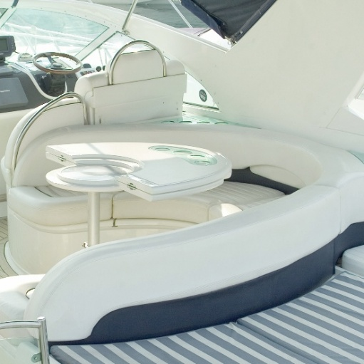ContiTech_pp_skai_Neptun | Maritime comfort meets modern design: seating upholstered with skai Neptun.
“Our portfolio provides a solution for every challenge and a product for every need. We offer materials that perform particularly well in heavily used exterior areas, as well as materials with easy-to-clean surfaces that demonstrate their strengths in interiors. In this way, we combine application-specific functionality, a wide range of designs and reliable quality from a single source,” says Christelle Perico-Darras, Head of Hospitality, Healthcare & Public Areas EMEA at SSL.
Cool Colors: greater comfort in direct sunlight
The skai cool colors Venezia and Valero product lines are a key focus. Special color pigments reflect some of the incoming near-infrared radiation. As a result, the material surface heats up less in direct sunlight than comparable dark surfaces with conventional pigments. This can increase seating comfort, particularly for exterior upholstery. At the same time, the materials are designed to meet the requirements of outdoor and marine applications. At the booth, Continental will use a demonstrator and a thermal imaging camera to make the temperature difference visible.
The finish makes the difference: resistant upholstery materials for interiors and exteriors
For interiors, Continental will showcase selected materials featuring staynu technology. The surface finish makes many types of everyday stains easier to remove, helping reduce cleaning requirements. The solutions on display include skai Toronto EN with a fine leather grain and skai Tovega EN with a microporous texture. Both materials were developed for high-traffic interiors such as hospitality and public-area applications and are available in a wide range of colors.
With skai Neptun Pescara, Continental will also present a material with a classic cowhide grain for exterior and marine applications. A surface finish developed using nanotechnology increases resistance to UV radiation, salt water and stains. The easy-care surface is designed for use on boats, yachts and cruise ships.
With its wide range of on-trend colors and modern textile grain, skai Misuna EN has become a classic among skai surfaces. The UV-resistant and saltwater-resistant material has recently become available for marine applications.
Material concepts with documented shares of renewable raw materials
Materials with documented shares of renewable raw materials will also play an important role in the trade show presentation. For suitable interior applications, Continental will present skai Evida and skai Evida Fiber. According to the product specifications, skai Evida contains up to 80 percent renewable raw materials, while skai Evida Fiber contains up to 90 percent. In each case, the figures refer to the specific product and its defined material composition. Continental is thus expanding the range of options for customers who consider individual sustainability criteria, such as the share of renewable raw materials, alongside technical and design requirements in their purchasing decisions.
Continental is a leading tire manufacturer and industry specialist. Founded in 1871, the company generated sales of €19.7 billion in 2025 and currently employs around 76,000 people in 54 countries and markets.
ContiTech is one of the world’s leading material experts for industry applications. The Continental group sector offers its customers reliable, safe and convenient industry and service solutions using a range of materials for off-highway applications, on rails and roads, in the air, under and above the ground, in industrial environments, for the food sector and the furniture industry. With about 20,000 employees (Status as of March 2026) at more than 60 sites globally, and sales of some 6.0 billion euros (2025), the global industrial partner is active with core branches in Asia, Europe and North and South America.
We welcome your feedback or questions

Oliver Heil
Spokesperson EMEA
ContiTech
Continental
Phone: +49 511 938 56375
Email: oliver.2.heil@contitech.com

Press portal: www.continental-industry.com/de/en/press
Websites: www.continental-industry.com/en
www.skai.com/de
LinkedIn www.linkedin.com/company/continental-industry

