Continental Launches VersaFlex Single-Ply Conveyor Belt, Delivering Strength, Flexibility and Uptime for Above-Ground Mining
- Engineered for High-Strength Performance and Superior Splice Integrity
- Designed to Maximize Uptime Through Lightweight Flexibility and Versatile Application

Fairlawn, Ohio, May 4, 2026. Continental’s group sector ContiTech today announced the launch of VersaFlex, a next-generation single-ply conveyor belt engineered to deliver high strength and performance customers can rely on, all while maximizing efficiency and uptime in above-ground mining applications.
“VersaFlex is built around reliable performance that drives uptime and lowers total cost of ownership, the one thing our customers value most,” said, Joe Cochran, Head of Product Management - Conveying Solutions, Industrial Solutions Americas, ContiTech. “With exceptional rip and tear resistance, a high-strength vulcanized splice and a lightweight carcass, this belt proves we can deliver strength and efficiency in a single-ply solution. At ContiTech, our vision is to be the first choice for material-driven solutions, providing mutual value creation opportunities with our customers through material expertise, innovation, total solutions, and long-term partnership.”
High Strength and Performance You Can Depend On
VersaFlex features an optimized finger splice design, creating superior vulcanized splice strength. The design is also mechanical fastener capable that offers added versatility in the field.
The belt, which is engineered for demanding operations, delivers rip and tear resistance with a lightweight carcass, and exceeds many multi-ply constructions operating in the same tension class. The VersaFlex single-ply product will be offered in ratings from 220 PIW to 550 PIW with a broad range of cover compounds to meet varying application and performance needs.
Enhanced Efficiency and Flexibility to Maximize Uptime
The versatile single-ply design is suitable for a wide range of above-ground mining applications and allows operators to tailor performance to their specific requirements.

By combining durability, adaptability, and ContiTech’s industry-leading service and support, VersaFlex reduces customers’ total cost of ownership and helps to minimize downtime and maintenance demands.
VersaFlex is available now through ContiTech’s network of distribution and service partners. For more information, visit VersaFlex Conveyor Belt
Continental is a leading tire manufacturer and industry specialist. Founded in 1871, the company generated sales of €19.7 billion in 2025 and currently employs around 78,000 people in 54 countries and markets.
ContiTech is one of the world’s leading material experts. The Continental group sector offers its customers reliable, safe and convenient industry and service solutions using a range of materials for off-highway applications, on rails and roads, in the air, under and above the ground, in industrial environments, for the food sector and the furniture industry. With about 20,000 employees (Status as of March 2026) at more than 60 sites globally, and sales of some 6.0 billion euros (2025), the global industrial partner is active with core branches in Asia, Europe and North and South America.

Press Contact

Paul Flake
Regional Spokesperson, Americas
Group Sector ContiTech
Email: paul.flake@continental.com

Images and Descriptions
VersaFlex is a single-ply conveyor belt designed for demanding above-ground mining applications, combining high splice strength, rip and tear resistance, and installation flexibility. Featuring an optimized finger splice design with mechanical fastener capability, the lightweight belt outperforms many multi-ply alternatives in the same tension class.
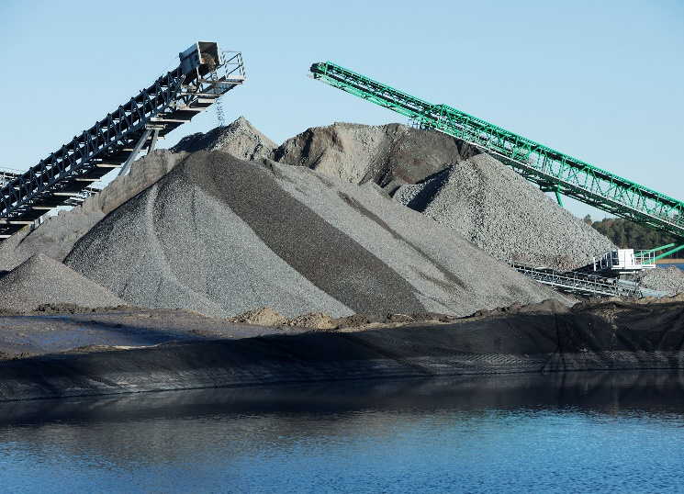

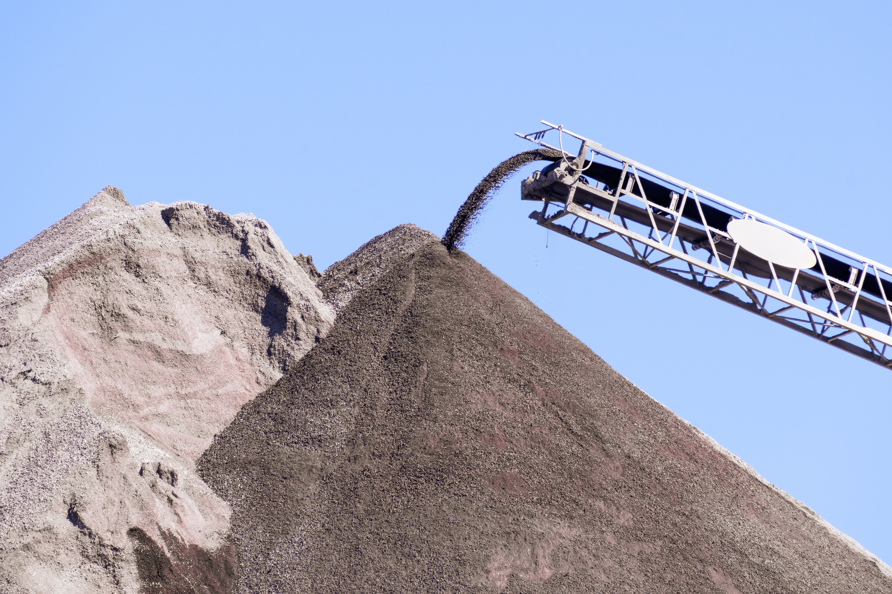
VersaFlex is a next-generation single-ply conveyor belt engineered to deliver high strength and performance customers can rely on, all while maximizing efficiency and uptime in above-ground mining applications. VersaFlex helps reduce downtime, maintenance needs and total cost of ownership.

