ContiTech Responds to Market Changes: Plant Closures Planned
- Response prompted by persistent decline in demand in customer sectors such as the automotive industry and lignite mining
- Around 580 jobs to be affected by the planned measures
- Plant closures planned at the locations in Bad Blankenburg, Moers, Stolzenau, and Geithain and Frohburg
- Personnel changes expected at the ContiTech locations in Hanover-Vahrenwald and Hamburg
- Measures to be structured in a socially responsible manner, with proven tools to help affected employees find new employment

Hanover, Germany, January 30, 2025. Continental’s ContiTech group sector is preparing further structural changes at German locations in 2025. Production is to be discontinued at the locations in Bad Blankenburg (Thuringia), Stolzenau (Lower Saxony) and Moers (North Rhine-Westphalia), while toolmaking is to be halted at the dual location in Frohburg and Geithain (Saxony). In addition, activities of the future independent business area Original Equipment Solutions (OESL) are to be scaled back at the Hamburg location. As part of the planned spin-off of Continental’s Automotive group sector, a production line is also to be relocated from the ContiTech site in Hanover-Vahrenwald to an Automotive site. A total of around 580 jobs are expected to be affected in the ContiTech group sector.
"With these planned measures, we are responding to market changes in individual customer sectors – particularly the severe, persistent declines in demand. Developments in the automotive industry and lignite mining in Europe are posing particular challenges for us," explains Philip Nelles, member of the Continental Executive Board and head of the ContiTech group sector. "The painful steps we are initiating are necessary to reposition the company for sustained economic growth. Given the current economic headwinds and accelerating pace of technological transformation, we must take action now to safeguard our future and drive forward our strategic realignment," Nelles continues. "We are committed to structuring the planned measures in a way that is as socially responsible as possible and giving as many employees as we can the opportunity to transfer to other parts of the company."
Repositioning ContiTech for the future
ContiTech specializes in development and materials expertise for products and systems made from rubber, plastic, metal and textiles. The group sector has been operating in a new organizational structure since the beginning of 2024, creating a basis for it to focus on expanding the industrial business. The planned measures will help to streamline this focus, create locations that are more economically resilient and adapt the product portfolio to shifting demand.
Best possible support for employees
The aim is to structure the planned measures in a way that is as socially responsible as possible. Continental will make use of established tools for this purpose. For employees at the locations, Continental will strive to find individual solutions on the internal and external job market in collaboration with employee representatives.
The Continental Institute for Technology and Transformation (CITT) offers employees tailor-made training courses, seminars and workshops to provide them with the skills and qualifications they need. ContiTech is also working together with other companies located near the affected sites to support employees in their search for new employment. The established tools include ContiMotion, a careers company for training and employment that Continental set up in cooperation with mining, chemical and energy industries union IG BCE. Continental notified employees at the affected location earlier today, and as a next step plans to enter into talks with local employee representatives.
ContiTech employs around 39,000 staff worldwide in 37 countries and markets. In Germany, ContiTech has 22 locations with a total of around 11,000 employees.
Information on the measures decided for each location:
Bad Blankenburg: The production of conveyor belts at the ContiTech location in Bad Blankenburg is to be discontinued and the plant closed. The planned closure will affect 185 jobs at the location. ContiTech is taking this step in response to the sustained change in demand resulting from the phase-out of lignite in Europe. Conveyor belts from Bad Blankenburg are predominantly used in South America (among others), a region that is already supplied by the ContiTech location in Ponta Grossa (Brazil).
Stolzenau: The plant in Stolzenau is to be closed. All 110 jobs at the location will be affected by the planned closure. Stolzenau, a production site for cargo compartment covers, is dependent on economic developments in the automotive industry. The market for cargo compartment covers has not recovered as anticipated, and demand has fallen sharply. Since the plant in Stolzenau manufactures just one product, it is heavily reliant on a small number of customers. The location is no longer running at sufficient capacity to sustain its operations, and no improvement to the situation is in sight. The possibility of a sale was explored, but negotiations did not result in a positive outcome. It was also examined whether production could be relocated to another site, but this was not financially feasible.
Moers: The Moers location is to be closed. All 47 jobs will be affected by the planned closure. The location is suffering from the ongoing decline in the special conveyor belt business. These special conveyor belts are a niche product, meaning production cannot be taken over by another location or region. For this reason, ContiTech has made the decision to remove this product from its portfolio.
Geithain and Frohburg: Both locations have for several years been experiencing a decline in demand for blow mold tools, with no prospect of significant improvement. Extensive efforts were made to restructure the portfolio, but ultimately these were not economically viable. Consequently, the plants in Geithain and Frohburg are to be closed. All 58 jobs at these locations will be affected by the planned closure.
Hanover: Continental’s ContiTech group sector currently manufactures air bellows for passenger-car air springs at the Hanover-Vahrenwald location as part of a cross-sector partnership with the Automotive group sector. Within the context of the planned spin-off of the Automotive group sector from Continental, production of passenger-car air springs will going forward be performed independently by the Automotive group sector. Production at the Hanover-Vahrenwald plant is therefore expected to be discontinued in the first half of 2026 and will be transferred to the Automotive plant in Jičín, Czech Republic. A total of 126 jobs will be affected by the relocation. The Vahrenwald plant remains a key location as part of ContiTech’s overall operating strategy.
Hamburg: The activities of the future independent business area Original Equipment Solutions (OESL) are to be scaled back at the Hamburg location. TechCenter activities such as prototyping and testing will be relocated to Hann. Münden, the location of the main laboratory for the future independent OESL, in order to exploit synergies arising from the structures that are already in place or will be housed there in the future. 53 of the 107 jobs at OESL in Hamburg will be affected.
Continental develops pioneering technologies and services for sustainable and connected mobility of people and their goods. Founded in 1871, the technology company offers safe, efficient, intelligent and affordable solutions for vehicles, machines, traffic and transportation. In 2023, Continental generated sales of €41.4 billion and currently employs around 200,000 people in 56 countries and markets.
ContiTech is one of the world’s leading industry specialists. The Continental group sector offers its customers connected, environmentally friendly, safe, convenient and cross-material industrial and service solutions in the agricultural sector, on rail and road, in the air, above and below ground, in industrial environments and for the food and furniture industries. With around 39,000 employees in 37 countries and markets and sales of around €6.8 billion (2023), the global industrial partner is active in Asia, Europe and North and South America.
Press contact

Oliver Heil
Spokesperson EMEA
ContiTech
Continental
Phone: +49 6196 87 2681
E-mail: oliver.heil@continental.com

Press portal: www.continental-press.com
Media center: www.continental.com/media-center
LinkedIn: www.linkedin.com/company/Continental-Industry

Images and captions
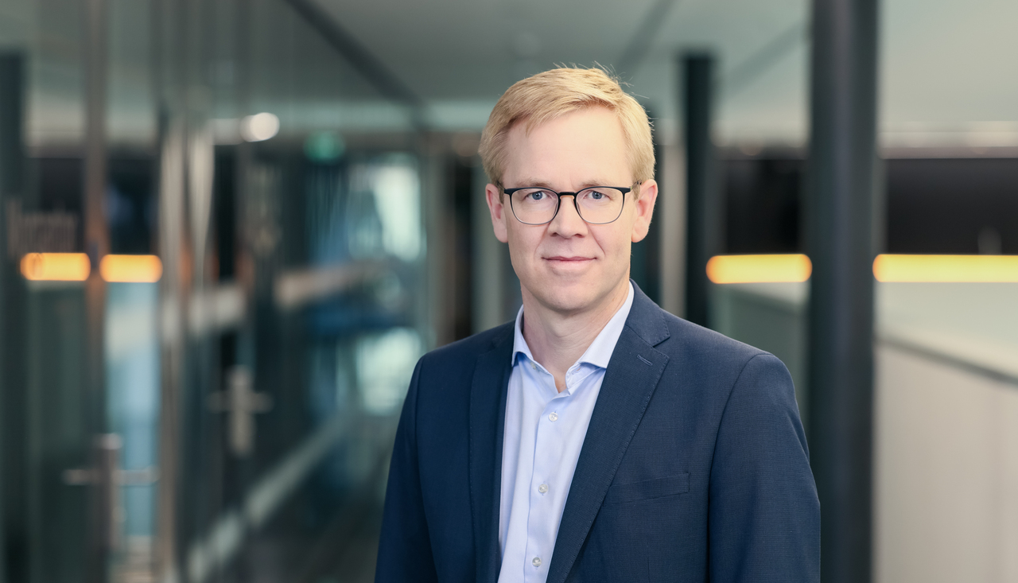Continental_PP_PhilipNelles | Philip Nelles, Head of the ContiTech group sector
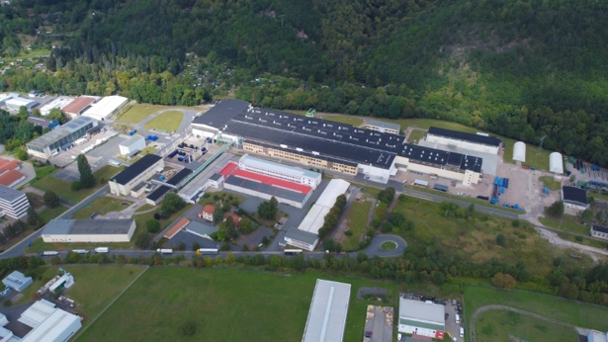  Continental_PP_Bad_Blankenburg | Bad Blankenburg location
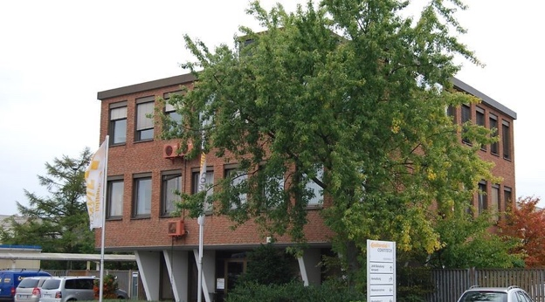  Continental_PP_Moers | Moers location
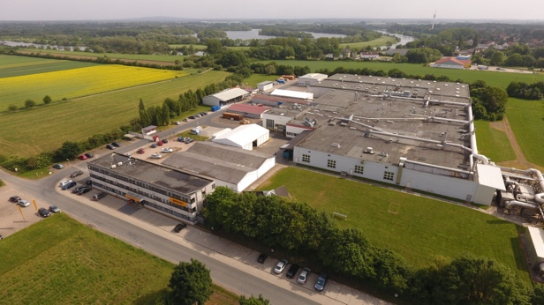  Continental_PP_Stolzenau | Stolzenau location
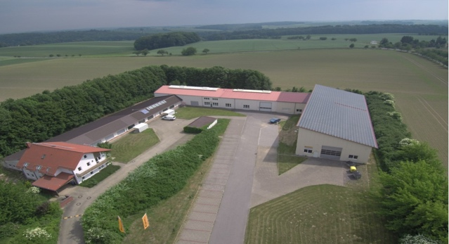  Continental_PP_Frohburg | Frohburg location
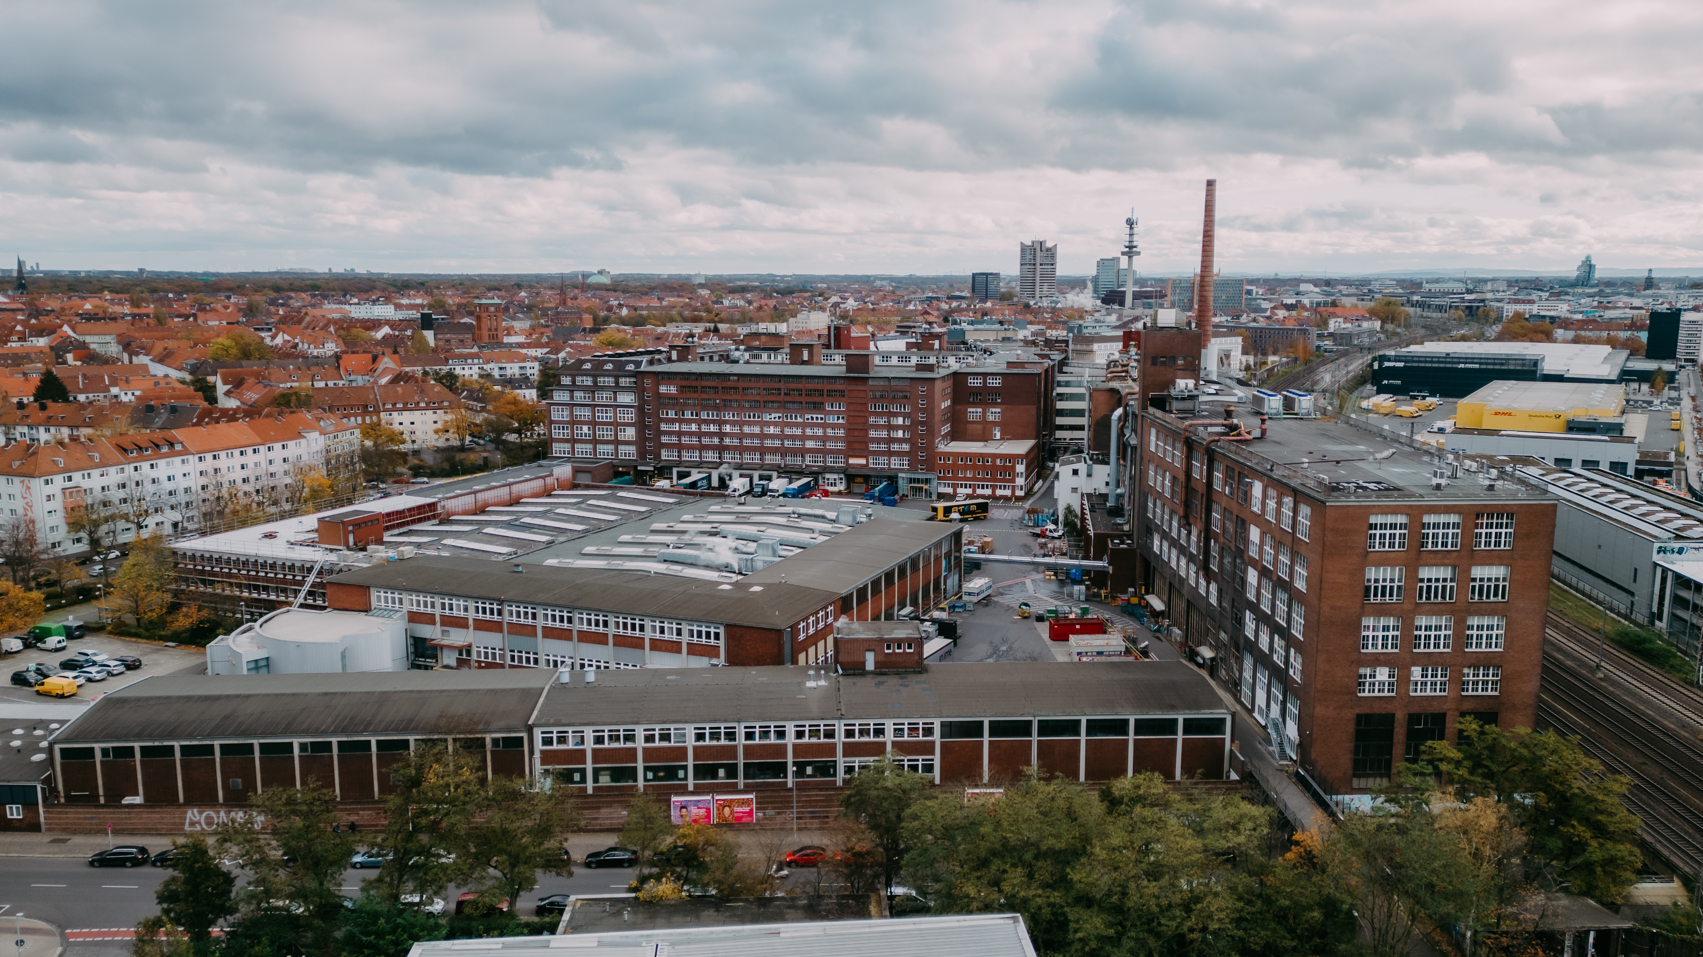  Continental_PP_Hannover-Vahrenwald | Hanover-Vahrenwald location
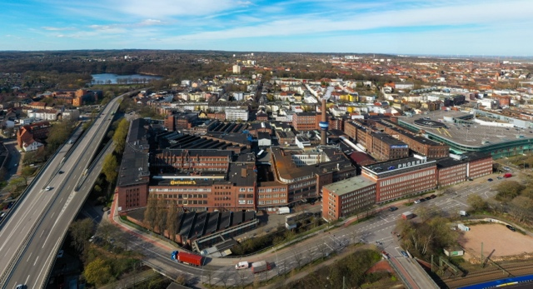  Continental_PP_Hamburg | Hamburg location

