ContiTech plans to expand Manufacturing Operations in Mount Pleasant, Iowa Facility
- More than $85 million USD investment planned to expand ContiTech’s Mount Pleasant facility, strengthening production capabilities across its hose and belt businesses
- New compounding center will enhance ContiTech’s manufacturing competitiveness and support its ability to meet growing market demand
- New investment anticipates creating approximately 50 new high-quality jobs
Mount Pleasant, Iowa, October 20, 2025. Continental’s group sector ContiTech announced that it plans to invest more than $85 million USD to expand its manufacturing operations in Mount Pleasant, Iowa.
The plant expansion includes construction of a state-of-the-art compounding center that will integrate production, warehouse and office operations. It underscores ContiTech’s commitment to delivering high-performance, material-based technologies, with a focus on hoses and belts. This advanced facility will further strengthen ContiTech’s competitiveness and reinforce its position as customer’s first choice for material-driven solutions.
The expansion is expected to create approximately 50 new, high-quality jobs. The Iowa Economic Development Authority (IEDA) Board has approved a package of loan and tax incentives through the IEDA’s High-Quality Jobs program to support the initiative.
“In today’s dynamic economic environment, we are investing in advanced capabilities not only to drive innovation and competitiveness across our industrial product lines, but also to meet the evolving needs of our customers,” said Philip Nelles, Member of the Continental Executive Board and CEO of ContiTech. “This expansion reflects our long-term commitment to the U.S. and the North American markets in general and our confidence in the strength of our team in Iowa. This project also contributes to local economic development, reinforcing our role as a reliable partner to the community we work and live in.”
The new facility will significantly enhance ContiTech’s ability to manufacture essential components, particularly hoses and belts, which play a critical role in supporting reliable flow and total conveyance across a wide range of industrial applications.

“At ContiTech, our commitment to customer centricity is foundational, and this expansion enables us to respond more quickly and effectively to our customers’ needs,” said Andreas Gerstenberger, CEO of ContiTech USA and Head of Business Area Industrial Solutions Americas. “By investing in this facility, we’re not only enhancing our operational capabilities, competitiveness, and supply chain resilience, we are also reinforcing our ability to deliver material-driven solutions. This expansion is a critical part of that process and a key enabler in our vision to become the first choice for our customers.”
ContiTech’s investment in a new compounding center in Mount Pleasant will strengthen its internal compounding capabilities, optimize its North American mixing footprint and support future growth. The facility will feature two state-of-the-art mixing lines integrated with an automated warehouse. The new compounding center will play a central role in ensuring consistent quality and efficiency in the production of rubber-based products. Engineered to withstand high shear forces and temperatures, the mixers enable thorough integration of ingredients. The result is a compound with uniform physical and chemical properties, ready for downstream processes such as extrusion, molding or calendaring.
Construction is anticipated to begin Q2 2026. The Mount Pleasant site plays a key role in ContiTech’s global supply chain, serving a wide range of industrial customers.
Continental is a leading tire manufacturer and industry specialist that develops and produces sustainable, safe and convenient solutions for automotive manufacturers as well as industrial and end customers worldwide. Founded in 1871, the company generated sales of €39.7 billion in 2024 and currently employs around 95,000 people in 54 countries and markets.
ContiTech is one of the world’s leading industry specialists. The Continental group sector offers its customers connected, environment-friendly, safe and convenient industry and service solutions using a range of materials for off-highway applications, on rails and roads, in the air, under and above the ground, in industrial environments, for the food sector and the furniture industry. With about 39,000 employees in more than 40 countries and sales of some 6.4 billion euros (2024), the global industrial partner is active with core branches in Asia, Europe and North and South America.

Press contact

Paul Flake
Regional Spokesperson, Americas
Group Sector ContiTech
Continental
Phone: +1 (330) 808-2971
Email : paul.flake@continental.com

Press portal www.continental-press.com
Media center continental.com/media-center

Images and Descriptions

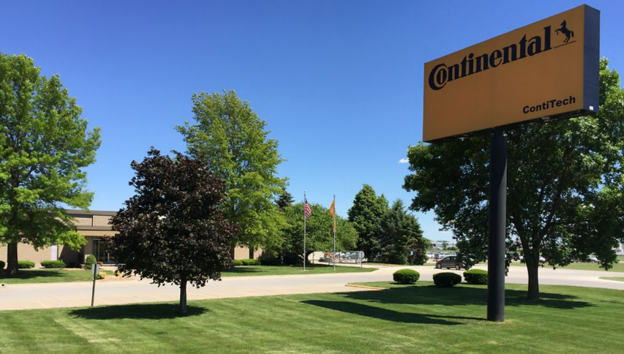
Mount Pleasant production facility. The plant is located on a 37-acre property in Mount Pleasant, Iowa.
ContiTech’s Mount Pleasant production plant in Mount Pleasant, Iowa. The site was founded in 1977 and has more than 220 employees. The plant specializes in manufacturing hoses for various applications.

