Manja Greimeier to Head ContiTech’s Industrial Solutions EMEA Business Area
- Appointment effective September 1, 2025; reporting directly to the head of ContiTech Philip Nelles
- Brings extensive leadership experience from Continental’s Tires and Automotive group sector
Hanover, Germany, October 7, 2025. Continental’s group sector ContiTech has appointed Manja Greimeier as the new head of its Industrial Solutions Europe, Middle East, Africa (IEMEA) business area. She previously held senior roles in Continental’s Tires and Automotive group sectors, most recently as head of the Original Equipment Tires business area.
Manja Greimeier took up her new role on September 1, 2025, and will report directly to Executive Board member for ContiTech Philip Nelles. Based at ContiTech’s location in Hanover-Vahrenwald, she will manage industrial operations across the EMEA region. One focus of her work will be on continuing to optimize organizational structures and processes across product groups and customer industries. In addition, as a member of ContiTech’s newly created Executive Management Committee, she will play a key role in shaping the future direction of the group sector, which is to be made independent and ideally sold in 2026. She succeeds Song Qi, who left the company for personal reasons.
The IEMEA business area encompasses ContiTech’s industrial business in Europe, the Middle East and Africa, including products made from rubber and plastics – such as hoses, conveyor belts and drive belts – for a wide range of industries.
Experienced leader with a focus on general management, sales and transformation
Manja Greimeier is an experienced leader with proven expertise in general management, sales and project management. She has successfully led a number of complex transformation initiatives in different areas and brings with her extensive international experience in the automotive industry.
Over the course of her career, she has held several strategic management positions at Continental, including as a managing director for Continental Reifen Deutschland GmbH and as a member of the Tires Board in the Tires group sector. Most recently, she was responsible for the global passenger-car and commercial-vehicle original equipment business. “Manja Greimeier brings a wealth of perspectives gained through her various management roles,” said Philip Nelles, Executive Board member for ContiTech. “She has repeatedly demonstrated her ability to drive change and inspire her teams. We’re delighted to have her on board as we work together to lead ContiTech into its next chapter as an independent company.”
Continental is a leading tire manufacturer and industry specialist. Founded in 1871, the company generated sales of €39.7 billion in 2024 and currently employs around 95,000 people in 54 countries and markets.
ContiTech is one of the world’s leading industry specialists. The Continental group sector offers its customers connected, environmentally friendly, safe, convenient and cross-material industrial and service solutions in the agricultural sector, on rail and road, in the air, above and below ground, in industrial environments and for the food and furniture industries. With almost 42,000 employees in more than 40 countries and sales of around €6.4 billion (2024), the global industrial partner is active in Asia, Europe and North and South America.
Press contact

Angelika Anna Kohns
Media and PR Manager
ContiTech
Continental
Phone +49 6196 87 2681
E-mail: angelika.anna.kohns@continental.com

Presseportal: www.continental-presse.de
Mediathek: www.continental.de/mediathek
LinkedIN www.linkedin.com/company/continental-industry

Images and captions
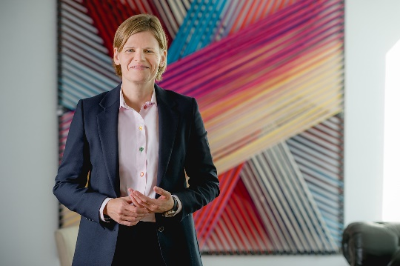  ContiTech_PP_Manja Greimeier | Manja Greimeier has taken over the leadership of the Industrial Solutions EMEA business area in Continental’s ContiTech group sector.

