On Course for Independence: ContiTech Introduces New Executive Management Structure
- Restructured leadership team will strengthen the group sector ahead of its planned independence from Continental
- New Executive Management Committee includes IT and Purchasing functions for the first time
- New managers appointed for the Surface Solutions, Industry Solutions EMEA and Industry Solutions APAC business areas as well as the purchasing department
Hanover, Germany, October 6, 2025. Continental’s group sector ContiTech has realigned its leadership structure. Specializing in rubber and plastic-based products for various industries, ContiTech is positioning itself for a future as an independent company. In April 2025, the Executive Board of Continental AG announced plans to make ContiTech independent and preferably sell it in 2026.
Going forward, ContiTech’s management will consist of a two-person executive team: Philip Nelles (head of ContiTech), who remains a member of Continental AG’s Executive Board, and Matthias Reinsberg (Finance & Controlling). They will be supported by a newly established Executive Management Committee (EMC), comprising nine members from the central functions and business areas. “This structure will enhance our agility and prepare us for independence. It covers all business areas and central functions to ensure continuity while simultaneously enhancing strategic decision-making”, says Philip Nelles. “Our leadership team brings together experience, expertise and a readiness for change to guide ContiTech through changing times and into a successful future.”
For the first time, Purchasing and IT will also be represented in this expanded management committee. Dirk Pott, who is new to ContiTech, will take charge of Purchasing. Laura Domchick will continue to be responsible for IT, reporting to Matthias Reinsberg. They will join the central functions already represented – Integrity & Law, led by Michael Neuheisel; Human Relations & Communications, led by Diana Hoppe; and Operations, Technology & QTC (Quality & Technical Compliance), led by Claus-Peter Spille. The central departments of Finance and Controlling will be represented by Matthias Reinsberg.
New leaders in three business areas
Leadership changes have also been made in three of ContiTech’s five business areas:
- Industrial Solutions EMEA: Manja Greimeier has succeeded Song Qi and is now responsible for the industrial business in Europe, the Middle East and Africa.
- Surface Solutions: Klaus Kreipe has taken over from Wolfgang Thomale.
- Industrial Solutions APAC: Rohit Markan will succeed Hannes Friederichsen in December and will manage the industrial business for the Asia-Pacific region.
Andreas Gerstenberger will continue to lead the Industrial Solutions Americas business area. The OESL business area, led by Dr. Dirk Leiss, which includes hose lines and bearing elements for combustion-engine and electric vehicles, is being sold to the globally active industrial holding company Regent.
Continental is a leading tire manufacturer and industry specialist. Founded in 1871, the company generated sales of €39.7 billion in 2024 and currently employs around 95,000 people in 54 countries and markets.
ContiTech is one of the world’s leading industry specialists. The Continental group sector offers its customers connected, environmentally friendly, safe, convenient and cross-material industrial and service solutions in the agricultural sector, on rail and road, in the air, above and below ground, in industrial environments and for the food and furniture industries. With almost 42,000 employees in more than 40 countries and sales of around €6.4 billion (2024), the global industrial partner is active in Asia, Europe and North and South America.
Press contact

Angelika Anna Kohns
Media & PR Manager
ContiTech
Continental
Telefon: +49 511 938 14022
E-Mail: angelika.anna.kohns@continental.com

Press portal: www.continental-press.com
Media center: www.continental.com/media-center

Images and captions
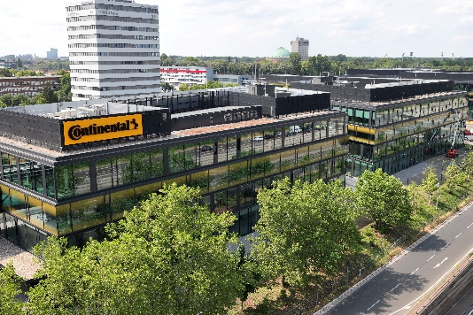  Continental_PP_Unternehmenszentrale | Continental’s ContiTech group sector is introducing a new management structure to prepare for its upcoming independence.

