Agritechnica 2025
ContiTech Now Offers Round Baler Belts in Original Equipment Quality for the Aftermarket
- Reduced downtime: efficient workshop repairs and, if needed, on-site installation at the farm
- Continental’s ContiTech group sector showcases material-driven agricultural products and solutions at Agritechnica in Hanover
- Rodrigo Maia, head of the Distribution business segment in the Industrial Solutions EMEA business area: “We are resolutely pursuing our strategy of also making our key products available to farmers as replacement parts”
Hanover, Germany, September 23, 2025. The Continental group sector ContiTech now offers round baler belts as replacement parts in original equipment quality. The company is thus addressing the growing demand from farmers and agricultural machinery dealers for high-quality components to maintain and repair round balers. The products are aimed specifically at the aftermarket and meet the same high Continental quality standards as the proven round baler belts the company has been supplying in the original equipment business for decades. A particular advantage of the new offering is speed of installation, since the belts can be fitted without fully dismantling the baler. Furthermore, their installation is not restricted to agricultural machinery workshops. Where minimizing downtime is a priority, the work can also be carried out directly on the farm. Round baler belts are among the key material-driven products and solutions that ContiTech will be showcasing at Agritechnica from November 9 to 15, 2025, in Hanover.
“We are resolutely pursuing our strategy of also making our key products available to farmers as replacement parts,” explains Rodrigo Maia, head of the Distribution business segment in the Industrial Solutions EMEA business segment. “The option of on-site installation at the farm shows how serious we are about our tagline ‘Engineered to keep farming running.’”
No long trips, fast replacement and seamless continuity
“Many farmers and agricultural machinery dealers have approached us requesting replacement parts since they were not satisfied with the specifications and quality of many round baler belts on the aftermarket,” says Peter Steer, regional sales manager for northern Germany in ContiTech’s Distribution business segment. “In consultation with them, we’ve developed a concept that allows us to install the belts on-site. This saves trips and time, so operations keep running smoothly.”
During harvest season, when the strain is high and long downtimes can be disastrous, this faster replacement can be critical to the success of agricultural businesses. Continental’s new round baler belts also save time in the workshop because the baler no longer needs to be fully dismantled for installation, as was previously the case. With this offering, ContiTech is underlining its commitment to provide farmers with practical, high-quality solutions that meet the demands of modern agriculture.
Large selection of widths and lengths
ContiTech’s baler belts are characterized by their high durability, dimensional stability and resistance. They consist of a three-ply high-performance polyester fabric with a rubber compound specifically developed for this application to ensure an optimal combination of tensile strength and flexibility. The belts are available in all standard widths – from 100 millimeters up to monobelts with a width of 1,180 millimeters. They can also be purchased by the meter and cut to size. Their tensile strength exceeds 450 N/mm. The surface comes with the option of a coarse texture or a diamond pattern, which supports reliable rotation of the bale and uniform material pickup. ContiTech’s round baler belts are now available as replacement parts from specialized agricultural product dealers.
Continental is a leading tire manufacturer and industry specialist. Founded in 1871, the company generated sales of €39.7 billion in 2024 and currently employs around 95,000 people in 54 countries and markets.
ContiTech is one of the world’s leading industry specialists. The Continental group sector offers its customers connected, environmentally friendly, safe, convenient and cross-material industrial and service solutions in the agricultural sector, on rail and road, in the air, above and below ground, in industrial environments and for the food and furniture industries. With almost 42,000 employees in more than 40 countries and sales of around €6.4 billion (2024), the global industrial partner is active in Asia, Europe and North and South America.
Press contact

Oliver Heil
Spokesperson EMEA
ContiTech
Continental
Phone: +49 511 938 56375
E-mail: oliver.heil@continental.com

Press portal: www.continental-press.com
Media center: www.continental.com/media-center

Images and captions
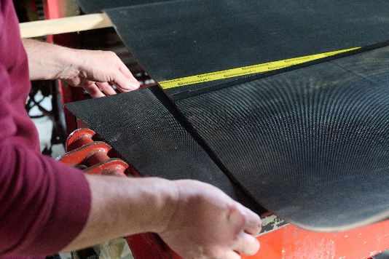  Continental_ContiTech_PP_BalerBelt_Preparation_02 | The belts are available in all standard widths. They can also be purchased by the meter and cut to size.
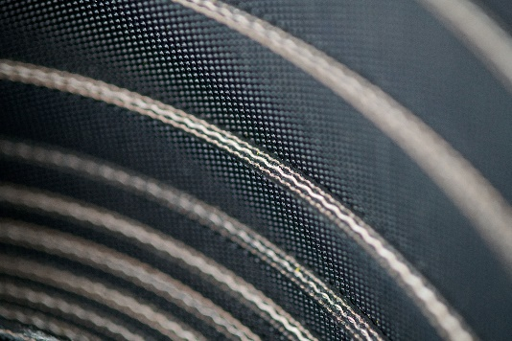  Continental_ContiTech_PP_BalerBelt | Continental’s baler belts consist of a three-ply high-performance polyester fabric with a rubber compound specifically developed for this application.
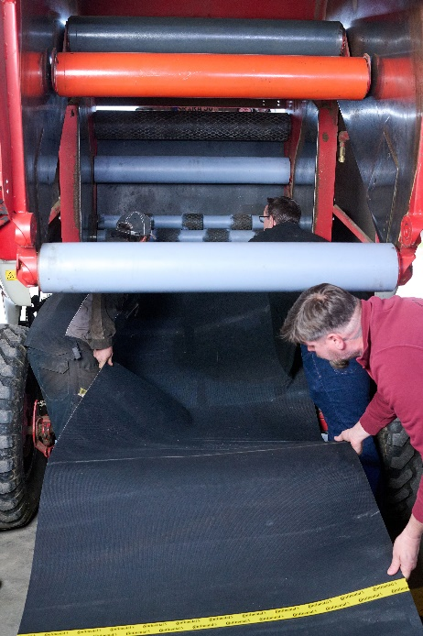  Continental_ContiTech_PP_BalerBelt_Installation | Continental’s round baler belts also save time because the baler no longer needs to be fully dismantled for installation.

