ContiTech Launches Production at New Hydraulic Plant in Aguascalientes
- Now operational, the new manufacturing facility strengthens local supply chains and supports growth in the Americas region
- Supporting the 'in the region, for the region' approach, the plant complements the Norfolk, Nebraska facility by offering production flexibility, increased responsiveness and operational efficiency
- New plant to manufacture high-performance hydraulic hoses for industrial markets, demonstrating ContiTech’s leadership and commitment to the industry

FAIRLAWN, Ohio, August 26, 2025. Continental’s group sector ContiTech has officially started production at its new hydraulics manufacturing facility in Aguascalientes, Mexico. The $90 million investment represents a major step in the company’s strategy to strengthen local supply chains, increase regional production capacity and bring innovative fluid power solutions closer to customers in the region.

The new 900,000 square feet site will manufacture high-performance hydraulic hoses for a wide range of industrial and mobile applications, including construction, agriculture, mining and energy sectors.
“The start of production in Aguascalientes marks a key milestone in ContiTech’s journey toward being a more agile, regionalized partner to our customers,” said Philip Nelles, Member of the Continental Executive Board and CEO of the ContiTech group sector. “At ContiTech, we build on 150 years of materials expertise. While our portfolio is broad and diverse, all our solutions are grounded in the same strength: high-performance materials that are mission critical, innovative, and engineered to perform. Whether they connect, convey, or cover, our products play essential roles across industries and applications.”
Consistent with Continental’s global manufacturing approach of building “in the region, for the region,” the Aguascalientes facility will serve regional markets with products engineered and produced locally to meet the specific demands of regional customers.
Nelles added, “Innovation has been at our core from the very beginning, and this new plant demonstrates our ongoing commitment to delivering smarter, faster, and more resilient solutions. By expanding our manufacturing footprint in the Americas, we are not only strengthening supply chain resilience and reducing lead times, but we are also reinforcing our role as a trusted, responsive partner for our customers throughout the region.”

“We are ready to lead in this segment. This new plant reflects our commitment to both innovation and proximity,” said Andreas Gerstenberger, CEO of ContiTech USA and Head of Business Area Industrial Solutions Americas. “With our customers increasingly looking for responsive and innovative solutions, we are proud to deliver with local production, advanced technology, and a skilled workforce. More than just expanding our footprint, this investment is about creating mutual value with our customers, partnering closely to help them succeed in their own markets. By placing customer needs at the center of everything we do, we aim to be their first choice for material-driven solutions, now and in the future.”
The Aguascalientes plant will work in close alignment with ContiTech’s existing manufacturing facility in Norfolk, Nebraska, offering production flexibility, increased responsiveness and operational efficiency. Together, the two locations will help ContiTech meet the ever-changing needs of customers by balancing volume, technology, and lead time across a coordinated regional network.
The plant opening reinforces ContiTech’s long-term focus on growth in key markets through investment in local infrastructure, talent and technology. The company plans to ramp up production gradually, with customer deliveries expected to begin in Q4 2025.

Continental develops pioneering technologies and services for sustainable and connected mobility of people and their goods. Founded in 1871, the technology company offers safe, efficient, intelligent and affordable solutions for vehicles, machines, traffic and transportation. In 2024, Continental generated sales of €39.7 billion and currently employs around 190,000 people in 55 countries and markets.
ContiTech is one of the world’s leading industry specialists. The Continental group sector offers its customers connected, environment-friendly, safe and convenient industry and service solutions using a range of materials for off-highway applications, on rails and roads, in the air, under and above the ground, in industrial environments, for the food sector and the furniture industry. With about 39,000 employees in more than 40 countries and sales of some 6.4 billion euros (2024), the global industrial partner is active with core branches in Asia, Europe and North and South America.

Press Contact

Paul Flake
Regional Spokesperson, Americas
Group Sector ContiTech

Email: paul.flake@continental.com

Website www.continental-industry.com
Press Portal www.continental-press.com
Media Center www.continental.com/media-center
Images
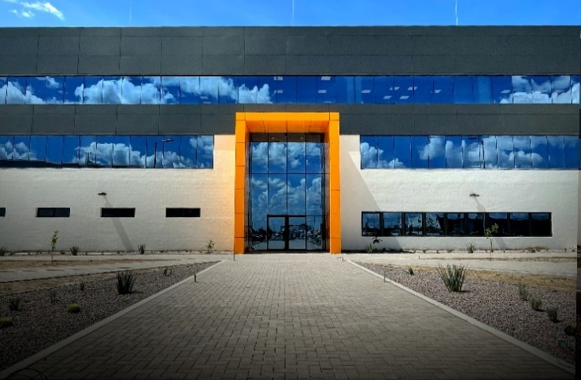
The Aguascalientes plant will work in alignment with ContiTech’s existing manufacturing facility in Norfolk, Nebraska, offering production flexibility, increased responsiveness and operational efficiency. Together, the two sites will help ContiTech meet the needs of customers by balancing volume, technology, and lead time across a coordinated regional network.
Located in the Vesta Industrial Park in Aguascalientes, Mexico, the new 900,000 square feet site will manufacture high-performance hydraulic hoses for a wide range of industrial and mobile applications, including the construction, agriculture, mining, and energy sectors.
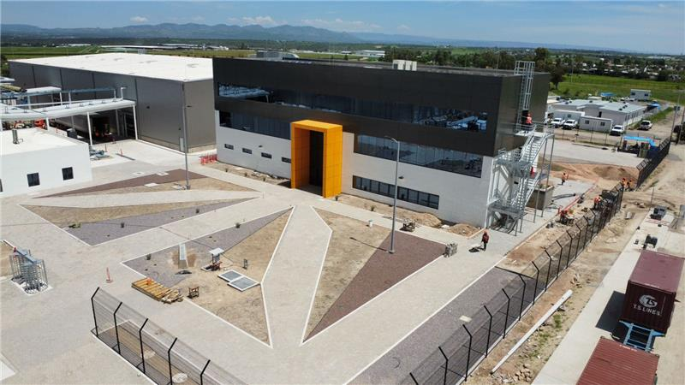
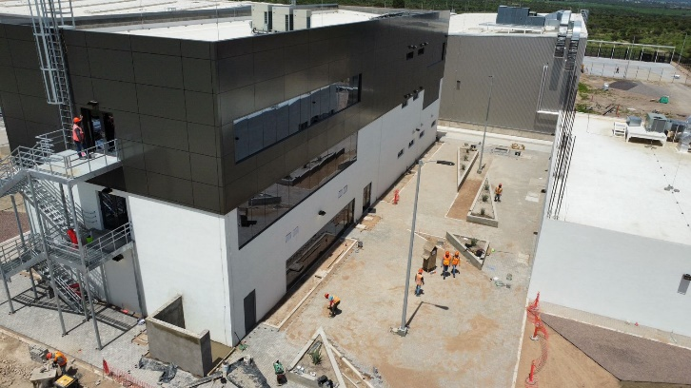
The $90 million investment represents a major step in the ContiTech’s strategy to strengthen local supply chains, increase regional production capacity and bring innovative fluid power solutions closer to customers in the region.

