Starting Signal for High-Pressure Hydrogen Hoses: Continental Commissions New Facility in Korbach
- Around €3 million invested in new production line for industrial hoses used to refuel, transport and store hydrogen
- New material combination increases the technical performance of polymers
- Further investments in complex hydrogen testing procedure planned at the location
Hanover/Korbach, Germany, April 2, 2025. Continental recently commissioned a new production line for hydrogen hoses at its location in Korbach. This means the company’s industrial group sector ContiTech is now able to offer safe and efficient solutions along the entire hydrogen value chain. These range from the production and transportation of hydrogen through to its storage, distribution and use in fuel cells and the refueling of cars, trucks, ships and aircraft. The investment amount for the production facility is around €3 million.

Hydrogen is considered a key building block for a more climate-friendly energy future. However, the safe storage and transportation of hydrogen pose considerable challenges. Dr. Michael Hofmann, Chief Technology Officer of ContiTech, says: “Our patent-pending hydrogen technologies from Korbach are an excellent example of our comprehensive material expertise and pioneering work. ContiTech has taken up the challenge of developing the most flexible and durable hydrogen dispensing hose. We are convinced that the hydrogen transition will also be driven by the availability of increasingly comfortable and high-performance components for users, and ContiTech is the first and only company currently offering this technology."
Novel combination of materials helps meet extreme hydrogen requirements
High-pressure fueling hoses for hydrogen must be able to withstand extreme loads of up to 700 bar – more than 200 times the pressure in a car tire. This high compressive strength enables use in areas that are crucial for hydrogen industries. To meet these requirements, Continental’s material experts have developed a new veneer hose using an unusual combination of various materials. This hose consists of thermoplastics to ensure hydrogen tightness, steel for pressure resistance and rubber for flexibility and durability, making the handling of hydrogen at dispensing stations efficient and safe.

During the development phase, care was also taken to use as many sustainable materials as possible. The inner hose is free from halogenated plastics, and the metal reinforcement is completely recyclable. The company is working in the long term to integrate even more alternative materials and recycling approaches into its products.
Tech Center, production, and testing facilities: ContiTech invests strategically
To meet the particularly stringent and increasing testing requirements of hydrogen technology, the company is planning to make further investments in extensive testing facilities at the location in Korbach over the next three years. This will involve upgrading existing systems and procuring new test benches to cope with even higher pressures. “Our location has extensive expertise in the production of industrial hoses. With the new production facility and the close collaboration with our colleagues at the Continental Tech Center Hydrogen Technologies in Hamburg, we are able to overcome the challenges associated with manufacturing and designing hydrogen hoses and offer our customers a variety of hydrogen hoses,” explains Sebastian Weyand, head of the ContiTech plant in Korbach. Customers have already expressed interest in Continental’s new hydrogen solutions.
With solutions such as hydrogen bunkering hoses and high-pressure hydrogen hoses, the company is making a significant contribution to the safe and efficient use of hydrogen as an energy source and is actively promoting the energy transformation. These measures are in line with Continental’s sustainability ambitions to achieve 100% carbon neutrality, 100% emission-free mobility and industry, a 100% circular economy and 100% responsible value chains by 2050 at the latest.

About the Korbach location and the Tech Center Hydrogen Technologies in Hamburg
Around 3,300 employees work in different group sectors at Continental’s location in Korbach. Besides producing hoses for ContiTech, the plant manufactures tires for passenger cars (including high-performance tires), motorcycles and bicycles. Already in 2022, the company invested more than €4,5 million in a new facility to produce industrial hoses at the site. Since 2023, Continental’s Tech Center Hydrogen Technologies in Hamburg has served as a collaborative platform for sharing knowledge and developing hydrogen technologies. The two locations work closely together to identify technical, regulatory and infrastructure-related challenges along the entire hydrogen value chain and jointly develop innovative solutions.
Continental develops pioneering technologies and services for sustainable and connected mobility of people and their goods. Founded in 1871, the technology company offers safe, efficient, intelligent and affordable solutions for vehicles, machines, traffic and transportation. In 2024, Continental generated sales of €39.7 billion and currently employs around 190,000 people in 55 countries and markets.
ContiTech is one of the world’s leading industry specialists. The Continental group sector offers its customers connected, environmentally friendly, safe, convenient and cross-material industrial and service solutions in the agricultural sector, on rail and road, in the air, above and below ground, in industrial environments and for the food and furniture industries. With around 39,000 employees in more than 40 countries and sales of around €6.4 billion (2024), the global industrial partner is active in Asia, Europe and North and South America.
Press contact

Angelika Anna Kohns
Media and PR Manager
ContiTech
Continental
Phone: +49 511 938 14 022
E-mail: angelika.anna.kohns@continental.com

Press portal: www.continental-press.com
Media center: www.continental.com/media-center
Hydrogen at ContiTech Hydrogen solutions | Continental Industry
LinkedIn www.linkedin.com/company/continental-industry

Images and captions
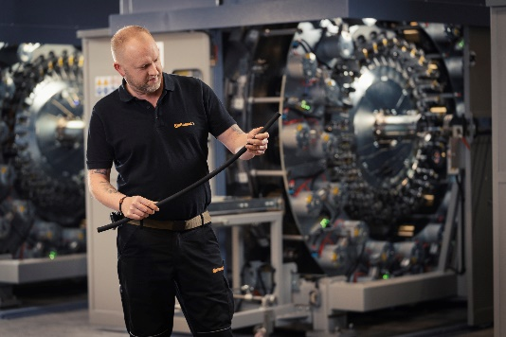  Continental_PP_H2-production_line | Employee in front of the new hydrogen facility at Continental’s location in Korbach
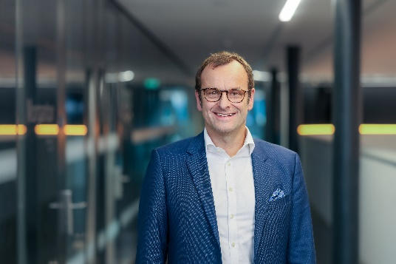  Continental_PP_Hofmann_Michael | Michael Hofmann, Chief Technology Officer for ContiTech
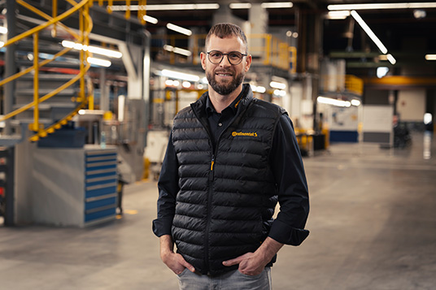  Continental_PP_Sebastian_Weyand | Sebastian Weyand, head of the ContiTech plant in Korbach
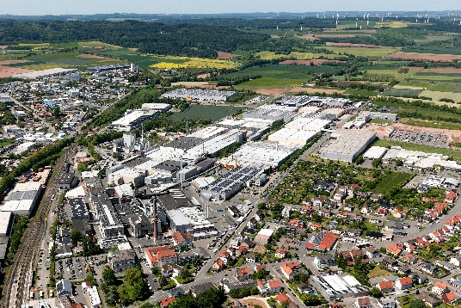  Continental_PP_plant_Korbach | Continental’s location in Korbach manufactures particularly flexible and resistant hydrogen hoses for refueling and transportation.

