Automechanika Frankfurt 2024

Continental Launches Major Product Range Expansion Initiative for the Aftermarket
- Continental offers new product groups, including sensors for driver assistance systems, chassis and steering components as well as high-pressure fuel pumps
- Brake disks and pads of the new "ATE New Original" product line for electric vehicles and future Euro 7 requirements
- Spare parts product groups in engine management, water pumps and belt drive kits are being progressively expanded
- Enno Straten, Head of Automotive Aftermarket: "We are responding to the increasing technical demands by expanding our portfolio in original equipment quality and service offers for workshops."
Frankfurt, Germany, September 10, 2024. Continental is comprehensively expanding its aftermarket product range in original equipment quality and will present the highlights at this year’s Automechanika. The technology company is adding new product groups to its portfolio, including spare parts for chassis and steering, as well as camera and radar sensors and high-pressure fuel pumps. The product range is being supplemented with services for high-quality repairs, such as "Remote Support", a new digital service that supports workshops during repairs via video chat.
"The vehicle fleet on our roads is changing rapidly. More and more vehicles with driver assistance systems as well as e-vehicles are reaching independent workshops, where customers rightly expect high-quality repairs," says Enno Straten, Head of the Automotive Aftermarket business segment at Continental. "In the future, only those who are prepared and have the right spare parts and qualifications will be able to earn good money. As one of the world’s leading suppliers with more than 150 years of experience, we support them in this endeavor. We are responding to the increasing technical demands by expanding our portfolio in original equipment quality and service offers for workshops."
Product range expands significantly in breadth and depth
The new product groups include cameras and radar sensors for driver assistance systems, which are increasingly being installed in smaller and mid-range vehicles. In this way, Continental is readying its resources for the growing market and will gradually add new components to its spare parts program, starting in mid-2025. Among the first products to be introduced are multifunctional camera modules, Long-Range, Adaptive Cruise Control (ACC) and Blind Spot radars for large-volume production models from Mercedes, BMW, Nissan, Volkswagen and Audi. Backed by more than 20 years of experience, Continental is one of the leading companies in the field of original equipment, having supplied over 200 million sensors and control units.
Premium range: Continental now also offers spare parts for chassis and steering
Continental is also significantly expanding its range of mechanical parts and components. In the future, workshops will also be able to order spare parts for wheel bearings and other chassis and steering components under the Continental brand. The decision to expand the product range to include components for these areas was based on a comprehensive analysis by the company’s aftermarket experts in the ContiTech group sector. Among other measures, they asked workshops in a broad-based survey which spare parts they would like to purchase from Continental in the future. The market launch will be staggered for the three product groups starting already this year and will be completed by mid-2025. Continental already offers broad coverage of the European vehicle fleet with the initial range, which will be consistently expanded.
"We now offer automotive mechatronics technicians even more spare parts that workshop customers can immediately recognize as premium thanks to the Continental brand – and they know they are getting 100% reliable and durable products – and a professional installation as well," says Rolf Sudmann, Head of Aftermarket in the Industrial Solutions EMEA business unit of the ContiTech group sector and responsible for the expansion of the product range.
ATE New Original – for the brakes of the next generation
At the same time, Continental is increasing its market coverage in the existing product groups. The company is breaking new ground with the braking discs and pads of the new product line ATE New Original. The novel coating concepts for brake discs and innovative friction mixtures are at the center of developments to comply with the particulate matter limits according to the Euro 7 standard. This will provide dealers and workshops with a product range that’s perfectly tailored to the growing number of electric vehicles. ATE will launch friction brake pairings consisting of braking discs and pad for VW’s ID.3 and ID.4 models, the TESLA Model S, the Cupra Born, and the Polestar 2 in the second half of 2025. ATE New Original complements the ATE Original line.
More than 700 new part numbers in engine management
Furthermore, Continental is significantly expanding its portfolio in engine management and fuel supply, particularly with fuel pump units as well as exhaust control valves, mass air flow sensors, and sensors for engine management. The expansion will include around 700 part numbers by 2025, increasing coverage by an average of 50 percent. High-pressure fuel pumps will also be introduced to the market for the first time next year.
The company is also now offering water pumps without control units – a practical and cost-saving option when the control unit of the old water pump is still fully intact. The range of belt drive kits, where all the parts needed for installation are delivered in a bundle with the belt, is being continuously expanded – most recently with a new timing belt kit developed specifically for the belt-in-oil technology requirements of Ford’s 2.0 EcoBlue engine. In the field of sustainable spare parts, Continental is also taking on a pioneering role by marketing the CONTI NXT Multi V-belt that contains a high proportion of renewable and recycled materials.

Continental develops pioneering technologies and services for sustainable and connected mobility of people and their goods. Founded in 1871, the technology company offers safe, efficient, intelligent and affordable solutions for vehicles, machines, traffic and transportation. In 2023, Continental generated sales of €41.4 billion and currently employs around 200,000 people in 56 countries and markets.
Continental offers a broad portfolio of original equipment spare parts for the aftermarket and can draw on more than 120 years of experience of working with vehicle manufacturers. With brands such as Continental, Uniroyal, Semperit and ATE, the technology company offers tens of thousands of different items, including tires, brakes and drive and thermal management components, as well as diagnostic solutions and tools and services for workshops. Continental is one of the most important suppliers in the independent automotive aftermarket.
Press contact

Alena Liebram
Media Spokesperson Aftermarket
Group Sector Automotive
Continental
Phone: +49 69 7603 72232
Email: alena.liebram@continental-corporation.com

Oliver Heil
Spokesperson EMEA
Group Sector ContiTech
Continental
Phone: +49 6196 87 2681
Email: oliver.heil@continental.com

Press Portal: www.continental-press.com
Media Center: www.continental.com/media-center
LinkedIn: www.linkedin.com/company/continental

Pictures and captions
  Continental_PP_ADAS_Sensoren | New in the Continental product range: multifunctional camera modules, Long-Range, ACC, and Blind Spot radars for large-volume production models from Mercedes, BMW, Nissan, Volkswagen, and Audi.
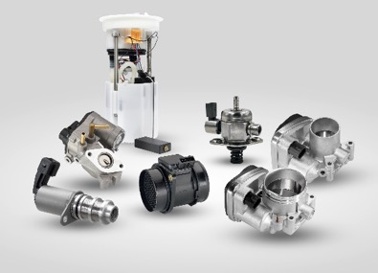  Continental_PP_Replacement_Parts | Continental is significantly expanding its portfolio for engine management and fuel supply – by around 700 part numbers by 2025.
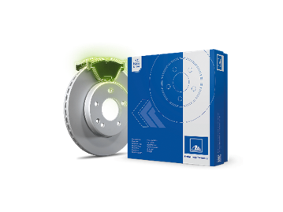  Continental_PP_ATE New Original_Verpackung | ATE New Original friction brake pairings, friction partners disc and pad, are at the center of developments to comply with the particulate matter limits according to the Euro 7 standard.
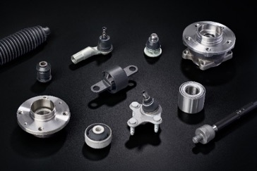  Continental_PP_New_Parts_  Steering_Chassis | Continental opens up new product groups and adds spare parts for steering and chassis to its product range.
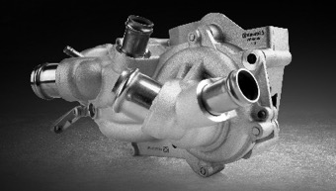  Continental_PP_Water_Pump | New from Continental: water pumps without a control unit can be a cost-effective repair alternative.

