InnoTrans 2024

Railway: Continental Hydraulic Bushings Reduce Maintenance Costs Through Softening the Blow
- Advanced technical design allows for a differentiation between high and low stiffness that is significantly better than that of conventional hydraulic wheelset guiding bushes
- Higher passenger comfort, prolonged lifespan of critical components: Continental takes the benefits of hydraulic wheelset guiding bushes to the next level
- Traffic service providers can reduce maintenance costs of their wheelsets – also through retrofitting as no modification of the bogie must be made
Hanover, Germany, September 20, 2024. Continental has developed a new generation of hydraulic wheelset guiding bushes for bogies on trains. These bushings can adapt the pressure that tracks assert on the wheelset significantly better than conventional hydraulic bushings. The advanced balancing of the pressure that impacts the wheelset increases the lifespan of critical train components and therefore offers an opportunity to reduce maintenance costs as servicing intervals may be prolonged and unplanned repair work can become less frequent. At the same time, passenger comfort is increased because the impact of track-sleepers on the wheels is noticeably reduced. Continental will explain the benefits of its new hydraulic wheelset guiding bushes at InnoTrans 2024 in Berlin, Germany, from September 24 through September 27 (Hall 9, booth 400).
Differentiation between static and dynamic longitudinal stiffness is significantly higher
In a train’s primary suspension system, hydraulic bushes are used to connect the primary spring swingarm with the bogie. They allow for some movement and flexibility within the primary suspension system for an optimal wheelset guiding. This is crucial for adapting to track irregularities and ensuring smooth operation of the train. Hydraulic bushings are essential for the train suspension system’s ability to adapt to the very different riding modes. They can support both: situations where a rigid suspension is required, i.e., high speed on straight rides. Or, in contrast, situations that demand soft suspension, i.e., curves or switches at low speed.
Continental hydraulic bushings enable a differentiation between static and dynamic longitudinal stiffness that is significantly higher than that of conventional hydraulic bushings. This means that very soft wheelset guidance can be achieved in curves and pressure from the tracks is reduced. In contrast, high directional stability is demanded on the straight at high speed. Here, the optimized wheelset guidance of Continental’s solution increases the positive impact of hydraulic bushings on passenger comfort, such as less noise and softer rides.
Positive effect on maintenance cost
The increased adaptability and thus more appropriate wheelset guidance that Continental achieved through the innovative design of its new generation hydraulic bushings has a positive effect on servicing intervals and maintenance cost, too. Continental’s hydraulic wheelset guiding bushes can be retrofitted with no modification to the bogie, as they are easily attachable. This makes it easier, e.g., for train operators with challenges in the field of maintenance cost to install them in trains already in operation. "As our wheelset guiding bushes adapt to pressure better than what is standard today, the wear of both rail and wheel can be significantly lower compared to conventional hydraulic bushings, all other factors equal," explains Sara Grotsch, head of Operations Unit Dynamic and Suspension Solutions in the Industrial Solutions EMEA Business Area at Continental’s group sector ContiTech, where the hydraulic wheelset guiding bushes have been developed. "That is why we are not only proud of our technology innovation but also of the potential effect on sustainability and efficiency it can have to the benefit of our customers, their customers and everyone riding a train, metro or tram."
Continental develops pioneering technologies and services for sustainable and connected mobility of people and their goods. Founded in 1871, the technology company offers safe, efficient, intelligent and affordable solutions for vehicles, machines, traffic and transportation. In 2023, Continental generated sales of €41.4 billion and currently employs around 200,000 people in 56 countries and markets.
ContiTech is one of the world’s leading industry specialists. The Continental group sector offers its customers connected, environment-friendly, safe and convenient industry and service solutions using a range of materials for off-highway applications, on rails and roads, in the air, under and above the ground, in industrial environments, for the food sector and the furniture industry. With about 42,000 employees in more than 40 countries and sales of some 6.8 billion euros (2023), the global industrial partner is active with core branches in Asia, Europe and North and South America.
Press contact

Oliver Heil
Spokesperson EMEA
Business sector ContiTech
Continental
Phone +49 6196 87-2681
Email: oliver.heil@continental.com

Press portal: www.continental-press.com
Media center: www.continental.com/media-center
Website: www.continental-industry.com

Pictures/captions
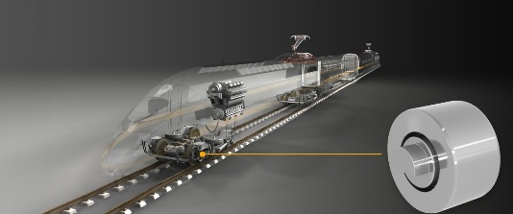  Continental_PP_Hydro_Bushing_  Transparent_Train | Hydraulic wheelset guiding bushes from Continental allow for higher passenger comfort and prolonged lifespan of critical components.
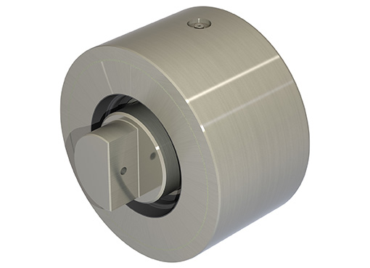  Continental_PP_Hydro_Bushing_  Railway | An advanced technical design allows for a differentiation between high and low stiffness that is significantly better than that of conventional hydraulic wheelset guiding bushes.

