Continental Launches First Prefabricated House
- ContiHome: first Continental prefabricated house enables vacations in tiny house in northern Germany
- Further prefabricated house available for booking in the Netherlands in the fall
- Available with or without trailer: modular design means campsite operators and vacation parks can tailor ContiHome to their needs
- Michael Hofmann, Chief Technology Officer at Continental’s group sector ContiTech: “With our materials expertise and our courage to break new ground, we want to help create a fantastic holiday feeling in a small space”
- Representative survey commissioned by Continental shows that more than two-thirds of people in Germany can imagine spending their vacation in a tiny home
Hanover, Germany, July 30, 2024. Continental has launched its first prefabricated house. The 30-square-meter, one-and-a-half-story tiny house dubbed the ContiHome is located in northern Germany on Lake Belau between Kiel and Lübeck. Overnight stays can now be booked via online portals. Starting in the fall 2024, the technology company for mobility and material solutions will be offering a second prefabricated tiny house for reservations near Amsterdam. With the ContiHome, the ContiTech group sector is primarily targeting vacation parks and campsites that offer their customers a higher level of comfort than conventional camping. The mobile accommodation is available with or without a trailer and impresses with its sustainable and functional surface materials. In addition to a bathroom and kitchen, it sleeps up to four people. “With our materials expertise and our courage to break new ground, we want to help create a fantastic holiday feeling in a small space,” says Michael Hofmann, Chief Technology Officer (CTO) for ContiTech.
The small prefabricated house is the latest example of Continental’s materials expertise. Since 2018, the ContiTech group sector has been offering a variety of surface materials for exterior and interior use as well as for furniture and upholstery in the home and living sector. In 2023 alone, ContiTech produced 197 million square meters of surface materials – equivalent to the size of around 27,750 football fields. “Our portfolio includes materials for a wide range of industries. We not only equip homes and vehicle interiors with our solutions, but also enhance the comfort of millions of people on cruise ships, in restaurants, hotels and football stadiums. As a constant companion in life, our surface products deliver impressive design, quality and functionality. And most importantly, they’re becoming more sustainable,” Hofmann continues.
One example from the portfolio is the breathable skai VyP Coffee artificial leather, which is made from around 65 percent renewable and recycled raw materials such as coffee grounds.
Vacationing in nature: campsites and tiny houses are popular
According to the German Federal Statistical Office, more people stayed at campsites in Germany in 2023 than ever before. Campsites recorded around 42.3 million overnight stays last year. This was 5.2 percent more than in 2022 (40.2 million) and 18.2 percent more than in 2019, the year before the coronavirus (35.8 million). A representative survey conducted in Germany for Continental in June 2024 underscores the popularity of campsites: just over half of respondents (52 percent) have a positive attitude toward camping vacations. People over the age of 45 are slightly less enthusiastic. Among those 55 and older, only 39 percent can imagine camping as a form of vacation.
Families with two to three children are particularly open to camping. Those open to camping also have a positive attitude toward luxury camping. For example, some 46 percent of those surveyed are interested in so-called “glamping”. Across all age groups, peace and quiet, privacy, proximity to nature and comfort are among the most important criteria when choosing vacation accommodation. More than two-thirds (around 69 percent) of respondents, regardless of age, could imagine vacationing in a tiny house, including a high share of camping enthusiasts (around 79 percent). “The high approval ratings for camping vacations in tiny houses show that we are tapping into the zeitgeist with the ContiHome. With the ContiHome, vacationers can experience the flexibility and independence of camping combined with the comfort and facilities of a vacation home,” says Michael Hofmann.
A lot to discover in a small space
The first ContiHome is located on the northern German glampsite run by provider George Glamp on Lake Belau between Kiel and Lübeck. Glamping is a more luxurious form of camping that involves unusual types of accommodation in the midst of nature. Combining the idea of a motorhome or caravan on the one hand and a hotel or vacation apartment on the other, the Continental tiny house fits right into this concept.
With a floorspace of 30-square-meters on one and a half stories, the ContiHome offers significantly more space than a motorhome or caravan. This applies to the living and sleeping areas as well as the kitchen and bathroom. Compared with a vacation apartment or hotel room, this type of accommodation offers more independence and privacy. Thanks to the fully equipped ContiHome, campers are independent of public sanitary and kitchen facilities. In turn, campsite operators can extend the season by setting up one or multiple ContiHomes.
From the outside, the design of the ContiHome impresses with large windows, an overhang and a sloping roof, creating a special feeling of space. The extensive window facades on three sides bring the occupants closer to nature, while a large skylight directly above the bed allows them to “sleep under the stars.” The sofa converts into an additional sleeping area and the dining table into a bed, and a functional piece of furniture creates additional seating. The unique shade systems can be operated at the touch of a button. Future vacationers will benefit from the modularity of the ContiHome in terms of equipment and floor plan, enabling vacation parks and campsites to tailor their tiny houses to their needs.
Thanks to its mobility and ease of setup, the ContiHome can provide vacation accommodation in a wide variety of locations, such as by the sea or a lake, in the mountains, on campsites or in leisure and vacation parks. Because the ContiHome is optionally available with a trailer, the tiny house is not only suitable for stationary use, but also as a temporary living space. Starting in autumn, the second ContiHome will be available for booking through the Basecamp Eco-Resort Ijmuiden.
High-quality, innovative materials for more comfort and price awareness
The ContiHome features high-quality and easy-to-clean surface materials, particularly in terms of feel and appearance. The innovative Continental materials include surfaces with “cool colors” technology, which ensures a pleasant indoor climate even at high temperatures. The need for chemical fillers has also been reduced by using vegan leather made from coffee grounds, for example.
Thanks to their durability and ease of maintenance and cleaning, the advanced materials ensure that the tiny house operator’s investment pays off faster. The durability, colorfastness and other properties of the surfaces are the result of Continental’s industrial and application experience in a variety of fields. In total, around 25 Continental surfaces are used for the interior and exterior of the ContiHome. These include Continental exterior films with “cool colors” technology, which reduce the heating of window profiles when exposed to strong sunlight. Here, special color pigments reflect up to 80 percent of near-infrared radiation. As a result, the surface temperature is up to 15°C lower than with other coatings.
From showroom to product
The ContiHome is based on a prototype that Continental originally developed in 2021 as a showroom for its surface materials. As a technology company for mobility and material solutions, Continental frequently combines functionality, robustness and sustainability in its products. The same was true of the showroom, where the idea was to explore the topic of “living in a small space,” inspired by global trends such as micro-housing and minimalism.
On this basis, the company clad and equipped an entire house, including the furniture, floors, walls, windows, facades and terrace, with its surface materials. The focus was on design, feel, functionality and comfort. The showroom attracted a great deal of interest from visitors on a number of occasions, so the company decided to develop the idea into a product. As a showroom, the ContiHome won the iF Design Award and the Red Dot Product Design Award in 2022.
About the Continental survey
Market and opinion research institute YouGov conducted a representative online survey on behalf of Continental in June 2024. In it, 2,042 German citizens aged 18 and over were asked about their vacation habits.
Continental develops pioneering technologies and services for sustainable and connected mobility of people and their goods. Founded in 1871, the technology company offers safe, efficient, intelligent and affordable solutions for vehicles, machines, traffic and transportation. In 2023, Continental generated sales of €41.4 billion and currently employs around 200,000 people in 56 countries and markets.
Press contact

Angelika Anna Kohns
Media & PR Manager
ContiTech group sector
Phone: +49 (0) 511 938 14022
Email: angelika.anna.kohns@continental.com

Press portal: www.continental-press.com
Media center: www.continental.com/media-center
Website: www.continental-industry.com
Website ContiHome: www.contihome.net/en/

images and captions
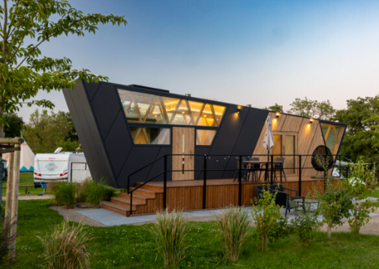  Continental_PP_ContiHome | Continental’s first prefabricated house is located on Lake Belau between Kiel and Lübeck.  Photo: Continental
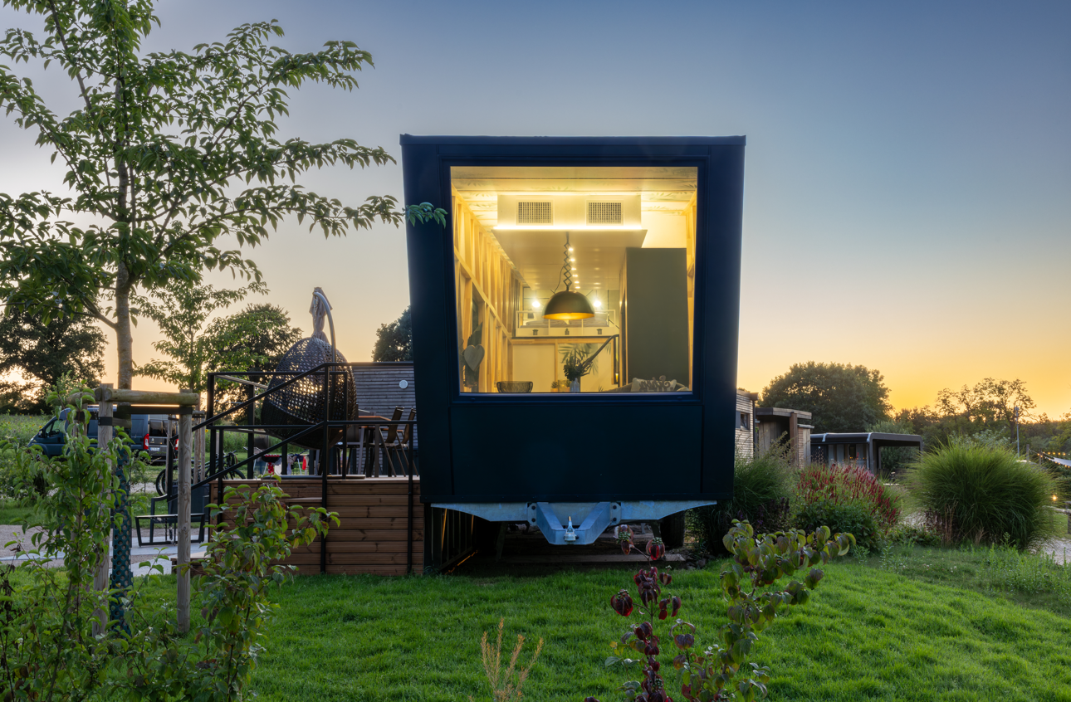  Continental_PP_Exterior view | Campsite operators and vacation parks can tailor ContiHome to their needs due to its modular design means.  Photo: Continental
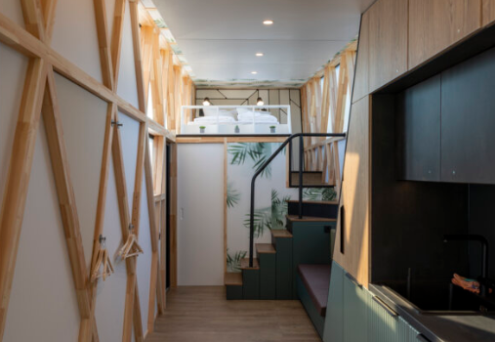  Continental_PP_Interior | The ContiHome consists of 30-square-meters featuring around 25 functional and sustainable Continental surfaces, indoors and out.  Photo: Continental
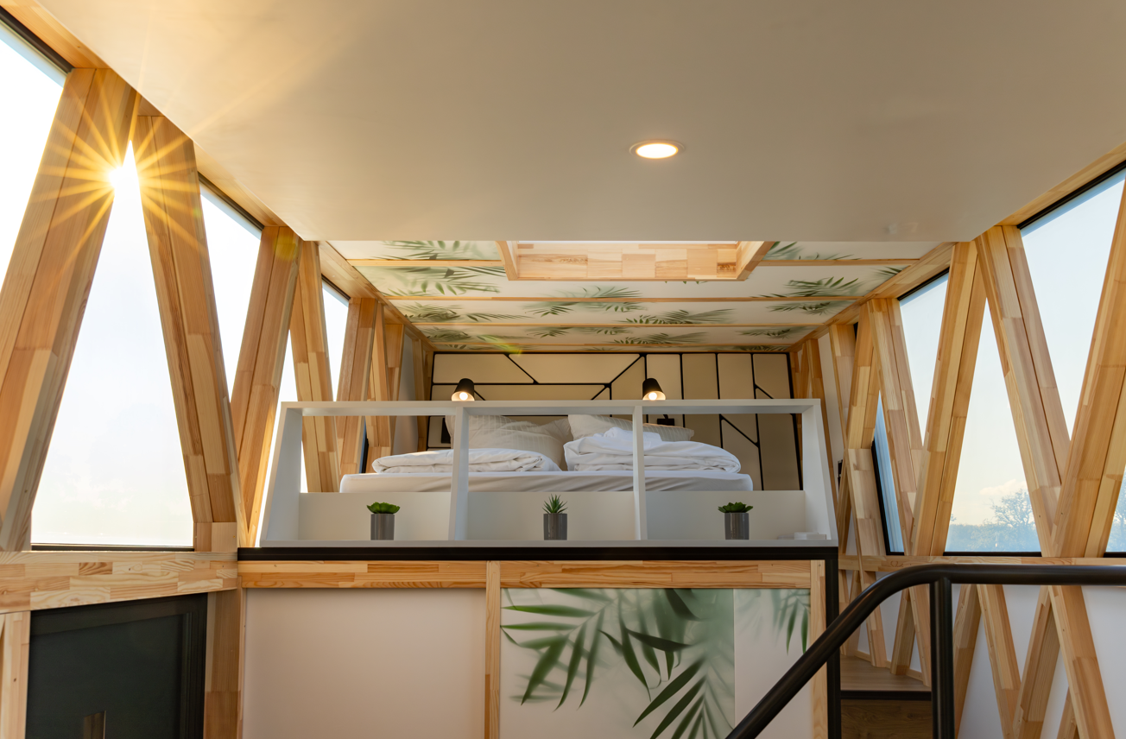  Continental_PP_Bedroom | Close to nature thanks to large windows on three sides and a large skylight directly above the bed.  Photo: Continental
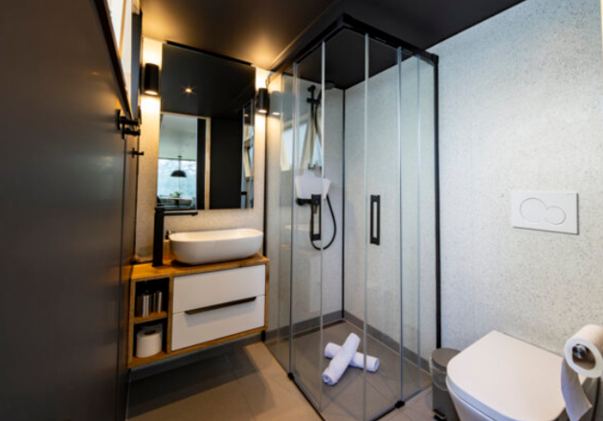  Continental_PP_Bathroom | The ContiHome offers a bathroom, kitchen and up to four sleeping options.  Photo: Continental

