Surfaces from Continental – New Door Panel Concept for the Vehicle Interior
- The fully functional model recently won the prestigious CMF Design Award 2023
- Door Panel Concept shows Continental’s vision for functional surface solutions
- Applications range from breathable and heatable surfaces to translucent and recyclable materials
Hanover, Germany, April 4, 2024. Continental has combined its functional surface solutions in a compact model. In the so-called Door Panel Concept, the technology company makes its diverse surface expertise visible and tangible in the form of a door panel consisting of five different functional surfaces. The Door Pancel Concept has not only been well received by customers, it was also recently honored with the CMF Design Award 2023 in Shenzhen, China. The prestigious award is presented by a jury of international experts for outstanding achievements in color, material and finish. Elements of the SPACE D design concept, which was presented for the first time at the IAA MOBILITY 2023, can also be found in the new model. In the SPACE D, Continental combines the functions of living, driving and working in an interior oasis concept.
CMF Design Award comes from the emerging Chinese market
Continental meets the requirements of the global markets with its surface solutions for automotive interiors. "Trends are the intelligent cockpit and the third space, i.e. the driving, working and relaxing experience combined in the vehicle as a third space alongside the home and workplace," explains Burak Uezel. Global Head of Automotive Design at the surface specialists at ContiTech. In (partially) autonomous vehicles with quiet electric drives, drivers and passengers no longer have to focus so much on visual or acoustic impressions from outside. "The focus is more on the interior, on the design and functionality of controls that can be integrated into surfaces," says Uezel.
The Chinese market is increasingly becoming a driver of innovation for autonomous driving and e-mobility. In this respect, it is no coincidence that Continental has received the CMF Design Award for its Door Panel Concept: the international committee of the CMF Design Conference is based in Shenzhen, China. The partners of the conference include renowned institutions such as the Shenzhen Design Federation, the design departments of universities in Nanjing and Beijing and the RAL Farben organization from Germany, which is responsible for color standards.
Focus on the user experience
When developing functional surfaces, Continental always focuses on the user experience. Examples include breathable surfaces for comfort on long journeys on hot days or morphing controls. "The award for our Door Panel Concept is confirmation of our advanced design approach," says Uezel. The translucent Xpreshn Hylite Concept and the directly heatable surface concept material from Continental, called heatable technology, are also shown on the model. "This allows us to illustrate various scenarios such as autonomous driving, standing in a traffic jam or getting into a car. In addition, there are various settings for activities such as eating, relaxing, watching movies, working and playing, which allow users to enjoy a varied experience in the vehicle," explains Uezel.
Completely new human-machine interfaces
Xpreshn Hylite Concept, which is indistinguishable from conventional surfaces when unlit, becomes visible as soon as it is illuminated from behind. The material can be used to integrate mood and task-dependent ambient lighting into the vehicle interior and harmonize it with other light sources such as switches. This enables completely new human-machine interfaces. "Car manufacturers can design their vehicles much more individually with our surface materials," says Uezel. Continental has also developed a translucent surface material that can be fully recycled. "The Panel Concept puts our surface solutions in direct relation to the megatrends of the global automotive industry and mobility in general. We are not only demonstrating our innovative strength, but also want to inspire vehicle manufacturers to create modern and sustainable interior solutions," emphasizes Uezel.
Fast and efficient heating
Continental's new heatable technology concept is also part of the Door Panel Concept. With this solution, the heating elements are integrated directly into the surface material and enable heating close to the body, which has a direct effect on the driver and passengers. The fast and efficient technology can be applied to a variety of surface materials and is not limited by the shape of the required heating area. It can therefore be used for components like seats, backrests and armrests for example. As an invisible, slim and particularly lightweight heating system, the material also achieves significant weight savings compared to conventional systems. It is therefore particularly suitable for use in electric vehicles to offset the weight of the heavy battery storage system to a small extent.
Continental develops pioneering technologies and services for sustainable and connected mobility of people and their goods. Founded in 1871, the technology company offers safe, efficient, intelligent and affordable solutions for vehicles, machines, traffic and transportation. In 2023, Continental generated sales of € 41.4 billion and currently employs around 200,000 people in 56 countries and markets.
As a surface specialist, Continental focuses on functional and design-led materials for the automotive, furniture and building industries, the printing industry and the do-it-yourself sector. The international, globally active technology company has pooled its surface expertise for all industries in the Surface Solutions business area. Its 6,000 employees develop, produce and market surface materials at 25 locations in Germany, Brazil, China, France, India, Italy, Japan, Mexico, Poland, Singapore, Slovenia, Spain and the USA.

Press contact:

Oliver Heil
Spokesperson EMEA
Business sector ContiTech
Phone: +49 6196 87-2681
Email: oliver.heil@continental.com
Press portal: www.continental-press.com
Media center: www.continental.com/media-center
Website: www.continental-industry.com

Pictures and Captions
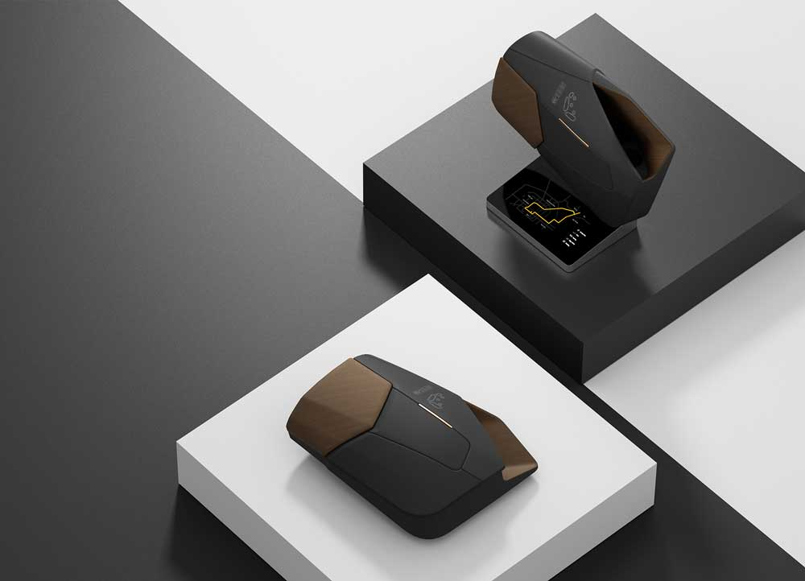  Continental_PP_Concept_Panel | With the compact Door Panel Concept, Continental combines all functional surface solutions for the vehicle interior.  Photo: Continental
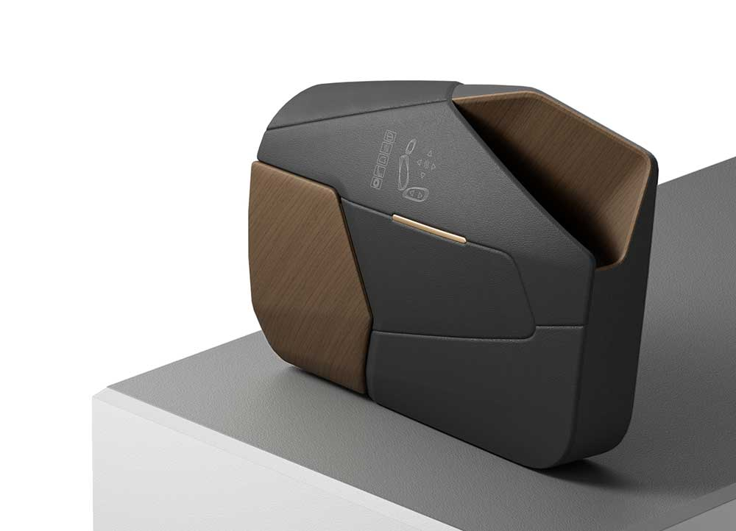  Continental_PP_Concept_Panel_Design | With the Door Panel Concept, Continental demonstrates design freedom in the visual and haptic design of surfaces.  Photo: Continental
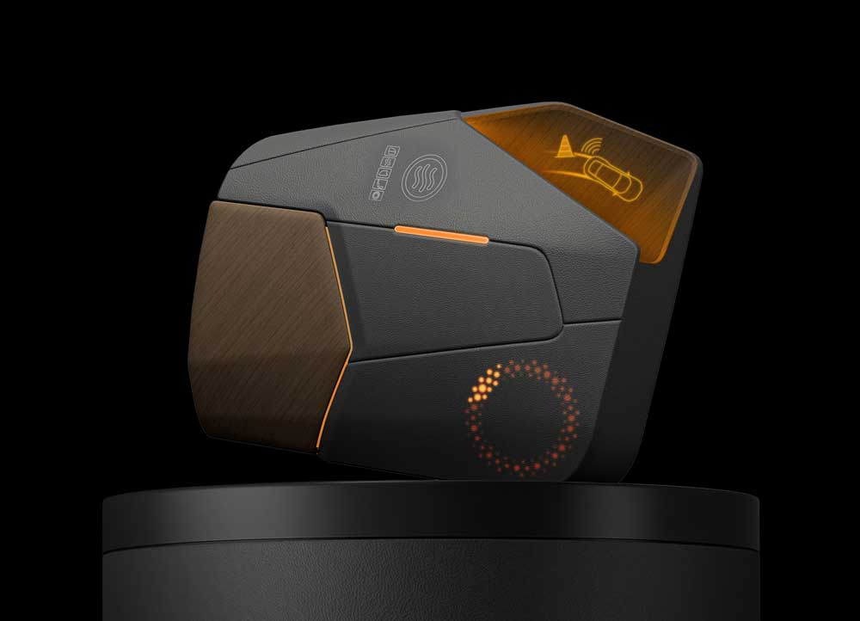  Continental_PP_Concept_Panel_Function | The model also stands for a wide range of functions that surface solutions from Continental can offer today.  Photo: Continental
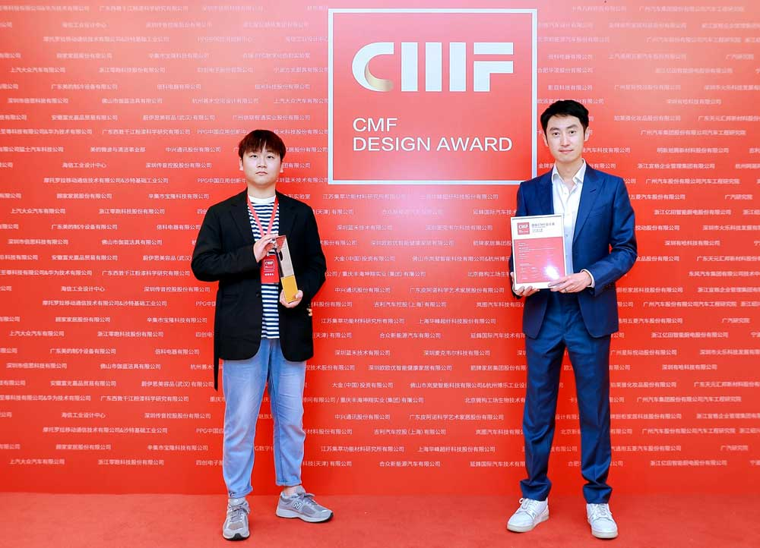  Continental_PP_Concept_Panel_Award | Kenneth Zhang (right), Head of Automotive Design APAC Region at Continental and Ziv Zhan Wei, Project Designer Automotive at Continental receive the CMF Design Award.  Photo: Continental

