Continental at Fensterbau Frontale

New Surface Materials from Continental Connect the Interior and Exterior of Buildings
- Double show debut for two exterior surfaces: Conti mattex resembling powder-coated aluminum and Conti woodec with its authentic wood look
- Weatherproof outdoor kitchen provides an example of new applications for outdoors
- New branding – parent brand Continental replaces the skai brand for exterior surfaces
Hanover/Nuremberg, Germany, March 14, 2024. New decors, new colors, new applications, new branding – Continental is bringing plenty of fresh reveals to the Fensterbau Frontale international industry showcase. At the world’s leading trade fair for windows, doors and facades taking place in Nuremberg on March 19 - 22, 2024, the surface specialists from Continental group sector ContiTech will be connecting interiors and exteriors. This is exemplified by two products making their show debut: Conti mattex and Conti woodec. Used on the outside of a window profile, these new surface materials blend perfectly into the visual appearance of the building envelope, while creating a direct link to the living space on the inside.
Until the 1980s, windows and doors were purely a means of letting light and people into buildings. But they have since evolved into indispensable design elements. They also have an important role to play in energy-efficient construction and energy-saving refurbishment. However, construction growth is weakening. In many countries, including Germany, Sweden, Denmark and Hungary, refurbishment projects will not be able to compensate for the decrease in new builds during the next few years according to forecasts by the IFO Institute for Economic Research. "So, it’s all the more important for manufacturers to fully utilize their scope for creativity if they wish to stand out from their competitors and impress the end customer," emphasizes Rainer Irouschek, Head of the Exterior Living business segment at Continental. At Fensterbau Frontale, the company is therefore exhibiting new materials and applications to help design a beautiful home by interconnecting the interior and exterior – all in keeping with its slogan for the show "… and it feels like home".
Outdoor kitchen creates a homely atmosphere
This central theme is also reflected in the concept for the Continental stand. An outdoor kitchen creates the atmosphere of a laid-back barbecue party and the sense of arriving home. The basic structure was built by a team of apprentices from the Continental site in Weißbach.
The outdoor kitchen’s overall concept and design is the work of the site’s in-house design center and was inspired by the ContiHome tiny house that serves as a mobile showroom. The kitchen features a built-in barbecue and a stone worktop, with cabinet fronts finished in Conti woodec and sides in a trendy wooden design with a striped look. "It has a high-quality, homely feel," says Irouschek. "It is very difficult to use real wood materials for outdoor kitchens; woodec creates the appearance and therefore the quality feel of wood, yet it isn’t prone to aging or weathering."
Show firsts exemplify holistic approach
When used on window frames, the authentic real wood look of Conti woodec allows it to spread the feel-good ambiance exuding from the interior furnishings to the building envelope, thereby exemplifying Continental’s holistic approach. "We see the window as an element of the interior design rather than part of the building envelope," explains surface expert Irouschek. "The wood decor creates a more homely feel." The decors Conti woodec Tropea Oak almond and Tropea Oak coffee are being exhibited for the first time. Their elegant striped design gives them added character, yet the absence of cathedrals and knots also maintains a sense of calmness.
Also celebrating its show debut, Conti mattex achieves an ultra-matte appearance that resembles the effect of powder-coated aluminum. This plain film can therefore give uPVC window frames the same quality feel as aluminum or wooden windows, providing a visually appealing and cost-efficient solution. It is used primarily on window profiles and is now also available in the colors mattex shine dark graphite, shine white aluminum, shine grey aluminum and shine deep bronze.
For a home you love to live in
Besides the surface solutions for window profiles, front doors and facades, Continental is also unveiling new exterior applications (including cladding), as well as dividing, sun protection and structural elements. A raised flower bed and stylish, practical storage boxes – all with exterior surfaces from Continental – further enhance the garden ambiance for outdoor living. "Not only do they all boast an appealing design, but they are also easy to care for and long-lasting too," promises Irouschek. "At Continental we have always offered ideal solutions for a wide range of applications in interiors, with our furniture films and artificial leather," he continues. "By merging interior and exterior, we are combining homeliness with a quality feel."
All products grouped under the banner of world-famous technology brand Continental
The technology company is also presenting a change of branding at Fensterbau Frontale, with the Exterior Living segment now pooled under the Conti brand instead of the previous skai brand. "Rebranding our exterior applications under the world-famous name of technology brand Continental gives them considerable appeal and makes it easier to enter new markets," Irouschek points out. "When it comes to interiors, on the other hand, skai will continue to be our powerful brand for artificial leather and furniture films."
The surface specialists from Continental are also showing their new image video at the industry’s leading trade show. It features the people behind the exterior surfaces, as well as offering some exclusive insights into the manufacturing process and showing the wide variety of possible applications.
Experience the new surface solutions from Continental on March 19 – 22 at Fensterbau Frontale in Nuremberg – Hall 5, booth no. 5-202.
Continental develops pioneering technologies and services for sustainable and connected mobility of people and their goods. Founded in 1871, the technology company offers safe, efficient, intelligent and affordable solutions for vehicles, machines, traffic and transportation. In 2023, Continental generated preliminary sales of € 41.4 billion and currently employs around 200,000 people in 56 countries and markets.
As a surface specialist, Continental focuses on functional and design-led materials for the automotive, furniture and building industries, the printing industry and the do-it-yourself sector. The international, globally active technology company has pooled its surface expertise for all industries in the Surface Solutions business area. Its 6,000 employees develop, produce and market surface materials at 25 locations in Germany, Brazil, China, France, India, Italy, Japan, Mexico, Poland, Singapore, Slovenia, Spain and the USA.
Continental surfaces from the Exterior Living segment are specially developed for outdoor use. As industrial coatings for a whole variety of structural elements, such as windows, doors, garage doors and facade claddings, they are permanently in use.
Press contact:

Axel Schmidt
Head of Communications
Marketing & Communications Surface Solutions
Phone: +49 7947 81-522
Email: axel.schmidt@continental.com
Press portal: www.continental-press.com
Media center: www.continental.com/media-center
Website: www.continental-industry.com
Pictures/captions
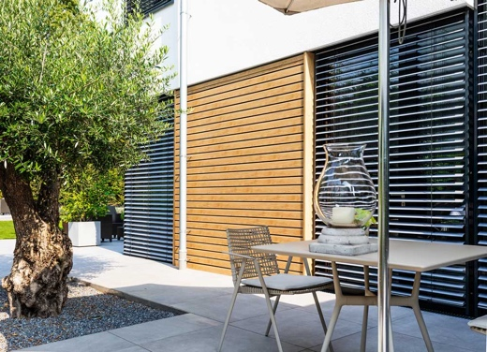  Continental_PP_woodec_Turner-oak | Authentic wood look for the facade: Conti woodec Turner Oak malt.  Photo: Continental
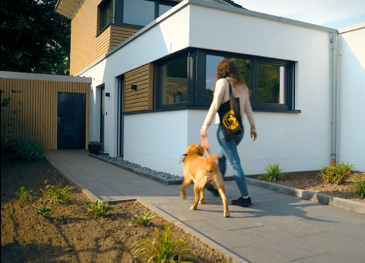  Continental_PP_mattex_woodec | Attractive and eye-catching: Conti mattex in anthracite gray on the window profiles, combined with Conti woodec Turner Oak malt on the facade.  Photo: Continental
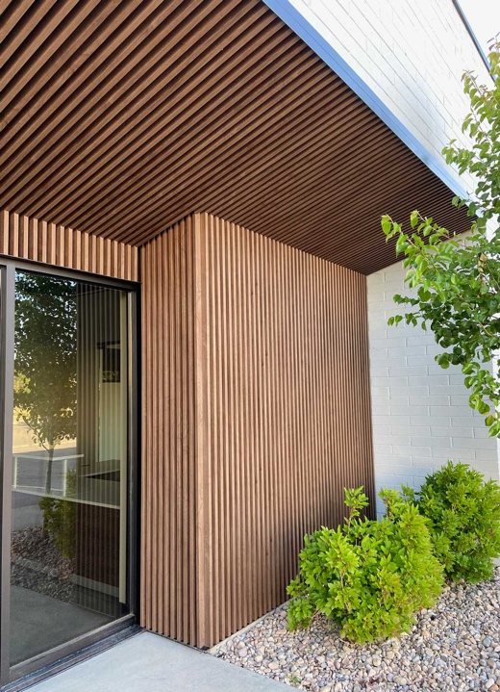  Continental_PP_woodec_optic | The modern striped look of the Conti woodec decors adds a new visual dimension.  Photo: Continental
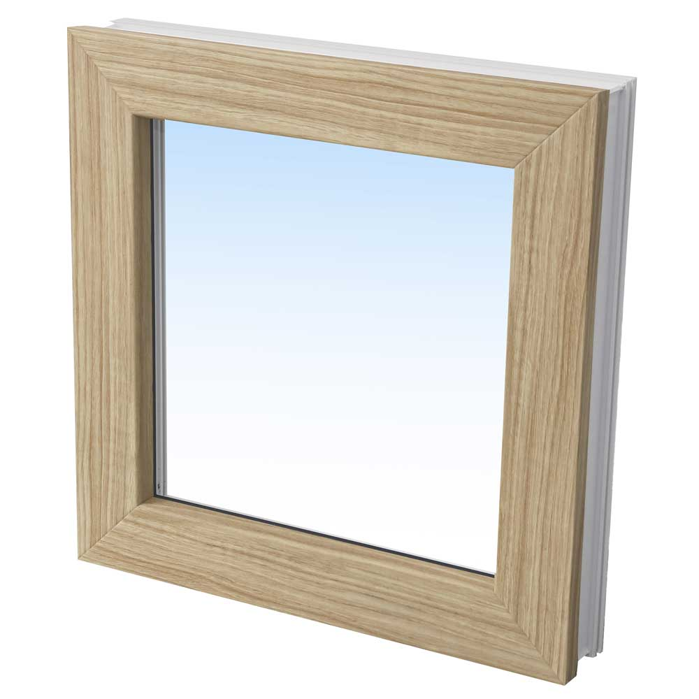  Continental_PP_woodec_Tropea-  Oak-almond | View of a window frame in Conti woodec Tropea Oak almond. Dispensing with rustic elements gives the new decor a calm, elegant and high-quality feel.  Photo: Continental
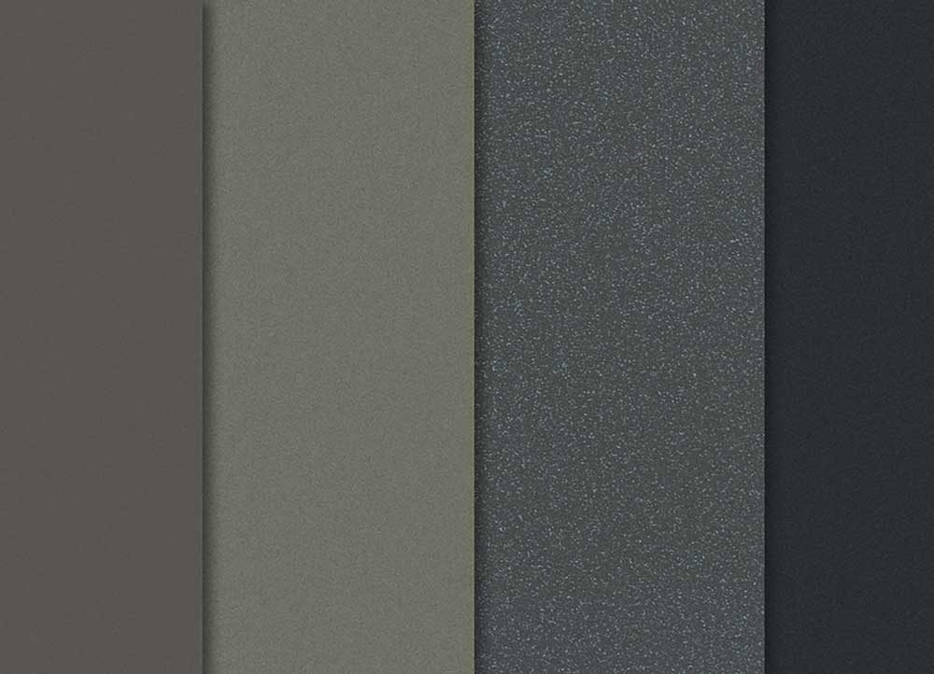  Continental_PP_mattex_panel | Conti mattex achieves an ultra-matte appearance that resembles the effect of powder-coated aluminum. It is shown here in four of the latest trend colors.  Photo: Continental
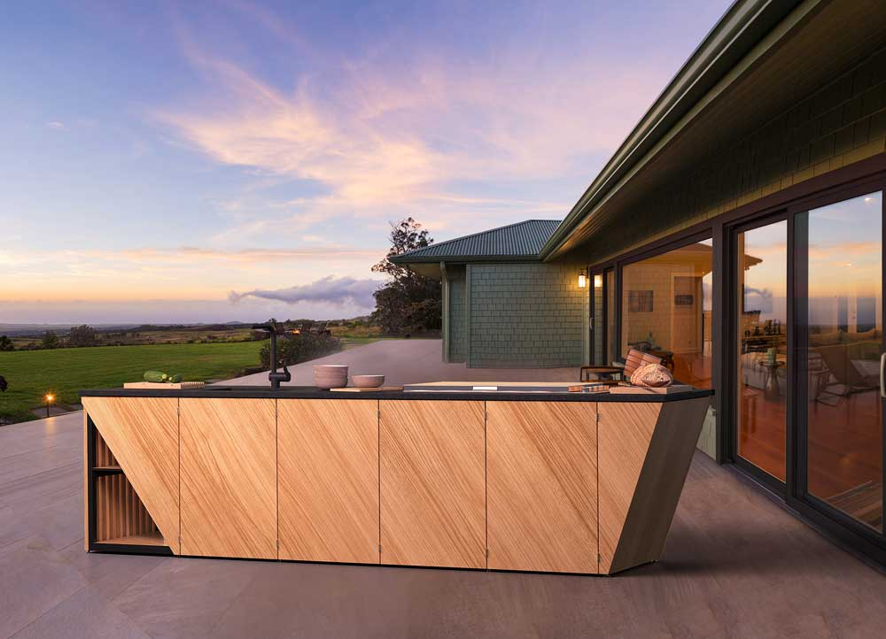  Continental_PP_Outdoor-kitchen | The outdoor kitchen is a key component of Continental’s stand concept at Fensterbau Frontale.  Photo: Continental

