Around $90 Million Investment In Mexico For Continental's New Hydraulic Hose Production Plant
- The facility in the west-central Mexican state Aguascalientes will increase regional manufacturing capacities, generating in its first stage 200 new jobs
- Philip Nelles, Member of Continental’s Executive Board for the Group Sector ContiTech: “Strengthening our industry business in the Americas region is a focus for us. It underlines our strategic approach to become the innovation leader and full range supplier for hydraulic hoses”
- The construction of the plant is planned to begin in the second half of 2024
Hanover, Germany, January 26, 2024. The German technology company Continental has announced, together with the governor of Aguascalientes, the construction of its new hydraulic hose plant for industrial purposes. The planned investment is of around 90 million dollars and is one of the biggest investments for Continental’s Group Sector ContiTech in 2024. This new facility will complement and increase Continental’s existing manufacturing capacities within the region and will generate in its first stage more than 200 jobs. With a total area of more than 85,000 m², it will be ContiTech’s largest location in Mexico, representing approximately the size of 12 soccer fields. The construction of the plant is planned to begin in the second half of this year, with a start of operation expected in the second half of 2025.
“Strengthening our industry business in the Americas region is a focus for us,” explained Philip Nelles, Member of Continental’s Executive Board for the Group Sector ContiTech. “This investment is our answer to the demand and growth of the hydraulic hose market in the region and underlines our strategic approach to become the innovation leader and full range supplier for hydraulic hoses. The new plant will allow us to further expand our hydraulics business with an extended portfolio of hoses for diverse key industries like agriculture, mining, construction, manufacturing, and energy.”
Andreas Gerstenberger, Head of Industrial Solutions Americas, added: “The hydraulic market is the largest hose and fittings market segment in our region. We have been in the hydraulic hose business for over half a century. With our new plant in Mexico, we will double our capacity in this field and address current and new customers in multiple industries, embracing our ‘in the region, for the region’ approach. Also, with its state-of-the art infrastructure including solar panels, process water reuse technologies, SmartFactory tools as well as machinery with high automation and optimal energy utilization, our new plant is perfectly prepared for additional expansion activities in the future.”
The new facility will be Continental's 22nd plant in Mexico and the second in the state of Aguascalientes. Continental’s operations in the country produce and develop automotive components, rubber products and tires and are exported to different countries, occupying more than 23,000 employees.

Continental develops pioneering technologies and services for sustainable and connected mobility of people and their goods. Founded in 1871, the technology company offers safe, efficient, intelligent and affordable solutions for vehicles, machines, traffic and transportation. In 2022, Continental generated sales of €39.4 billion and currently employs around 200,000 people in 57 countries and markets.

Press contact

Wolfgang Reinert
Head of Media & Public Relations
Group Sector ContiTech
Phone: +49 511 938 1304
Email: wolfgang.reinert@contitech.de
Press portal: www.continental-press.com
Media center: www.continental.com/media-center
Sustainability at ContiTech: www.continental-industry.com/en/campaigns/sustainability

Pictures / captions
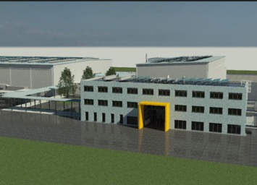  Continental_PP_Aguascalientes | Image synthesis of the new plant in Aguascalientes, Mexico.
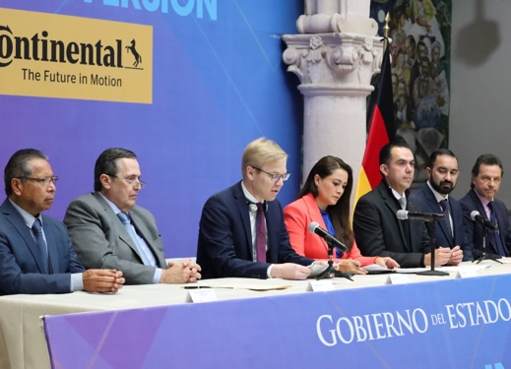  Continental_PP_Government Aguascalientes | F. l. t. r.: A.A. Moreno (President Industrial Cluster Aguascalientes); M. Galluzzi (Continental Mexico); P. Nelles (CEO Group Sector ContiTech); M.T. Jiménez (Governor of Aguascalientes); M.A. Gonzalez (Ministry Economic Development); E. Barros (ContiTech Mexico), A. Ortega (Vesta Industrial Park)

