Continental Strengthens its Business with Solutions for the Printing Industry
- Broader global presence following acquisition of Trelleborg’s printing technology business
- Complementary product portfolios achieving high levels of brand awareness
- Customers benefit from collective expertise
- Around 600 new employees at eight sites in seven countries
Hanover, Germany, May 3, 2023. Continental has fully acquired the printing technology business of Trelleborg, a company headquartered in Lodi Vecchio, Italy. This strategic step expands the technology company’s range of surface solutions in the field of printing technology at the same time as boosting its business with industrial clients. “Everyone gains from the merger,” emphasizes Sven Hlywiak, who heads the global industrial activities outside the automotive sector in Continental's Surface Solutions business area. After all, the product portfolios of the two companies complement one another and are both characterized by a high level of brand awareness. “Both businesses are already synonymous with innovation and quality in their own right,” continues Hlywiak. “This move pools our collective expertise, allowing customers to benefit from impressive capabilities and an even broader global presence.”
Dario Porta, President of Trelleborg Printing Solutions, is looking forward to working together. “I am delighted that we will now be part of a large and powerful corporation,” he says. “We will bring our experience and know-how to the existing team of printing experts at Surface Solutions and learn from one another. Together, we will continue to expand our business.”
Collective expertise for further rapid growth
As a result of the acquisition, Continental will gain approximately 600 employees at eight locations – in Italy (two), France, Slovenia, the USA, Brazil, Japan and China – who mainly produce printing blankets for offset and digital printing. Continental employs around 800 people at three sites – in Germany (two) and China – to develop and manufacture a range of products. These include precision printing blankets for sheet-fed and web offset printing under the Conti-Air and Phoenix Xtra Blankets brands, flexographic printing forms for direct engraving (Conti Laserline) and elastomer-coated materials for a wide range of applications in other industries.
Hlywiak is confident that the merger will yield positive results for all the locations of both partners and their employees. “Two global players are joining forces. Not only do the products complement each other, the employees of the two companies are also united by a corporate culture of openness and respect. This will result in even better products and services – at competitive conditions, for the benefit of our customers.”
Continental develops pioneering technologies and services for sustainable and connected mobility of people and their goods. Founded in 1871, the technology company offers safe, efficient, intelligent and affordable solutions for vehicles, machines, traffic and transportation. In 2022, Continental generated sales of €39.4 billion and currently employs around 200,000 people in 57 countries and markets.

Press contact

Wolfgang Reinert
Head of Media & Public Relations
Group Sector ContiTech
Phone: +49 511 938-1304
Email: wolfgang.reinert@continental.com

Press portal: www.continental-press.com
Media center: www.continental.com/media-center

Pictures/Captions
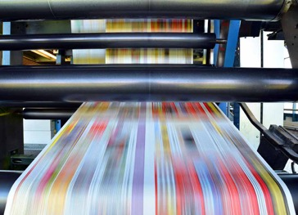  Continental_PP_Offset_Printing | A long reel of paper runs over the printing rollers at lightning speed on this large offset printing press.  Photo: Adobe Stock
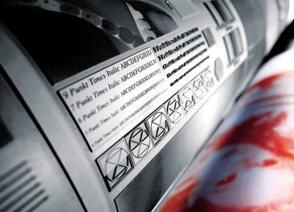  Continental_PP_Flexodruck | Flexographic printing is mainly used for printing packaging.  Photo: Continental
  Continental_PP_Sven_Hlywiak | Sven Hlywiak heads the global industrial activities outside the automotive sector in Continental's Surface Solutions business area.  Photo: Continental
  Continental_PP_Dario_Porta | Dario Porta, President of Trelleborg Printing Solutions.  Photo: Continental

