Continental Strengthens Drive Belt Portfolio Of Industrial Division Through Uniform Brand Identity
- More efficient handling thanks to globally harmonized portfolio and naming structure for industrial drive belts
- Product portfolio becomes clearer and more transparent
- Modernization of selected belt series and introduction of new product lines
- All regions worldwide to be embedded in the new naming structure by end of 2023
Hanover, January 31, 2023. Standard, Advanced, Supreme Performance: This is how the performance level of Continental’s drive belts will be visually identified in its industrial segment in the future – uniformly, worldwide. With its new and globally aligned name and brand structure, the technology company aims to bundle its forces for a clear, comprehensive and efficient presence. “We are harmonizing our portfolio worldwide and improving transparency for our customers, who can now read the performance level and properties of a belt directly on the product,” says Rodrigo Maia, who heads up Continental’s industrial drive belt business. “With our unified approach, we will continue to strengthen the Continental brand and our belts will appear in the premium look that matches their product quality. This opens the door for further improvements and new products.”
In concrete terms, this means that Continental will not only make its belt portfolio more transparent, but also improve the performance and properties of some of its belt series. Moreover, completely new product lines are being launched on the market to expand the existing range. “Our customers and partners, and of course ourselves, will benefit from our globally harmonized, transparent and broad portfolio. If, for example, a plant fails owing to exceptional circumstances in the future, another location can step in. This enables us to work more efficiently and increase productivity,” adds Maia.
For decades, Continental has been providing first-class industrial belt drive solutions and services that contribute to the success of its customers and partners worldwide. “We want to consistently demonstrate this premium approach to the outside world. In the future, it will be visibly reflected in the appearance of the belts and the naming structure,” says Sascha Heyde, the product manager responsible for belt drive solutions in Continental’s industrial segment. “These are changes, of course. But the same quality standard and people that our customers are familiar with stand behind them. We will all continue to provide the best quality, technology and service to keep our customers’ and partners’ operations running as smoothly as ever. That is why we chose the term ‘continuity’ for our communication approach.”
All regions will be using the naming structure by the end of 2023.
Maia sums up: “Bringing all products, competencies, innovative technologies and services together under one name is an important step in ensuring the long-term success of Continental and our strategic business partners. And that is the step that we are taking now.”
Continental develops pioneering technologies and services for sustainable and connected mobility of people and their goods. Founded in 1871, the technology company offers safe, efficient, intelligent and affordable solutions for vehicles, machines, traffic and transportation. In 2021, Continental generated sales of € 33.8 billion and currently employs more than 190,000 people in 58 countries and markets. On October 8, 2021, the company celebrated its 150th anniversary.
Press contact

Wolfgang Reinert
Head of External Communications
Group Sector ContiTech
Phone: +49 511 938-1304
Email: wolfgang.reinert@contitech.de

Media Center: www.continental-press.com
Media Center: www.continental.com/media-center.com

Images and captions
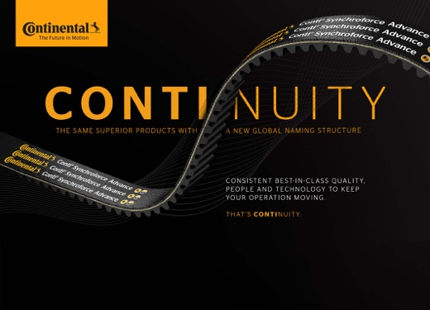  Continental_PP_New_Naming | The term "continuity" aptly describes it: The new naming structure is a logical consequence at Continental.
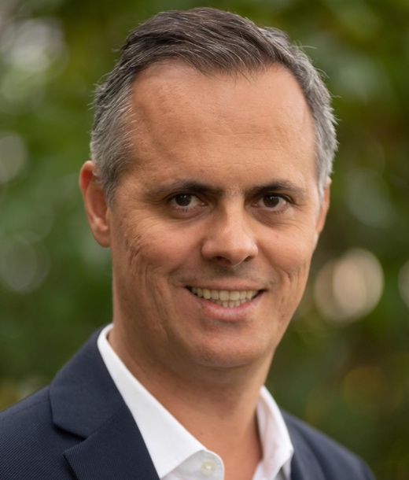  Continental_PP_Maia | Rodrigo Maia, head of Continental’s industrial drive belt business.
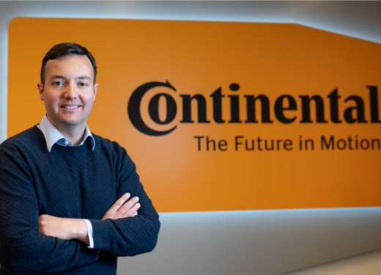  Continental_PP_Heyde | Sascha Heyde, product manager for belt drive solutions in Continental’s industrial segment.

