Energy Efficiency Label Highlights Continental Conveyor Belt Energy Savings
- Label allows operators to make informed decisions when selecting conveyor belts
- Developed in cooperation with US Association for Rubber Products Manufacturers
- Energy-optimized Conti Eco series rubber compounds minimize rolling resistance
Hanover, October 27, 2022. We are all familiar with them from tires or electrical appliances: energy efficiency labels indicating how economical a product is in terms of energy consumption. Continental is the first conveyor belt manufacturer worldwide to identify its products with an energy efficiency label which the company has developed jointly with the US Association for Rubber Products Manufacturers (ARPM). The North American conveyor belt industry worked closely together to create the recently released scale. “The energy efficiency label is an important and targeted communication tool. We all know how important it is to conserve our resources and the environment, and to develop efficient and sustainable solutions,” explains Michael Hofmann, responsible for Marketing Management at Continental Conveying Solutions. “We are excited to be able to provide this added value to our customers and help them make better decisions and be transparent.” Continental is also currently working with other associations around the world on this issue.
The A to G of energy efficiency
The label helps conveyor belt systems operators make informed decisions in order to lower their energy consumption when selecting conveyor belts. Depending on the rolling resistance of the compound used in the conveyor belt, the energy efficiency ranges from class A (best energy saving) down to class G. A number provides the relative measure of the energy efficiency factor that resulted in that class achievement. “Energy efficiency plays an important role from an economic and environmental point of view,” says Sebastian Seibold, responsible for Research & Development at Continental’s Business Area Conveying Solutions. After all, low energy consumption not only reduces operating costs, but also has a positive effect on the conveyor system’s CO₂ footprint. In fact, the belt accounts for up to 60 percent of the energy consumption of the entire system.
The decisive factor for the energy efficiency of conveyor belts is their rolling resistance. Conveyor belts with the lowest rolling resistance are also the most energy efficient. This is because they require less power – and therefore less energy – to move the belt.
Energy optimization pays off
“We have developed sustainable solutions that are worthy of the name. Our experts have optimized a number of material design features in this regard,” explains Seibold. For this purpose, Continental has developed energy-optimized rubber compounds for the lower covers of its Conti Eco series that minimize rolling resistance on the conveyor belt system. This enables significant energy consumption reductions during operation and, accordingly, a significant reduction in CO₂ emissions. Depending on the final system design, the Eco Plus conveyor belt can achieve energy savings of 15 percent and the Eco Extreme up to 30 percent compared to a standard conveyor belt – a huge savings potential in the long term, especially when the many years of service life typical for conveyor belts is taken into account.
And, last but not least, this top performance in terms of sustainability pays off in hard cash. On a conveyor system with a length of five kilometers, our Eco Extreme solution can provide more than 1,500,000 kWh of savings per year, enough power to support more than 450 average households for a year! Furthermore, the belts enable an optimized conveyor system design, which can additionally reduce investment costs by up to 40 percent.
“With the development of our Conti Eco conveyor belt series, our materials experts have once again succeeded in creating more sustainable solutions without sacrificing performance or quality.” says Seibold.

Continental develops pioneering technologies and services for sustainable and connected mobility of people and their goods. Founded in 1871, the technology company offers safe, efficient, intelligent and affordable solutions for vehicles, machines, traffic and transportation. In 2021, Continental generated sales of € 33.8 billion and currently employs more than 190,000 people in 58 countries and markets. On October 8, 2021, the company celebrated its 150th anniversary.
Press contact

Sébastien Bonset
External Communications Manager
Group Sector ContiTech
Email: communications@media-continental.de

Press portal: www.continental-press.com
Media Center: www.continental.com/media-center

Images and captions
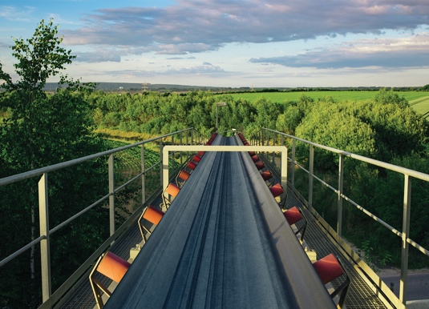  Continental_PP_EnergyLabel | The energy efficiency label helps conveyor belt systems operators make informed decisions in order to lower their energy consumption when selecting conveyor belts.
  Continental_PP_Michael_Hofmann | Michael Hofmann, responsible for Marketing Management at Continental Conveying Solutions
  Continental_PP_Sebastian_Seibold | Sebastian Seibold, responsible for Research & Development at Continental’s Conveyor Belt division

