Continental Inaugurates 200-Crore Greenfield Surface Solutions Plant in Pune
- Philip Nelles, Member of Continental Executive Board: “We want to strategically grow in the Asia-Pacific region and India will play a major role”
- Indian team will manufacture premium surface materials for car interiors and two-wheeler seats, largely catering to the domestic market
- New surface solution plant with focus on reducing environmental impact and lower the carbon footprint
Pune, India, April 8, 2022. Technology company Continental yesterday inaugurated its greenfield plant in Pune, India, manufacturing surface solutions materials mainly for the Indian automotive and two-wheeler market. With investments totalling about 2 billion Indian Rupee (more than 20 million Euro) covering facilities and machinery, Continental will produce premium surface materials for car interiors, including electric vehicles as well as two-wheeler seats, catering primarily to the domestic market and exports. “Growing our business in the Asia-Pacific region is one of our main strategic pillars. Amongst others, India will play a major role to strive for our goal. That’s why we continue to invest into our Indian locations. Thus, we will remain close to our customers maximizing value creation”, said Philip Nelles, Member of the Continental Executive Board and Head of Group Sector ContiTech at the inauguration ceremony in Pune.
Continental offers a wide range of premium quality surface solutions to ensure that customers will have a variety of options of interior combinations to attract car buyers. Compared to natural leather, the company’s surface material products are durable, innovative, easy to maintain, and affordable. Keeping up with its sustainability focus Dr. Dirk Leiss, heading the business area Surface Solutions emphazied: “Premium vehicle interiors are increasingly becoming important for car users. Our surface materials provide both, luxury and comfort, improving the overall driving experience.” The new location is Continental’s sixteenth surface solutions plant globally, producing well-known surface materials like Acella Eco used by worldwide top car manufacturers and automotive brands. Dr. Leiss added: “Our surface solutions come with the guarantee of state-of-the-art quality and heritage of more than 300 years in the industry.”
Prashanth Doreswamy, President and CEO of Continental India explained, “Continental has been growing steadily in the Indian market. We have now invested in Pune, a significant and long-established hub for the automotive industry, and we aim to be our customers’ first partner of choice for surface solutions. With this, we reaffirm our commitment to the local market, aligned to our ‘in the market, for the market’ philosophy.”
Sustainability is a key driver
The 149,000 square feet (approx. 14,000-square-meters) manufacturing facility, with an initial annual capacity of five million square meters of surface materials can be scaled up to 10 million square meters. “We are committed to our environment and are doing a lot to ensure that we are constantly reducing our carbon footprint,” said Landry Tchapda, head of the surface solutions plant management. He further explained: “The new plant features best-in-class energy efficiency standards, sustainable production processes, an ergonomic work environment, 100 percent sewage and wastewater treatment as well, exhaust air treatment of all processes, and use of energy from renewable source.”
During the inauguration ceremony Tchapda also mentioned: “With skilled workforce and cutting-edge technology at our disposal, our production is world-class, to cater to the requirements of our customers. In addition to production, storage, logistics, purchasing, and sales, we have also scheduled resources and capacities for laboratories, design and product development. India is a promising market to grow. So, we expand our operations at a rapid pace. Our innovative surface solutions are available for a variety of car interior and two-wheeler applications and we strive to be making us the market leader in near future.”
The new surface solutions plant in Pune will primarily manufacture Acella Eco and Acella Lux materials, which add aesthetic value to vehicle interiors. Eco-friendly foam foil Yorn and Yorn Light will also be produced in the near future.

Continental develops pioneering technologies and services for sustainable and connected mobility of people and their goods. Founded in 1871, the technology company offers safe, efficient, intelligent and affordable solutions for vehicles, machines, traffic and transportation. In 2021, Continental generated sales of €33.8 billion and currently employs more than 190,000 people in 58 countries and markets. On October 8, 2021, the company celebrated its 150th anniversary.
Continental has been present in India for close to 50 years through technology partnerships (Continental Tires since 1974) and joint ventures for its various businesses. Today, the tier 1 automotive supplier, tire manufacturer, and industrial partner operate across India – with about 8000 employees across 13 locations, including seven plants that cater to the Indian market and a Technical Center that supports Continental's global R&D activities.
Press contact

Axel Schmidt
Head of Communications Surface Solutions
Continental
Phone: +49 7947 81 522
Email: axel.schmidt@continental-corporation.com

Asad Ghalib Pasha
Corporate Communications
Continental Automotive India
Phone: +91 9886646959
Email: asad.ghalib.pasha@continental-corporation.com

Press portal: www.continental-press.com
Media center: www.continental.com/media-center
LinkedIn: www.linkedin.com/showcase/continental-industry
Twitter: www.twitter.com/Conti_Industry

Pictures and captions
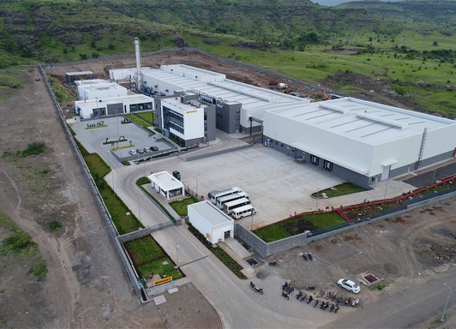  Plant | Continental inaugurates Surface Solutions India plant in Pune.
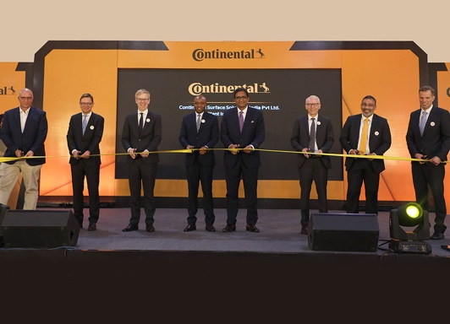  Ribbon Cutting | Ribbon Cutting From left: Dr. Juergen Morhard, Consul General of theFederal Republic of Germany; Alexander Jockisch, Head of Sales Business Area Surfaces; Philip Nelles, Member of Continental Executive Board and Head of Group Sector ContiTech; Landry Tchapda, Head of Surface Solutions Plant Management India; Prashanth Doreswamy, President and CEO of Continental India; Dr. Dirk Leiss, Head of Continental Surface Solutions Business Area; Nagendra Pai, Country Head Sales and Service Organization Conti Tech,, India; Dr. Steffen Reinsch, Head of Global Operations Surface Solutions.
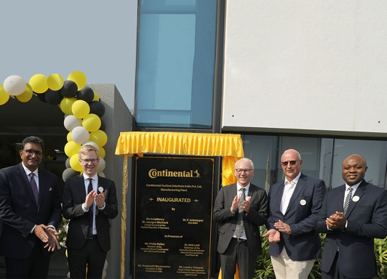  Inauguration Stone Unveiling | Unveiling of the inauguration stone (from left): Prashanth Doreswamy, President and CEO of Continental India; Philip Nelles, Member of Continental Executive Board and Head of Group Sector ContiTech; Dr. Dirk Leiss, Head of Continental Surface Solutions Business Area; Dr. Juergen Morhard, Consul General of the Federal Republic of Germany; Landry Tchapda, Head of Surface Solutions Plant Management India.

