More Efficient and Sustainable: Continental Plans to Invest in Steel Cord Conveyor Belt Production in Brazil
- Technology company to invest 25 million euro for expansion of production facilities in Brazil and push further its transformation efforts towards carbon neutrality
- Response to Continental’s continuous growth in the South American market
- Start of production of the new facilities and machinery is tentatively scheduled for early 2024
Brasilia, Brazil, February 16, 2022. Continental plans to significantly expand its capacities in Brazil with an investment of 25 million euro (more than 160 million Brazilian Real). “At the moment, we are negotiating a tax incentive package with some states in Brazil to confirm the final location in February", says Hannes Friederichsen, heading the global conveying solutions activities at Continental. “The additional capacity will ensure that we can better meet the growing need for high strength belts – with a strength higher than 6000N/mm and up to 10000 N/mm – used in mining operations throughout the South American market.”
Additionally, the expansion of mixing areas is planned and will accommodate future compound demand. Further activities in the pipeline: building expansion and installation of a press line.
This investment will ensure that Continental can equip the chosen plant with the latest conveyor belt manufacturing technology. These changes would then help lead the way for Continental’s sustainability goal of being complete climate neutral along the entire value chain by 2050 at the latest. Since the end of 2020, all purchased electricity for the company’s manufacturing sites worldwide has been switched to green power and is already climate neutral. By 2040, Continental’s entire own production will be climate neutral. Correspondingly, as part of the expansion, Continental is working to improve the chosen plant’s ecological footprint by making the production 100 percent carbon neutral – similar to its plant in Santiago de Chile, Chile.
Furthermore, as part of the Continental Recycling Initiative, the business area Conveying Solutions, serving the global raw material industries with solutions around bulk material handling, is exploring sustainability options for recycling as well as for the refurbishments of belts.

“Around the globe, Continental is committed to employing and providing the safest and most sustainable solutions in the mining industry,” says Friederichsen. “By far the world's largest regional market for heavy steel cord belts is in South America, determined by the three countries Brazil, Chile and Peru. With the planned expansion, we are therefore responding to the ever-rising local demand for ores like iron and copper as a result of urbanized and electrified mobility. We are supplying this market with two production sites, one in Ponta Grossa and one in Santiago de Chile. By continuing to produce locally, we reduce CO₂ emissions and can save transportation costs. This is part of our commitment to a sustainable future.“
Continental develops pioneering technologies and services for sustainable and connected mobility of people and their goods. Founded in 1871, the technology company offers safe, efficient, intelligent and affordable solutions for vehicles, machines, traffic and transportation. In 2020, Continental generated sales of €37.7 billion and currently employs more than 192,000 people in 58 countries and markets. On October 8, 2021, the company celebrated its 150th anniversary.
Press contact

Antje Spormann
External Communications ContiTech Group Sector
Continental
Phone: +49 511 938-1304
Email: antje.spormann@continental.com

Press portal: www.continental-press.com
Media center: www.continental.com/media-center
Twitter: www.twitter.com/Conti_Industry
LinkedIn: www.linkedin.com/company/Continental-Industry
YouTube: www.youtube.com/c/ContinentalIndustry

Picture/caption
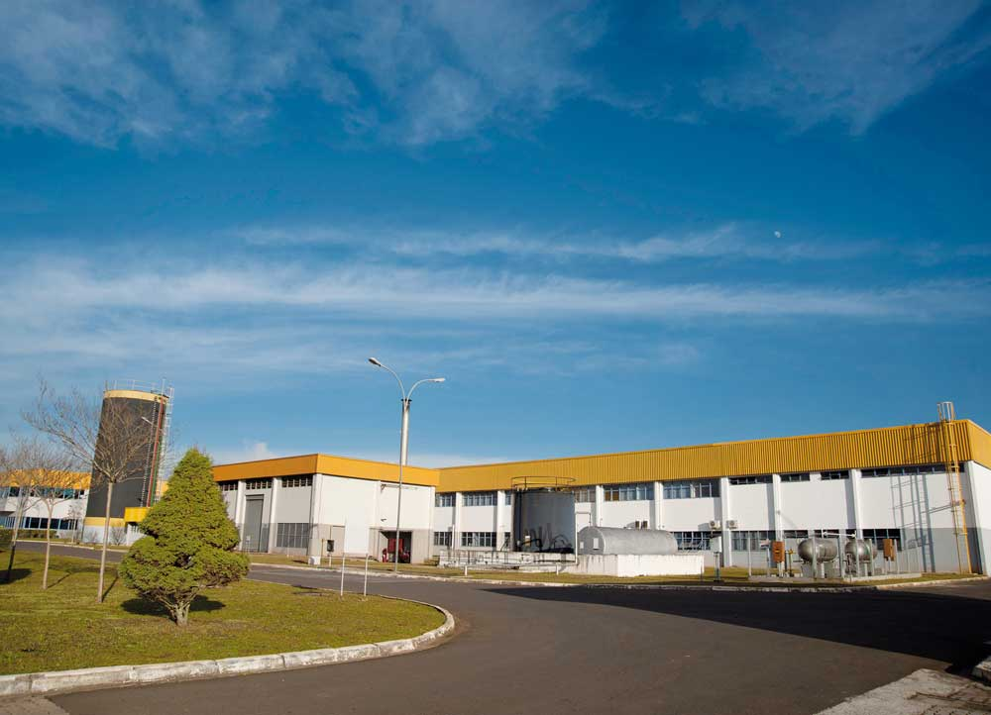  Continental_PP_Brasilien | Continental plans to invest further in Brazil. A plant in Ponta Grossa already manufactures conveyor belts there.

