With its ContiHome, Continental Provides a Glimpse of the Future of Living
- Continental equips an entire house with its own materials
- Tiny house demonstrates competence in the construction and furniture industries with a multitude of surfaces
- Showroom shows possible solutions for rising rent costs, lack of living space, and resource scarcity
Hanover/Weißbach, Germany, February 3, 2022. With its tiny house, the technology company Continental has achieved something that construction and furniture suppliers have long dreamed of: equiping an entire house with nothing but its own materials – inside and out. “Our new showroom is called ContiHome and shows the diverse options that we offer with our broad palette of products,” Ralf Imbery, Director of Innovation, Transformation, and Design at Continental, explains. “A house that was developed from the ground up with our competence in the construction and furniture industries and our surface know-how.” Continental hasn’t simply furnished any building with its own materials, but rather conceived, designed, and built the complete show house itself. The result of all of this is a smart and mobile tiny house that reflects current trends and also provides a glimpse of the future of living, making the entire portfolio of products tangible at trade fairs and events.
Comfortable and sustainable living in a small space
“Micro housing” and “minimalism” are two trends reflected in the ContiHome because tiny houses are an answer to rising rent costs, lack of living space, and resource scarcity. Whether you are sleeping, cooking, eating, relaxing, or working, the ContiHome makes it all possible in just 32 sqm of floor space. This is achieved by means of a holistic design concept consisting of various surface materials, design elements, and functional areas that can be selected as needed. Coordinated entertainment and mood elements, such as lighting and sound, can be easily controlled by app or a touchscreen located at the entry door. You can create atmospheres to optimally support any use. ContiHome makes living in a small space not only environmentally friendlier than in a large house, but also simultaneously more comfortable.
Mobile and flexible
The primary virtues of the ContiHome are its mobility and flexibility. Mounted on a trailer, its location can be changed at any time. It is also fully furnished. The multi-functional furniture, which serves as a sideboard, workstation, or eating area, is particularly flexible, as are the retractable deck and the hidden storage compartments in the stairs and seating area. The concealed electric fireplace in the kitchen is also a smart solution. It works with steam and can be used as a room divider.
Long-lasting and recyclable surfaces
The furniture, floors, walls, windows, façades, and deck are all covered in easy-to-care-for and long-lasting surfaces by Continental and demonstrate our core competencies in the areas of haptics, design, functionality, aesthetics, and comfort. One of our goals was to fulfill the desire for sustainable products that many consumers have through the use of recyclable materials. As a result, the laminated window profiles can be 100 percent recycled and can be utilized to manufacture new window elements for a second lifecycle. “In general, we strive for longevity in our developments, everything is geared towards ensuring that our materials can be used for as long as possible,” Imbery clarifies the goal of the surface specialists at Continental.
Holistic design concept
In small spaces in particular, where sensory perceptions are concentrated, it is important that the various materials, forms, and colors harmonize with each other in an optimum fashion. Holistic design also plays an important role with regard to the varied life situations for which the ContiHome can be used. It is characterized by industrial design and is distinctive, rectilinear, and pragmatic. In order to ensure that coziness does not take a backseat to modernity, warm natural colors are used in addition to the popular black and anthracite tones.
One example of the individual accents is the wallcovering in the sleeping area, which is made of digitally printed artificial leather. An innovative highlight is the clock in the ContiHome. It shows the time using a backlit translucent material. The creative potential is also reflected in the design of the façade. Here, there is a surprising mix of materials, with an authentic wood look and extremely matte dark surfaces.
“With our ContiHome, we want to invite customers and partners to think outside the box,” says Ralf Imbery. “That is why we have combined the various characteristics of our products in a single project – innovative, designed with functional surfaces, sustainable and intelligent. And we inspire a new way of thinking.”
–––––––––––––––––––––
Information box: why small houses are booming
Two years of the pandemic have once again given an additional push to two lifestyle mega-trends: home offices and social cocooning (preferring to meet with family, friends, and acquaintances at home rather than going out together). Both trends have led us to spend more time at home. This makes the furnishing of our own four walls more important. Many people’s priorities have shifted toward a minimalist, sustainable home. This has been supported by a survey of the market and opinion research institute YouGov. It found that interest in tiny houses has more than doubled during the past one and a half years. In addition to concentrating on what is important, increasing real estate prices and construction costs as well as construction material supply bottlenecks have contributed to this. As a result, around 23 percent of people surveyed could imagine living in a tiny house.
–––––––––––––––––––––

Continental develops pioneering technologies and services for sustainable and connected mobility of people and their goods. Founded in 1871, the technology company offers safe, efficient, intelligent and affordable solutions for vehicles, machines, traffic and transportation. In 2020, Continental generated sales of €37.7 billion and currently employs more than 192,000 people in 58 countries and markets. On October 8, 2021, the company celebrated its 150th anniversary.
Press contact

Axel Schmidt
Head of Communications Surface Solutions
Continental
Phone: +49 7947 81 522
Email: axel.schmidt@continental-corporation.com

Press portal: www.continental-press.com
Media Center: www.continental.com/media-center
Website: www.continental-industry.com/en/campaigns/contihome

Images/captions
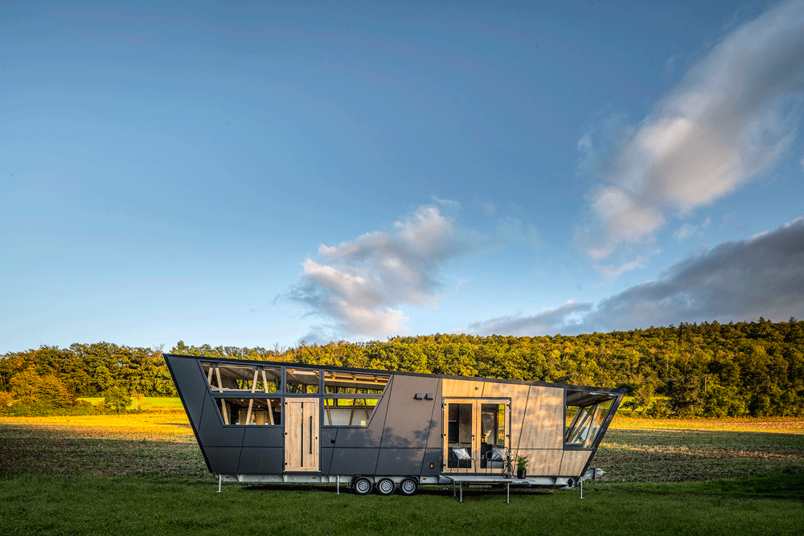  Continental_PP_ContiHome | A smart and mobile tiny house that reflects current trends and also provides a glimpse of the future of living: the ContiHome.  Photo: Continental
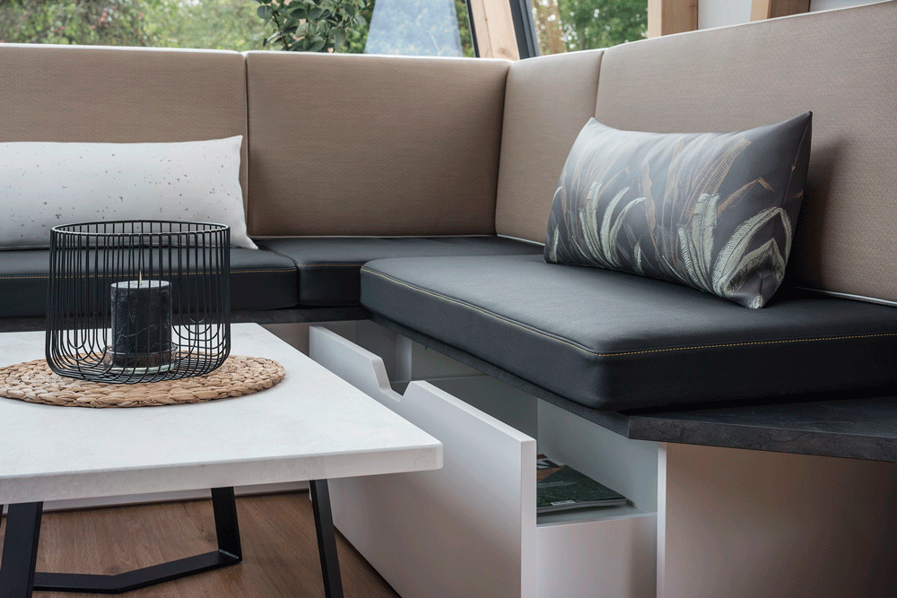  Continental_PP_SmallSpace | The multi-functional furniture in the ContiHome offers a lot of room in a small space.  Photo: Continental
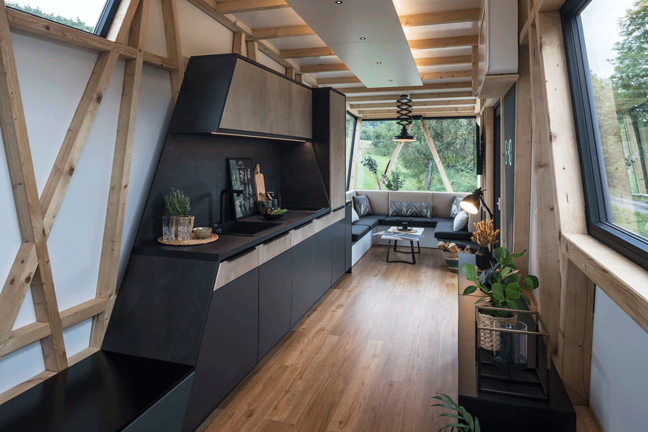  Continental_PP_Design | The ContiHome is characterized by a holistic design concept.  Photo: Continental
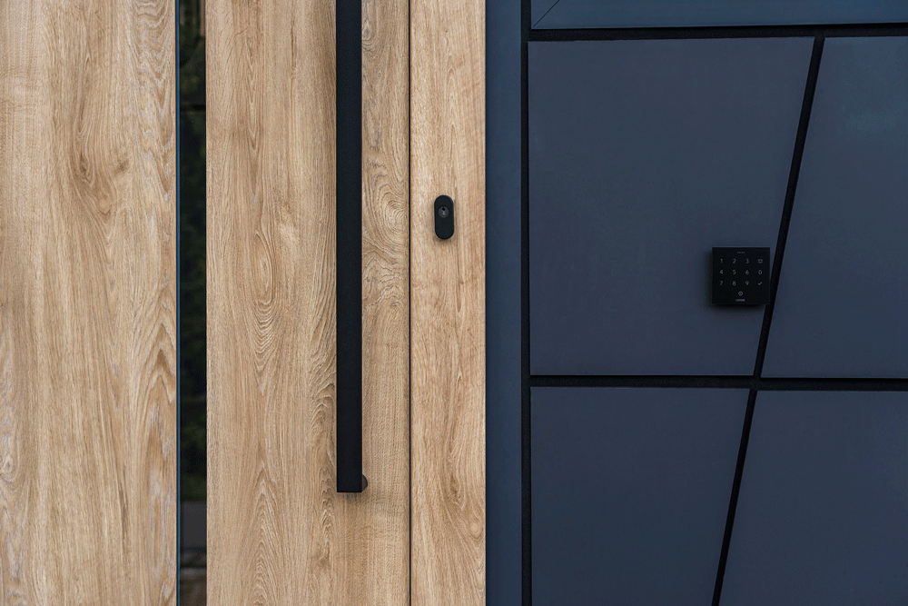  Continental_PP_SurfaceTechnology | The ContiHome bundles the surface technologies of Continental – not just inside, but also outside.  Photo: Continental
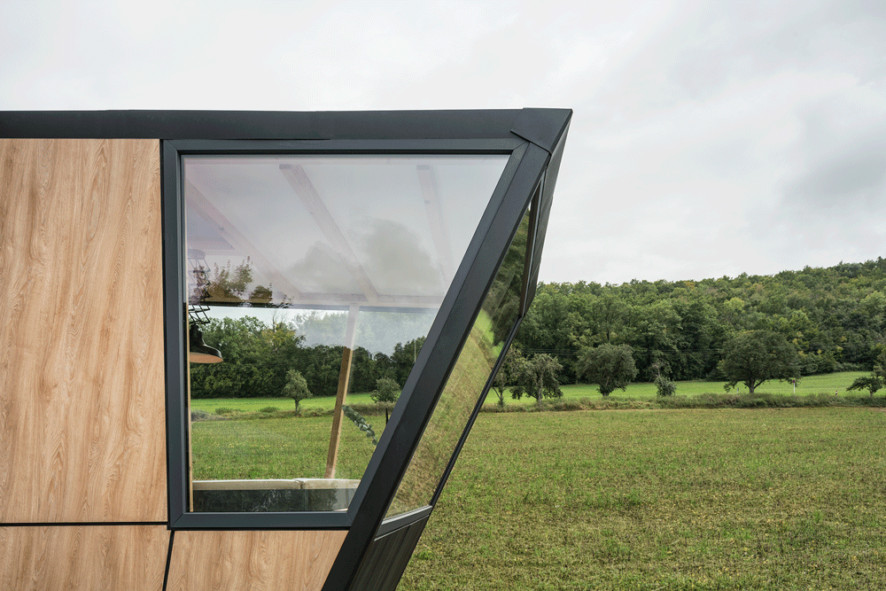  Continental_PP_Sustainability | The laminated window profiles can be 100 percent recycled and can be utilized to manufacture new window elements for a second lifecycle.  Photo: Continental
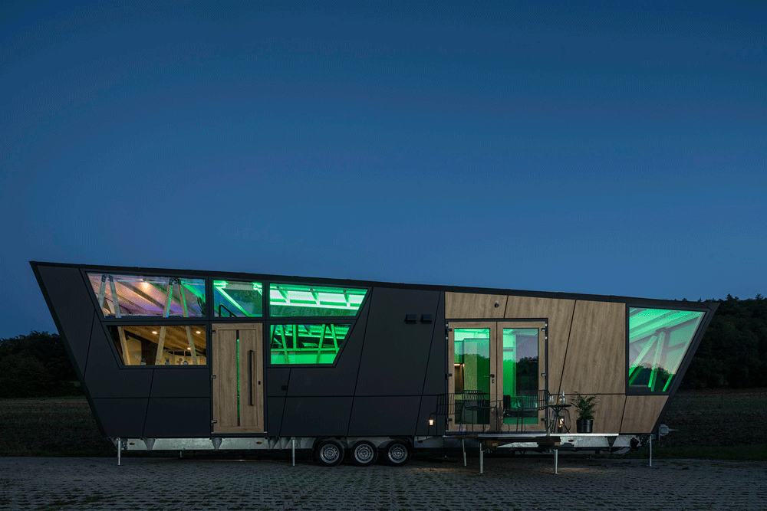  Continental_PP_SmartHome | Mood elements, such as lighting and sound, create the right atmosphere for any occasion. They can be easily controlled via app or using a touchscreen located at the entry door.  Photo: Continental

