Continental further Strengthens Industrial Business with Acquisition of the Vulk & Montage Group in Sweden
- Continental further expands its range of services in the important industrial area of central Sweden
- The operations will be integrated into Continental’s Conveying Solutions business area, one of the leading specialists for conveying and off-highway solutions worldwide
- The Vulk & Montage Group is a leading service provider for the conveyor industry in Central Sweden
Stockholm, Sweden, September 8, 2022. Continental has acquired the conveyor and maintenance company Vulk & Montage, based in Karlstad, Sweden. This acquisition complements the portfolio of Continental and establishes the technology company in the heart of Sweden’s industrial area. “With the Vulk & Montage Group, we are able to offer an entire service & solution package in addition to the current Continental product portfolio to our industrial customers in Central Sweden. The acquisition underscores again our goal of further expanding our service business directly with our customers and aligning our focus accordingly,” explained Song Qi, who is responsible for the global business with conveyor belt system solutions at Continental. Completion of the acquisition is subject to approval by the competent antitrust authorities. The two parties have agreed not to disclose the purchase price.
Vulk & Montage has four locations in Karlstad (Headquarters), Örebro, Mora and Stockholm, Sweden. The company is a leading service provider for the conveyor industry in central Sweden, operating out of their four branches and one rubber workshop. Vulk & Montage provides add-on products such as belts, belt scrapers, industrial hoses, screens, wear rubber, lightweight conveyor belts, technical plastics and additional services like lining (cold and hot), spraying polyurethane, sandblasting, and paintwork.
Continental’s Conveying Solutions is one of the world’s leading specialists in conveying and off-highway solutions, with customers in key industries such as mining, agriculture, automotive and plant engineering. Beyond its comprehensive product portfolio, Conveying Solutions’ goal is to respond to specific customer needs and to provide holistic and efficient solutions for every conveying task in the most environmentally friendly way possible – from plant design, production and installation to preventive maintenance and repair. Conveying Solutions has more than 5,800 employees at 54 locations in 16 countries.
Continental develops pioneering technologies and services for sustainable and connected mobility of people and their goods. Founded in 1871, the technology company offers safe, efficient, intelligent and affordable solutions for vehicles, machines, traffic and transportation. In 2021, Continental generated sales of € 33.8 billion and currently employs more than 190,000 people in 58 countries and markets. On October 8, 2021, the company celebrated its 150th anniversary.

Press contact

Sébastien Bonset
External Communications Manager
Group Sector ContiTech
Phone: +49 511 938-10422
Email: sebastien.bonset@continental.com

Press portal: www.continental-press.com
Media center: www.continental.com/media-center

picture/caption
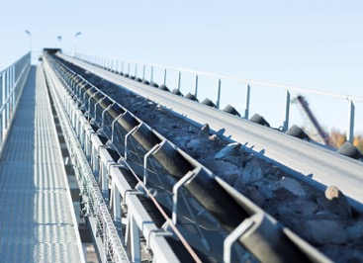  Continental_PP_Quarry_Jehander | At Jehander’s quarry, Continental conveyor belts are being used for the smooth transportation of rubble from the Stockholm mega-tunnel so that it can be reused for the road construction requirements involved in the infrastructure project.

