Smart factory: Continental plans largest investment in a decade in Korbach hose production
- Planned investment of around five million euros for new production line for greater flexibility
- Automated and networked plant will optimize existing manufacturing and enable production of new products
- With new standards for ergonomics and safety: Start of production in Korbach planned for the end of 2023
Korbach, Germany, May 16, 2022. New production technologies, new applications, new customers: Continental plans to invest around five million euros in a new plant for the production of industrial hoses at its Korbach site. The production line, which will operate around the clock seven days a week, is scheduled to start up at the end of 2023. This is the largest investment in Korbach in over ten years.
With the new line, the technology company can manufacture existing products even more efficiently, while at the same time expanding its portfolio and increasing its competitiveness. Goals: To optimally position the Korbach site for the future and further expand the business areas, particularly in the industrial sector. “The new line will improve our manufacturing process enormously. We are producing more sustainably, more flexibly, more safely and more ergonomically,” emphasizes Torsten Dietmann, head of the hose plant in Korbach, adding: “Networked and automated plant elements based on a smart factory approach guarantee energy-efficient production and ideal value creation in the process.” ContiTech reacted very prescient to house the new S-Line. Trough efficiency measures in one of the production halls space for the new plant and thus also for innovative technologies was already created at an early stage.
More efficient, flexible and sustainable production
With a capacity of around five million meters per year, the new production line in Korbach in northern Hesse will soon be able to manufacture industrial hoses with an inside diameter of up to 38 mm – for food and water, but also for fuels or coolants.
A major plus of the new line is its flexibility: It can produce hoses using different techniques, with inner layers of either rubber or plastic. Thus, both rubber hoses and hybrid hoses made of these two materials are produced on it.
“This gives us tremendous flexibility. On the new plant, we are continuing to manufacture standard products, but also adding new applications. This enables us to better adapt to rapidly changing market needs and expand our product portfolio in a focused manner,” says Dietmann.
Continental’s investment is not just about greater product diversity and increased competitiveness – it also focuses on the issue of sustainability. Thanks to the additional materials expertise and various recycling options, the Korbach site is taking an important step toward climate-neutral production, in line with the Group-wide strategy.
Similarly, the topic of sustainability is an important component of the new “Site Perspective” company agreement, which came into force in January. Following this, the Korbach site is striving for sustainable and self-sufficient production. To make the tires of the future even more energy-efficient and environmentally friendly in terms of production, use and recyclability, Continental is systematically investing in research and development of new technologies, alternative materials and environmentally compatible production processes. The company’s own cogeneration plant, which supplies the entire production facility with climate-friendly energy and heat, is just one of the projects that has already been implemented. Energy generation is based on recycling waste, which makes it possible to save fossil fuels and conserve natural resources.
A clear commitment to the location
“An investment doesn’t just mean spending money to modernize and digitize machines and technologies. First and foremost, it means trust – trust in our employees and the site,” Andreas Gerstenberger, Executive Vice President of the industrial section of the company in the USA, explains. “Our entire hose team in Korbach can be very proud of themselves, for what they have achieved and this investment: they have shown how strong they are in a difficult market environment. Creatively, flexibly and quickly, the colleagues have taken up the challenges, and made this important investment possible in the first place. It’s a clear commitment to Korbach as a location.”

Continental develops pioneering technologies and services for sustainable and connected mobility of people and their goods. Founded in 1871, the technology company offers safe, efficient, intelligent and affordable solutions for vehicles, machines, traffic and transportation. In 2021, Continental generated sales of €33.8 billion and currently employs more than 190,000 people in 58 countries and markets. On October 8, 2021, the company celebrated its 150th anniversary.
Every day, Continental’s plant in Korbach produces tires for passenger cars, industrial vehicles, bicycles and motorcycles, as well as hoses for the industrial and automotive sectors. The site currently employs over 3,500 people. A special highlight of Continental’s Korbach site is the High-Performance Technology Center (HPTC), which offers the opportunity to develop and test new manufacturing processes in tire construction.

Press contact

Kim Jeanette Neubauer
Korbach Site Communications Officer
Phone +49 5631 58 1043
Email: kim.jeannette.neubauer@conti.de

Sébastien Bonset
External Communications, ContiTech group sector
Phone: +49 511 938-14022
Email: sebastien.bonset@continental.com

Press Portal: www.continental-presse.de
Media center: http://continental.com/media-center

pictures/captions
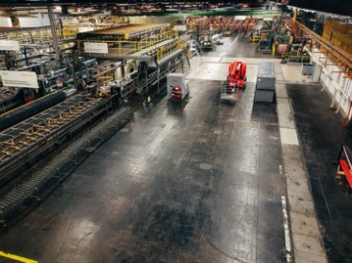  Continental_PP_Korbach_1 | Continental is planning to invest around five million euros in a new plant for the production of industrial hoses at its Korbach site in Germany.
  Continental_PP_Korbach_3_  Gerstenberger | Andreas Gerstenberger is the Executive Vice President of Continental’s industrial section in the USA.
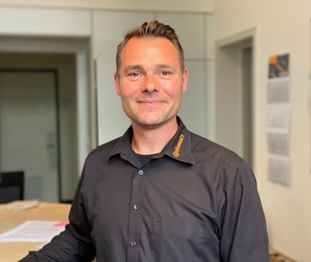 | Torsten Dietmann, head of the hose plant in Korbach, Germany.
Continental_PP_Korbach_4_
Dietmann

