IAA Mobility

AMBIENC3 Celebrates World Premiere in Munich: Continental Showcases Vehicle Interior of the Future
- Retro meets the future: VW T2 microvan conversion presents the latest surface solutions and innovative, sustainable materials and technologies
- AMBIENC3 concept vehicle previews what we can expect from the on-board equipment of vehicles in the years ahead; driving, working and relaxing define the interior of the future
- Continental concept vehicle focuses on sustainability, design, functionality, third space and customer orientation
Hanover/Munich, Germany, September 6, 2021. Driving, working and relaxing – three activities that are set to merge together in the digital, connected and sustainable vehicles of the future. With this in mind, Continental has developed close to the perfect vehicle interior. Visitors to the IAA Mobility event in Munich can experience the future of vehicle interiors inside the AMBIENC3, a concept vehicle in which everything is designed and imagined within a shared blueprint: stylish, light and robust surfaces for the floor, walls and ceilings, the seats, lounge and tables; natural, subtle and bright colors; warm, clearly defined lighting effects and unobtrusive sounds.
The AMBIENC3 houses driving, working and relaxing within a “third space”. The vehicle is brimming with new surface solutions made from innovative and sustainable materials. Speaking of sustainability, in keeping with the trend for upcycling, the AMBIENC3 is based on a VW T2 microvan. Already a vehicle of rich emotional charm, the T2 now also provides a meeting point for retro appeal and future direction. “With the AMBIENC3 we are connecting a globally renowned icon of the automotive world with new, intriguing surfaces and future-focused technologies, whose attributes assist driving, working and relaxing as effectively as possible and distinguish them through color, design and material,” says Ralf Imbery, Global Director Innovation, Transformation & Design at Continental’s surface experts. “With the AMBIENC3 we are demonstrating our expertise in terms of sustainability, design, functionality, ‘third space’ development and customer centricity. It sees us bringing together key drivers for the future of the mobile interior.”
Focus on sustainability
Continental has used natural and renewable raw materials in the development of the surfaces, as well as recycled and reclaimed materials, but avoided any compromise in quality: “Passengers in the AMBIENC3 can breathe freely thanks to low-emission, low-pollutant materials. Light surfaces also help to lower the vehicle weight,” underlines Imbery. “This reduces energy consumption – and, by extension, CO₂ emissions – and therefore also increases the driving range of electric vehicles.”
Natural, subtle, bright colors, plus gently flowing forms are defining elements of the AMBIENC3 interior and give it a cozy yet modern feel. The interior helps motivate passengers to work, but also encourages them to relax. Buttons and switches are nowhere to be seen. Although the functions in the AMBIENC3 are always intuitive to use, there are no permanently visible controls. Shy technology is the key here: in “off” mode the functions in the surfaces are invisible at first glance.
Design and function go hand in hand
Other innovative highlights of the Continental concept vehicle include a light and sound concept that creates different moods, and heatable materials. Made using functional printing methods, these can generate heat in seconds. Other surfaces in the AMBIENC3 are distinguished by special attributes such as optimized soiling characteristics, maximum abrasion resistance and even self-healing in the event of damage.
Continental also has an eye on the megatrend of autonomous driving with the AMBIENC3. By the time fully automated driving has arrived – if not before – we will be using time spent in a car for other activities besides steering, accelerating and braking. Alongside the driving zone, the new concept vehicle therefore also offers working and relaxing areas, each with their own approach to design and materials. And as we focus inwards, so the surfaces employed here will become ever more important. This will ultimately lead to an upgrading of vehicle interiors; they will need to be more visually appealing and the surfaces should also provide a haptic experience. The different activities will be enhanced with mood functions such as light and sound. The concept underpinning this fusion of living and working areas in a vehicle is known by the term “third space”.
Customized solutions, innovative technologies
The AMBIENC3 sets new standards, not least in customer orientation. With solutions and surfaces that can be customized using digital printing techniques, Continental is presenting automakers with a host of options when it comes to tailoring vehicles to their customers’ individual requirements, upgrading interiors with new and surprising functions, and ensuring connectivity.
Featuring technologies developed by Continental, the surfaces in the AMBIENC3 stand out as genuine all-rounders. For example, staynu (i.e. “stay new”) technology makes surfaces more dirt resistant, easier to look after and more robust than ever. As the name implies, this technology helps the material to stay (and look) “as new” for longer. Material equipped with this protection is used for the driver’s seat in the AMBIENC3. Stains are no longer an issue, and the material is long-lasting, low-cost and environment friendly.
Other surfaces in the AMBIENC3 use laif technology, which delivers outstanding breathability – i.e. it allows air and water vapor to pass through – and an exceptional soft feel. An agreeable side effect of this new technology is that the breathable surfacing provides passive temperature control. Offering the look and feel of real leather, surfaces with laif technology provide an excellent alternative for which no animal need give up their life.
Continental – leading the way in mobility for 150 years
“There is impressive teamwork behind the new concept vehicle,” explains Imbery. “Taking their place alongside the futuristic surfaces in the concept vehicle are innovative technologies and solutions, such as the speaker-less audio system Ac2ated Sound, the ProViu 360 camera system enhancing safety on the road, the photovoltaic charger on the vehicle roof for sustainable energy generation, Intelligent Glass Control, the eTravel.Companion and DAB radio with USB and Bluetooth connectivity.”
And it isn’t only the AMBIENC3 that stands for tradition and the future, but Continental as a whole. Indeed, mobility has provided the heartbeat of the company for 150 years now – and will continue to do so. “The AMBIENC3 is something you really need to feel, to sense, to experience,” sums up Imbery. That’s why Continental is inviting all visitors to the IAA Mobility event in Munich on September 7-12, 2021 to enter the AMBIENC3 – and get acquainted with the future of vehicle interiors today. For a comprehensive overview of the new concept and all its details, see also the AMBIENC3 multimedia web portal.
Continental develops pioneering technologies and services for sustainable and connected mobility of people and their goods. Founded in 1871, the technology company offers safe, efficient, intelligent and affordable solutions for vehicles, machines, traffic and transportation. In 2020, Continental generated sales of €37.7 billion and currently employs around 233,000 people in 58 countries and markets. In 2021, the company celebrates its 150th anniversary.
Press contact

Axel Schmidt
Head of Communications Surface Solutions
Continental
Phone: +49 7947 81 522
Email: axel.schmidt@continental-corporation.com

Press portal: www.continental-press.com
Media center: www.continental.com/media-center
Website: www.continental-industry.com/en/campaigns/ambienc3

pictures/captions
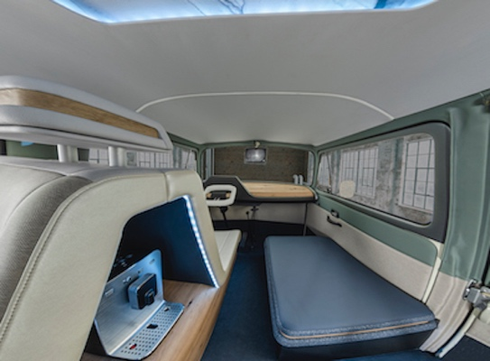  Continental_PP_AMBIENC3_1 | “Third space” is the term used to describe the concept presented by the AMBIENC3 which brings together driving, living and working areas.
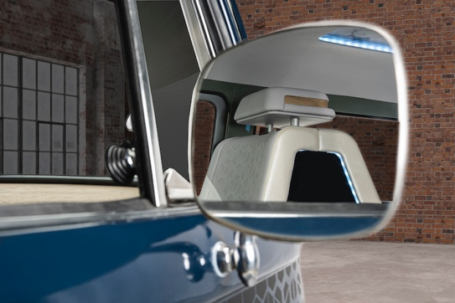  Continental_PP_AMBIENC3_2 | Looking back as well as forwards: In the AMBIENC3, retro meets visionary, connecting the past, present and future of mobility.
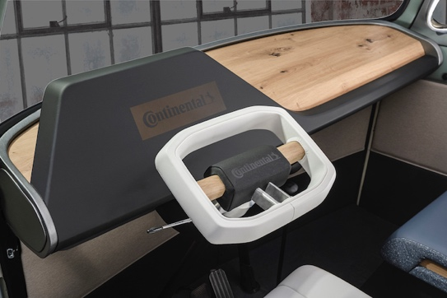  Continental_PP_AMBIENC3_3 | The driver’s seat of the future: A stylish, natural wood look shares the space with a high-tech cockpit including the eTravel.Companion.
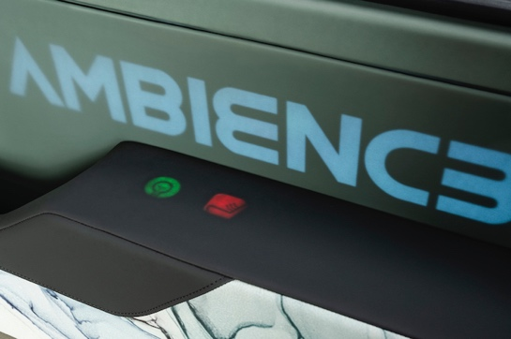  Continental_PP_AMBIENC3_4 | The on-board functions are always intuitive to use, but there are no permanently visible controls. Shy technology is the key here.
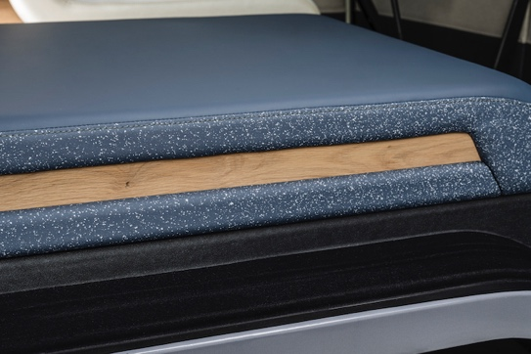Continental_PP_AMBIENC3_5 | Continental used natural and renewable raw materials, as well as recycled and reclaimed materials in the development of the interior surfaces.
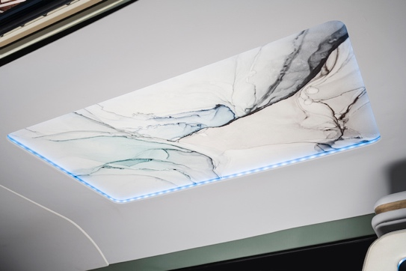  Continental_PP_AMBIENC3_6 | The interior helps motivate those on board to work, but also invites them to relax.
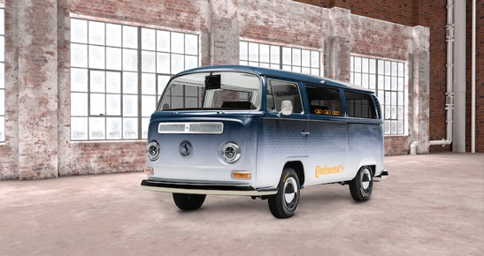  Continental_PP_AMBIENC3_7 | Retro meets futuristic: In keeping with the trend for upcycling, the AMBIENC3 is based on the VW T2 camper van – a vehicle of rich emotional charm.
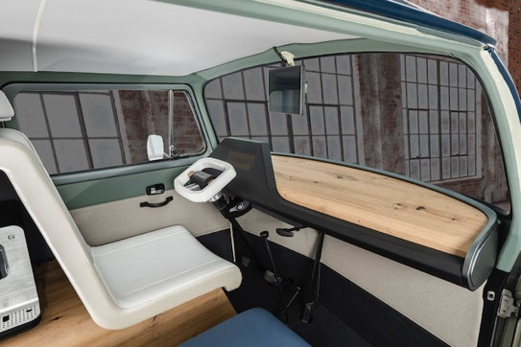  Continental_PP_AMBIENC3_8 | On the road to autonomous driving: A natural wood look adorns a high-tech cockpit with shy technology.
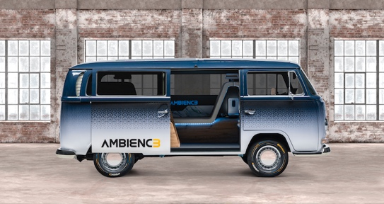  Continental_PP_AMBIENC3_9 | One highlight of the concept vehicle from Continental is a light and sound concept that creates different moods.

