A digital solution for the logistics industry – Fleetmatch makes fleets more effective and truck drivers happier
- Fleetmatch from Continental combines a job portal for fleets with app-based loading dock evaluation for drivers
- Digital solution tackles the challenges of the logistics industry and innovatively contributes to the mobility of the future
Hamburg, Germany, November 18, 2020. Technology company Continental has developed a digital solution that puts logistics companies and professional drivers in contact with one another easily and effectively. Fleetmatch is a platform that not only functions as a job portal geared to logistics fleets, but also – as an app – enables drivers to view job offers and rate loading docks, all from their smartphone. The application is meanwhile seeing extensive use in the Hamburg metropolitan region, with its strong logistics sector.
Fleetmatch addresses the needs of the logistics industry
With Fleetmatch, Continental is stepping up to meet two challenges: the shortage of professional drivers on the market, and the widespread underappreciation of this occupation. Portions of logistics fleets often stand idle for lack of drivers: in Germany alone, there's a shortage today of more than 40,000 trained professional drivers. This shortfall has a particularly negative impact on major logistics locations such as Hamburg. “We get professional drivers behind the wheel of the right trucks in the shortest time possible by matching up the expectations of drivers and fleets,” says Roger Bunzel, who's leading in managing the Fleetmatch project. As an add-on, drivers can use the function for rating loading docks and bays: “The lack of appreciation is a major deficiency in this industry plagued by time pressure. It must be absolutely frustrating for any driver who, after successfully detouring around a traffic jam, ends up having to wait forever for a free loading dock,” Bunzel explains.
Job-matching offers both drivers and fleets the opportunity to find each other
It only takes a few minutes for fleet managers to place their company profile and job advertisements online on the website. A unique selling point of Fleetmatch is the active search via filters for drivers with specific qualifications, making it possible to contact specific drivers in targeted fashion: if a driver matches a specific job, the fleet can unlock the corresponding driver profile. While this unlocking is subject to a fee for fleets searching on the website, the app is available to all drivers free of charge. In the web-based solution, companies only see professional
drivers who have released their profile for job matching, i.e. the potential to match a driver with a fleet. Job providers and job seekers can then find a number of ways to get together: drivers can proactively swipe a job offer to the right in the smartphone app, and his application is transmitted to the fleet, while fleet managers can either wait for applications for their job vacancies, or use the active search function to unlock selected driver profiles.
In addition to the system's core function – job matching –, many professional drivers also make extensive use of the loading dock evaluation function, assigning stars based on three criteria: Was I treated with appreciation? How were the loading/unloading conditions? Was the waiting time reasonable? “Thanks to these loading dock ratings, Fleetmatch gives drivers a strong voice and sends a clear signal calling for greater appreciation of this essential occupation,” notes Bunzel.
The Fleetmatch app has already been downloaded more than 30,000 times
With its functions, design, and overall concept, Fleetmatch has really struck a chord with the industry. In the 16 months since its launch, the app has been downloaded more than 30,000 times from the Google Playstore, and 4.5 million Facebook users have been reached via the Fleetmatch Facebook page. Several thousand loading dock ratings have meanwhile been received, along with many positive responses from drivers, fleet managers, and industry associations and experts. Hotspots reflect the real, actual economic and infrastructural conditions on site. For example, while the app has been downloaded just as much in the Rhine-Main conurbation and the Ruhr region as in the Hamburg metropolitan area, in actual fact more than 2,000 companies provide the port of Hamburg with road-based goods transport, and the logistics industry in this trading city of the old Hanseatic League is served by a workforce numbering some 250,000. “Fleetmatch helps to increase the efficiency of the entire fleet and improves driver motivation and satisfaction. It also enhances road safety when well-trained professional drivers are moving the loads from A to B,” explains Bunzel, summing things up. And there are already lots of ideas for new app functions: "It's not a question of whether we'll continue to develop the system, but rather of what our next steps will be."
Fleetmatch – a product born of the company's own cross-divisional expertise
Focusing on market needs is key – and for onward development of this digital solution, too. The application was created as part of an international project for new business models that Continental as a technology company launched in September 2018. The initial five-person
Fleetmatch team in Hanover was also advised by digital experts at Continental's Innovation and Digitalization division in Hamburg. “It's extremely helpful to find such capable sparring partners within your own company,“ says Roger Bunzel.
Continental develops pioneering technologies and services for sustainable and connected mobility of people and their goods. Founded in 1871, the technology company offers safe, efficient, intelligent, and affordable solutions for vehicles, machines, traffic and transportation. In 2019, Continental generated sales of €44.5 billion and currently employs more than 233,000 people in 59 countries and markets.
Press contact

Jochen Vennemann
External Communications Manager
ContiTech
Phone: +49 511 938-18024
Email: jochen.vennemann@contitech.de

Press portal www.continental-press.com
Media center www.continental.com/media-center
Internet www.fleetmatch.app
Social media www.facebook.com/fleetmatch

pictures/captions
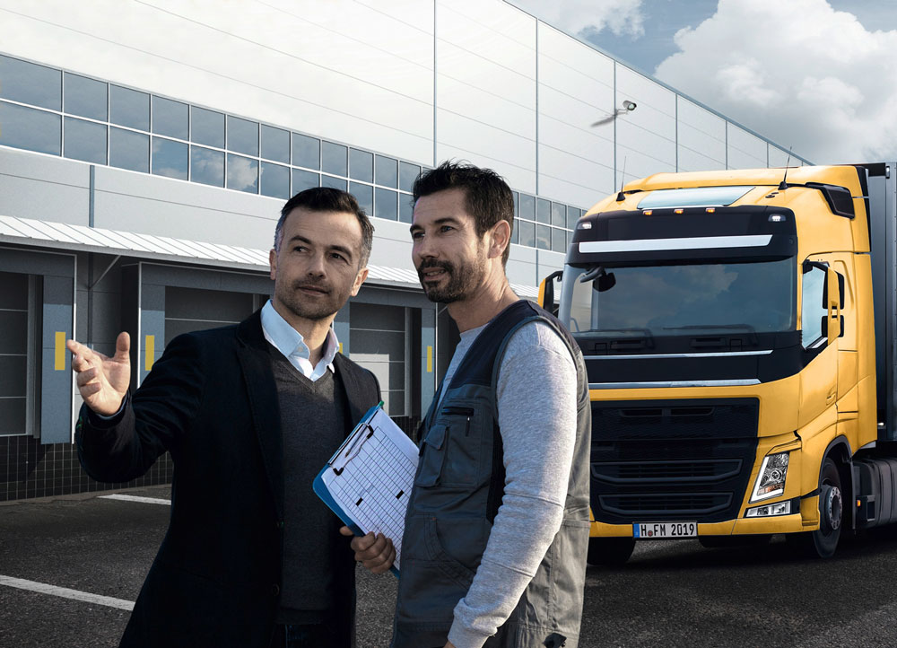  Continental_PP_Fleetmatch_01.jpg | With the digital Fleetmatch solution, Continental connects fleets and qualified professional drivers.
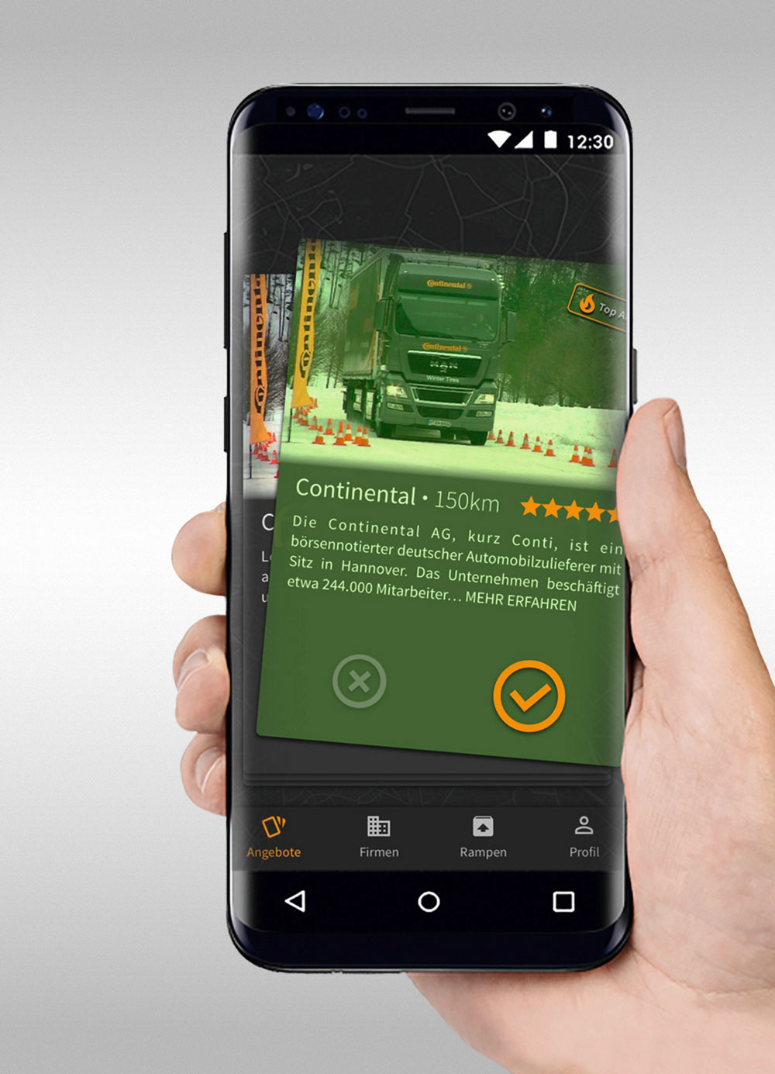  Continental_PP_Fleetmatch_02.jpg | The Fleetmatch app has already been downloaded more than 30.000 times.
  Continental_PP_Fleetmatch_03.jpg | Roger Bunzel is leading Marketing & Sales in Continental’s Fleetmatch project.

