Everything at a glance – Continental launches web portal for the automotive aftermarket
- Clearly arranged – the technology company bundles information about all offers for the independent aftermarket on one website
- Uncomplicated – find the right spare parts with the new online catalog
- User-friendly – seven languages and a responsive design
Schwalbach/Hanover, January 21, 2020. The technology company Continental is bundling information about its product and service portfolio for the automotive aftermarket in a new online portal. In the future, workshops and dealers will be able to see at a glance all the Continental products, brands and services that support the independent aftermarket. “As one of the largest automotive suppliers and tire manufacturers in the world, we develop technologies for the future. We make our comprehensive know-how and our product and service portfolio available to our partners in the spare parts market. We already offer a wide range of products, including tires, drive components, electronics, brakes and diagnostic solutions – and we’re continuously expanding this portfolio. In a longer-term perspective, we intend to offer everything for future mobility from one single source – and this includes the relevant services, training courses and sales promotion concepts for workshops and dealerships. An information platform that can handle this is indispensable,” says Stefan Doetsch, Head of Sales for the Independent Aftermarket business unit at Continental.
Searched for & quickly found – online catalog helps to identify spare parts
For the first time, Continental is now providing a free and comprehensive online catalog that brings together all brands and products. This will enable dealers and workshops to easily identify the right spare part from the range on offer. The right contact person for a product group can also be found easily and quickly – and explanatory and product videos are also available.
The website will be initially available in seven languages: German, English (US and international), French, Italian, Russian, Serbian and Spanish – and the technology company is gradually expanding the offer. The website also recognizes the country from which it is being accessed and automatically opens in the correct language. The developers have also placed great emphasis on a design that is user-friendly and responsive, so the site is always clearly presented – regardless of whether it’s being accessed from a computer, tablet or smartphone.
Workshops and dealers can access the online portal at www.continental-aftermarket.com.
Continental develops pioneering technologies and services for sustainable and connected mobility of people and their goods. Founded in 1871, the technology company offers safe, efficient, intelligent, and affordable solutions for vehicles, machines, traffic and transportation. In 2018, Continental generated sales of €44.4 billion and currently employs more than 240,000 people in 60 countries and markets.
Drawing on more than 120 years of cooperation with vehicle manufacturers, Continental offers a broad range of spare parts in OEM quality for the aftermarket. Under brands like Continental, Uniroyal, Semperit, ATE, VDO and GALFER, the technology company manufactures tens of thousands of products, including tires, brakes, drive components and thermal management components. It also provides diagnostic solutions, tools and services for repair shops. Continental is one of the most important suppliers in the independent automotive aftermarket.
Press contact

Christopher Schrecke
Head of Media Relations/Internal Communications
Commercial Vehicles & Services
Continental
Phone: +49 69 7603-2022
E-mail: christopher.schrecke@continental-corporation.com

Press portal: www.continental-press.com
Media center: www.continental.com/media-center

Pictures and captions
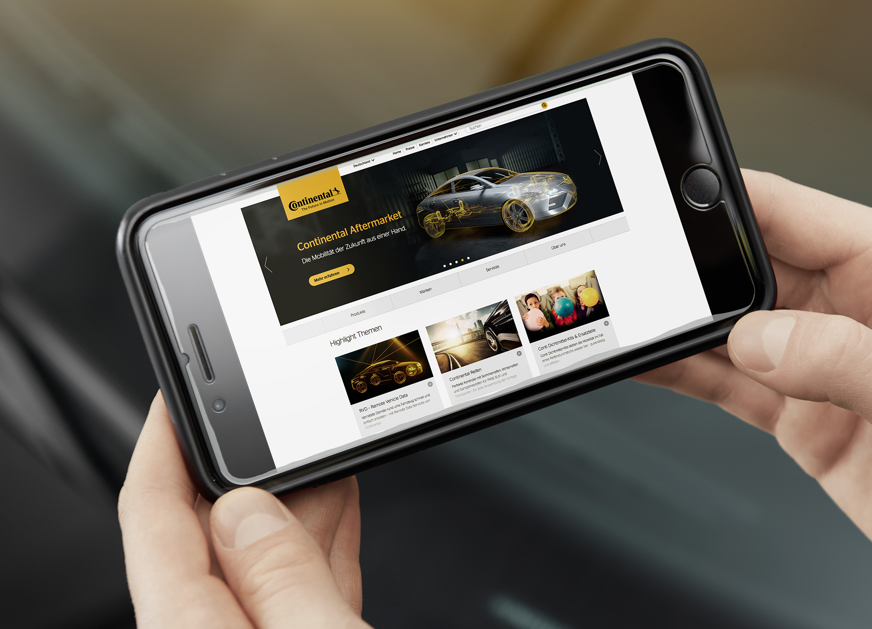  Continental_pp_Webseite_AAM_  Start.jpg | Continental is bundling information about its product and service portfolio for the automotive aftermarket in a new online portal.
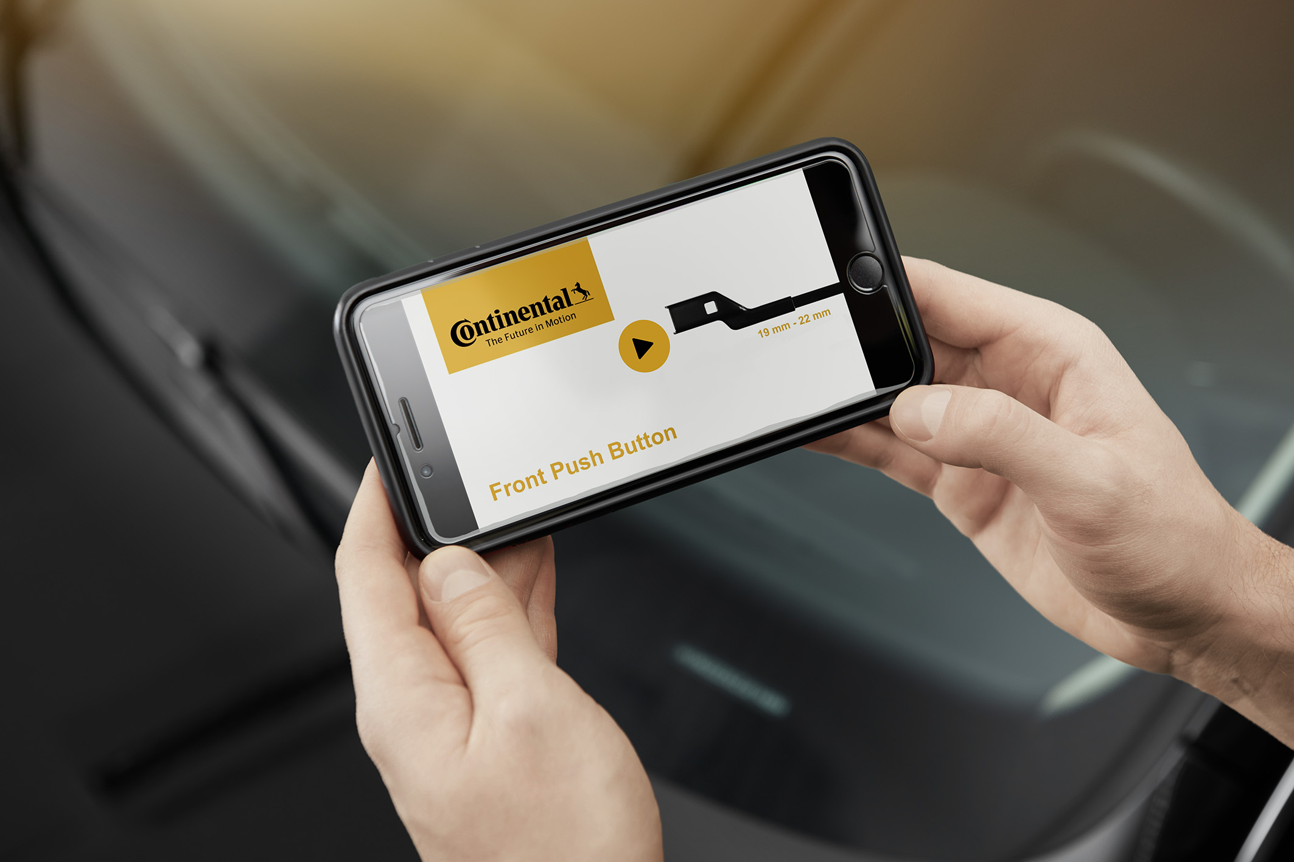  Continental_pp_Webseite_AAM_  Video.jpg | In the new online portal, users can also find video instructions for assembling products such as windshield wipers.
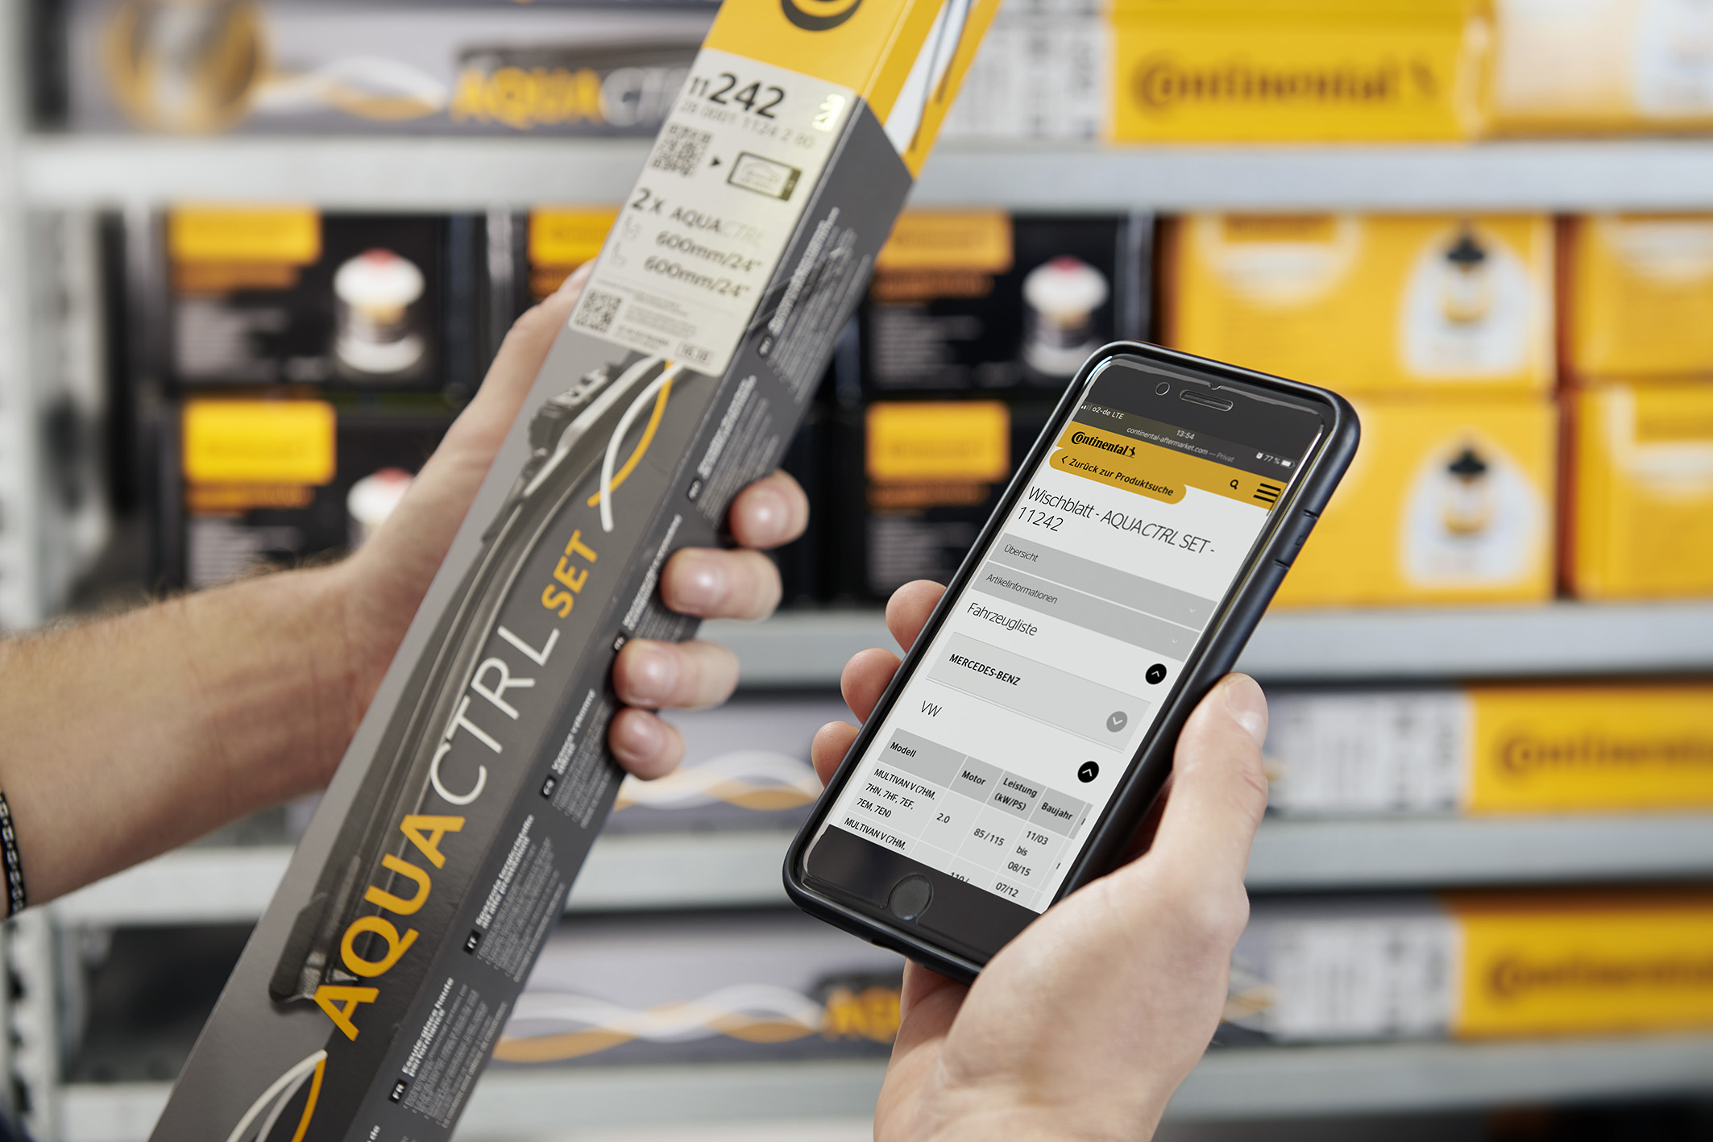 | Which product matches which vehicle model? This question can be quickly answered on Continental’s new aftermarket portal.
Continental_pp_Webseite_AAM_
Verwendung.jpg

