Continental Launching Multi V-Belt in OEM Quality on the Agricultural Spare Parts Market
- High-performance and cost-efficient products are specially designed for the requirements of the agricultural sector
- Multi V-belt portfolio available ex-warehouse starting fall 2019
- Users can find the right replacement product in the online catalog
Hanover, November 2019. Technology company Continental is launching a wide range of OEM quality multi V-belts on the agricultural spare parts market. This means that, in the future, farmers will benefit twofold when replacing their multi V-belts: powerful belts as installed by the manufacturer and cost-efficiency.
Safety during operation
Multi V-belts assume a central function in driving components in agricultural machinery. They transfer engine power to auxiliary units such as dynamos or generators and provide the entire energy supply in modern harvesters. Multi V-belts ensure that harvesting operations run smoothly, safely and trouble-free. In modern combine harvesters and tractors, they are subjected to increasingly powerful forces and thus higher levels of wear and tear. This makes it all the more important that the belts are of a high quality standard.
Continental uses its many years of experience gained in the automotive OEM market for the benefit of the agricultural spare parts market. “Thanks to the technology transfer, farmers also have the opportunity of obtaining high-quality multi V-belts from their dealers without compromising on quality,” emphasizes Alexander Behmann, application engineer for agricultural belts at Continental. “OEM quality gives operators even more certainty that there will be no unplanned downtime during the short harvest period, which could mean high financial losses for a farmer.”
The multi V-belts are specially designed for the requirements of the agricultural sector. “High resistance to dirt and dust is particularly indispensable to agricultural machinery,” says Behmann. “Just as much as the reliable transmission of power in cold and wet conditions and a high tolerance for disk offset.” The multi V-belts also have a special cover fabric made of polyamide. This ensures that the belt runs particularly quietly and is wear-resistant.
The machines are generally serviced after the season in the fall, when the heavily stressed multi V-belts are also replaced. With the new belt range, farmers now have access to multi V-belts in OEM quality that are available as regular spare parts ex-warehouse. The multi V-belt portfolio is available from fall 2019 for the markets of Europe, the Middle East and Africa.
Finding the right belt – in the online catalog
Practical service: registered customers can easily find the right drive belt for the agricultural sector in the new Continental Online Catalog. Users are provided with an overview of the complete range and can quickly find a suitable replacement product by searching by manufacturer, model or OE article number. This is because the catalog includes the latest models from manufacturers and offers convenient decryption and translation of the OE article number for the spare parts market. Multi V-belts from Continental also have a QR code on the packaging that customers can use to obtain an overview of the systems that use the corresponding belt.
Continental will also be showcasing the new multi V-belt portfolio at the world’s leading trade fair, Agritechnica, in Hanover from November 10 to November 16, 2019 (Hall 4, Booth C22). Experts will be available to provide more information about drive belts for the agricultural sector.
The online catalog is available at agridur.continental.com .

Continental develops pioneering technologies and services for sustainable and connected mobility of people and their goods. Founded in 1871, the technology company offers safe, efficient, intelligent and affordable solutions for vehicles, machines, traffic and transportation. In 2018, Continental generated sales of EUR 44.4 billion and currently employs more than 244,000 people in 60 countries and markets.
Contact for journalists

Jochen Vennemann
External Communications Officer
ContiTech
Phone: +49 511 938-18024
E-mail: jochen.vennemann@contitech.de

Press portal: www.continental-press.com
Media library: http://continental.com/media-center
Twitter: www.twitter.com/Conti_Industry
LinkedIn: www.linkedin.com/company/Continental-Industry
YouTube: www.youtube.com/ContiTechGlobal

Images and captions
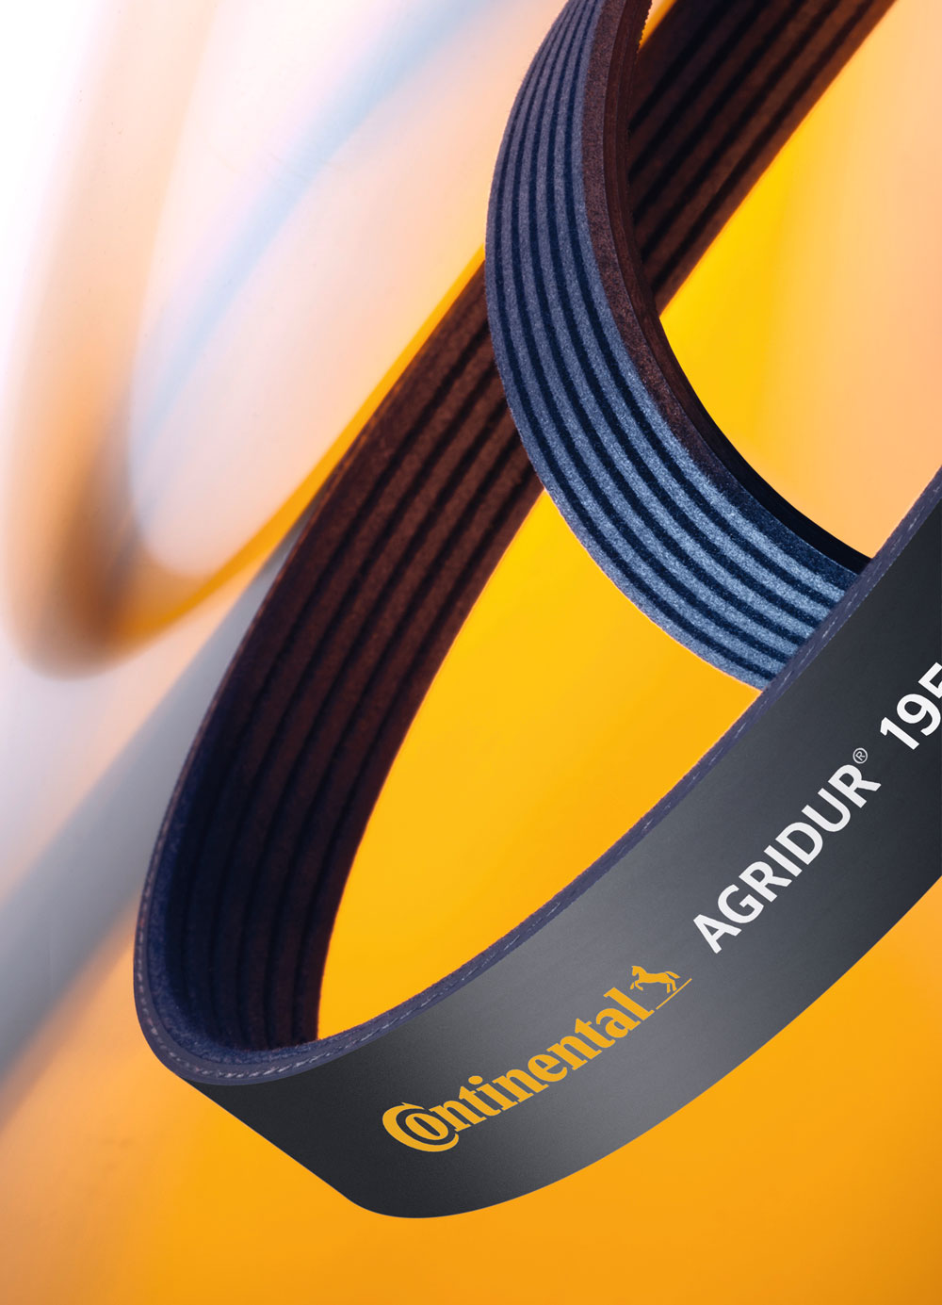  Continental_PP_Components_Agricultural_Industry_Agridur_KRR | As high-performance drive belts in agricultural machinery, V-ribbed belts from Continental ensure reliable power transmission.

