Continental Launches New Partnership with Kalkhoff
- New eBike models equipped with Continental eBike System
- New drive system advancements as part of a close development partnership
Eschborn, July 5, 2019. Technology company Continental has teamed up with German bicycle manufacturer Kalkhoff to develop specially adapted system components and firmware for a customized drive solution. “This is a first step in our relationship, clearly showing our ability to create customized products for market leaders that push the envelope of eBike technology“, says Jörg Malcherek, responsible for Bicycle Systems business activities at Continental.
Kalkhoff’s new models feature Continental’s 48V platform with a host of customized and co-developed improvements such as a new 660 Wh integrated down tube battery (IDT) and an increased drive unit maximum torque of 75 Nm. “This is the result of co-developed changes to system components, but also months of fine-tuning and testing”, reveals Malcherek. In addition to traditional support level options (1-4/Boost), Continental now provides new firmware that includes three new rider-definable driving modes - Range, Balance and Power - allowing users to customize the drive system’s performance depending on their riding needs. The result of the new development will be rounded off by the newly designed XT 2.0 Bluetooth display that can be paired with the free eBike app offering connectivity features such as navigation, weather information and topography-based range.
The newly established partnership was launched last weekend in Ulm in the presence of dealers from Germany, Austria, and Switzerland, where Kalkhoff showcased their new Endeavour 3.C and Image 3.C models. Tammo König, Kalkhoff’s Product Director comments, “This is a great start to our partnership and we are excited to build on our relationship with Continental. Our new co-created product features alongside Continental’s existing eBike app have received a fantastic response from our dealers."

Continental develops pioneering technologies and services for sustainable and connected mobility of people and their goods. Founded in 1871, the technology company offers safe, efficient, intelligent and affordable solutions for vehicles, machines, traffic and transportation. In 2018, Continental generated sales of €44.4 billion and currently employs around 245,000 people in 60 countries and markets.
Press contact

Nils Niederheide
Marketing and PR
Continental Bicycle Systems
Phone: +49 69 7603-9804
E-mail: nils.niederheide@contitech.de

Antje Lewe
Spokeswoman
Head of External Communications
ContiTech
Phone: +49 511 938-1304
E-mail: antje.lewe@contitech.de

Continental Bicycle Systems www.continental-bicycle-systems.com
Press portal: www.continental-press.com
Media center: www.continental.com/media-center
Twitter: www.twitter.com/Conti_Industry
LinkedIn: www.linkedin.com/company/Continental-Industry
YouTube: www.youtube.com/ContiTechGlobal

Pictures and captions
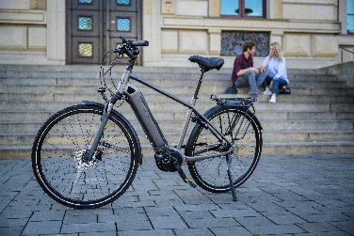 Continental_pp_24062019_554.jpg | The intensive partnership between Continental and Kalkhoff results in new Kalkhoff eBikes that base on several hardware and software optimizations have been introduced for model year 2020.  Photo: Continental
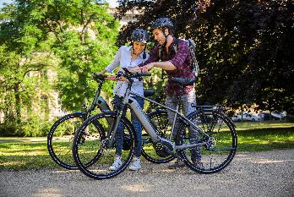 Continental_pp_24062019_881.jpg | The XT2.0 Display with Bluetooth integrated can be paired with the eBike App to offer advanced features such as Navigation, Weather-Information and topography-based range calculation.  Photo: Continental
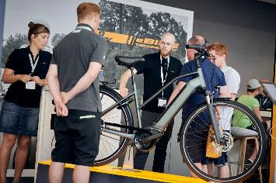 | At the sales event in Ulm, Germany Kalkhoff launched the new eBike models with Continental 48V eBike system to dealers from Germany, Austria and Switzerland.  Photo: Kalkhoff
Continental_pp_Kalkhoff Sales-Event

