Techtextil 2019

Upholstered Surfaces for Urban Environments:
Digital, Individual, Breathable, Cool
- skai Design Lab makes it possible to change the color, size and repeat of designs quickly and simply for digitally printed upholstered surfaces
- Thanks to its breathable surface, laif VyP Nappa offers a high comfort, especially for extended periods of sitting
- skai cool colors Venezia opens up new possibilities for manufacturers of outdoor furniture
Frankfurt am Main, May 14, 2019. From May 14 to 17, 2019, technology company Continental will be exhibiting innovative surfaces that go beyond their primary function as a cover at Techtextil in Frankfurt am Main. The full spectrum of technical surfaces will be on show in the wide variety of contexts in which they are used as well as their highly diverse properties. The exhibition would not be complete without interiors for residential and commercial buildings in urban environments. Besides the design aspect, increasing importance is being attached to the function of furniture surfaces. The versatile skai cushion cover materials made from coated textiles are trendsetters in the world of furniture and call attention to themselves with outstanding innovations. There is history behind this, as the skai brand recently celebrated its 60th anniversary.
With these materials, Continental is showing in many ways how furniture surfaces can make our everyday lives not only more beautiful and comfortable, but more individual, too. That applies to the commercial sector in particular: to the hotel, food service and shopfitting industries, for example. New possibilities for interior designers and furniture designers will also be on show. The technology company will be demonstrating the challenges that urban environments pose for surfaces and illustrating the link between function, color and design at stand G46 in hall 3.0.
skai Design Lab – digital printing opens up a new dimension in customization
The trend for customization continues to grow. The increasing success of the digital printing range encourages Continental to add a further innovative element in this area in the shape of the skai Design Lab. With the new web-based skai Design Lab, customers can now select a suitable digital print design for their project from a database of several thousand designs. The designs can be customized and adjusted in terms of color, size and repeat online in a very short time – thus providing a variety of design options for interior designers and contract outfitters. The selected designs are printed digitally on two different artificial leather material qualities. There are three grain options for embossing: from the fine sand structure and the typical textile structure to the classic leather grain.
In recent years, numerous customer-specific designs for special projects have been successfully implemented using digital printing. The skai Design Lab is now the logical next step: the company allows customers to create unique designs quickly and easily. In terms of the design development process, it is a minor revolution. Customers can go to the portal online, log in there with their username and password – and in an instant they will be at the heart of the skai Design Lab with all of its variety. What’s more, it does not cost them anything: neither for registration, nor for use, nor for services such as sample orders. The skai Design Lab Kit will be unveiled at Techtextil, while a new video, which easily explains all functions, will also be celebrating its premiere for the launch.
laif VyP Nappa redefines comfort
The hybrid material laif VyP Nappa made from vinyl and polyurethane combines the best properties of both source materials as it is a durable material with a soft surface. In the process, only raw materials that do not contain conventional solvents and are based on high-quality, aqueous polyurethane systems are used. The material is permeable to air and water vapor, which makes it particularly comfortable to sit on. laif VyP Nappa has already won three awards. It received the Materialica Design & Technology Gold Award and was a winner of the German Innovation Award and German Design Award.
Thanks to its breathable surface, the product sets new standards in comfort. No matter how long you sit down for, nothing will begin to stick or feel unpleasant. As a result, laif VyP Nappa is predestined for use in conference centers, cinemas, hotel lobbies or the office. It is also perfectly suited to use in restaurants and bars. VIP lounges, too, are an ideal environment for this extraordinary surface. What’s more, when used on board aircraft, its breathability not only ensures more comfort, but also provides passive air conditioning. This is due to the air exchange that happens by the movement on the seat while driving.
In addition, the material is tear-resistant, extremely long-lasting, ultra-wear-resistant and easy to clean. At Techtextil, Continental will be showcasing laif VyP Nappa with a detailed classic leather grain and picking up on current trends with a wide range of 14 colors.
Opening up new possibilities
The trend toward cushions for outdoor furniture continues. Many people do not want to go without comfort, even in the garden or at the pool. Up to now, cushions for outdoor use were available only in bright colors. This is because dark colors absorb a lot of heat from the sun, which makes sitting or lying down impossible. With skai cool colors Venezia, Continental has a smart innovation to address this in its range. The cool colors technology features special pigments that reflect up to 80% of the thermally effective near-infrared radiation in direct sunlight. This reduces heat build-up on the surface by up to 25%. The innovative technology has already proven itself in other business areas, such as in seat coverings for convertibles or window frames. Here, the darker the color is, the greater the effect. skai cool colors Venezia now enables the full range of colored skai cushion cover materials to be used outdoors, which was almost impossible previously due to the build-up of heat. In addition, the surface is particularly hard-wearing and easy to clean thanks to the nano coating. This allows manufacturers of upholstered furniture for outdoor use to be even more responsive to the requirements of their customers.
Continental develops pioneering technologies and services for sustainable and connected mobility of people and their goods. Founded in 1871, the technology company offers safe, efficient, intelligent, and affordable solutions for vehicles, machines, traffic and transportation. In 2018, Continental generated sales of €44.4 billion and currently employs around 245,000 people in 60 countries and markets.
Press contact

Axel Schmidt
Head of Communications
Benecke-Hornschuch Surface Group
Phone: +49 7947 81-522
E-mail: axel.schmidt@hornschuch.de

Service Links

skai Design Lab: www.skai.com/interior/

Press portal: www.continental-press.com
Media center: www.continental.com/media-center
Twitter: www.twitter.com/Conti_Industry
LinkedIn: www.linkedin.com/company/Continental-Industry
YouTube: www.youtube.com/ContiTechGlobal

Pictures and captions
Continental_pp_skai_  DesignLab_1.jpg | Customers can choose from several thousand designs in the skai Design Lab. This design is called skai Amazing.
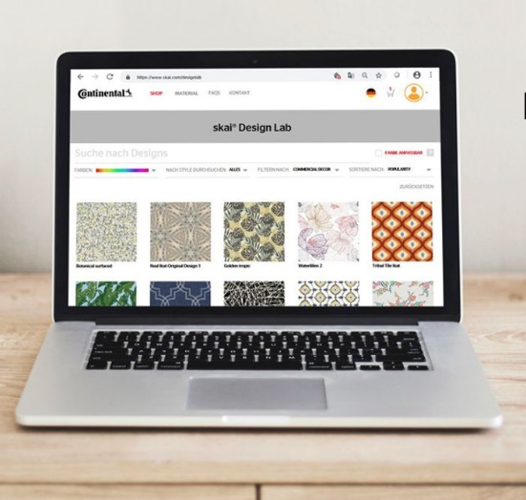  Continental_pp_skai_  DesignLab2.jpg | In the skai Design Lab, every design can be customized in terms of color, size and repeat.
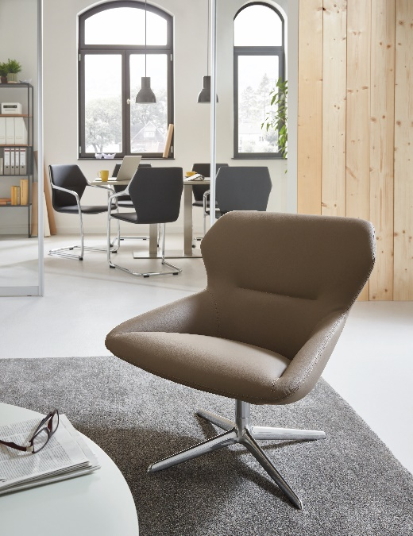  Continental_pp_laif VyP Nappa_1.jpg | How favorite pieces of furniture are created: the breathable laif VyP Nappa is permeable to air and water vapor and therefore offers a superior comfort experience.
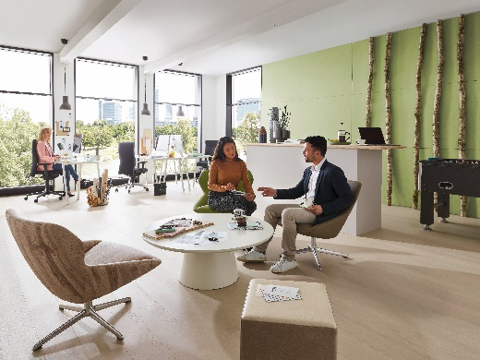  Continental_pp_laif VyP Nappa_2.jpg | laif VyP Nappa is ideal for seating that is used for extended periods, like in this office.
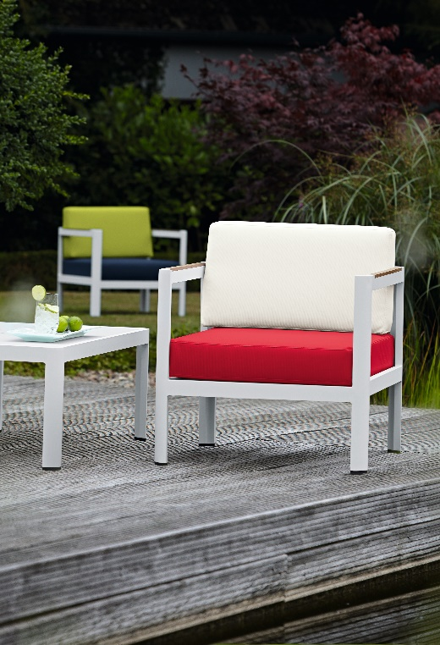  Continental_pp_skai_cc_  Venezia_1.jpg | With skai cool colors Venezia, the entire range of colors is available for outdoor furniture. The tried-and-tested technology reflects thermal radiation.
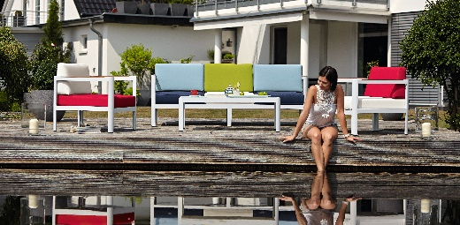  Continental_pp_skai_cc_  Venezia_2.jpg | Even when it is exposed to direct sunlight, upholstered furniture stays comfortably cool with skai cool colors Venezia.

