Techtextil 2019

Elastomer-coated Fabrics from Continental Ensure a High Level of Safety at Extremes of Heat and Cold
- Fabrics for drysuits help to regulate body temperature
- Materials for protective and work clothing offer a high level of comfort
Frankfurt am Main, May 14, 2019. Thanks to a range of heat protective coated fabrics, the technology company Continental helps to ensure the safety of workers in a whole range of deployment situations. The company supplies, for example, materials for protective suits that protect workers if they come into direct contact with heat sources in extremely hot environments. The suits are also designed to protect wearers against extremes of cold and are even capable of withstanding temperatures as low as -196°C for short periods. The fabrics are available in numerous surface and color variants, including signal colors. Their high flexibility and low material thickness make them comfortable to wear.
The chemical protection suit, for example, which is manufactured using “Next Generation” fabric, is a reliable aid for firefighters as well as in industrial environments such as refineries and oil rigs and in shipbuilding. The highly flame-retardant material ensures a high degree of safety in environments where gases form and there is a risk of fire. The protective suit is designed in accordance with the requirements of the National Fire Protection Association (NFPA).
Highly watertight even under water
Extremely thin, yet as stable as a protective shield: For drysuits, the technology company supplies coated fabrics that offer safety and protection in and under water. This tough material, which is just 0.5 mm thick and weighs around 450 g/m², remains watertight even when pushed to extremes. And because it is extremely flexible and pleasant to the touch, it is also comfortable to wear. The innovative Condensation Control Technology (CCT) also regulates body temperature, making the material perfect for professional and leisure divewear.
Protection against harsh weather
Continental’s Dynactiv Protection portfolio also encompasses a range of safe and comfortable products for protective and work clothing, including innovative clothing materials for waders, coats and raincoats. These knitted fabrics are coated with polyvinylchloride (PVC), possess antistatic properties and protect wearers against harsh weather conditions. The surface specialist also produces not only fluorescent materials, but also acid- and alkaline-resistant products.
Demand for solutions in China too
Continental’s coated fabrics are also highly sought-after in China. Last year, the company established production facilities in Changshu to cater directly for the Chinese market. The plant mainly manufactures products for inflatable solutions and systems for applications including life rafts and materials for folding bellows. The safety products developed as part of Continental’s folding bellows business field are certified to the fire protection standards such as EN 45545-2. In addition to its comprehensive portfolio, the company offers its customers a range of rubberized fabrics, belts and sealing compounds.
Continental develops pioneering technologies and services for sustainable and connected mobility of people and their goods. Founded in 1871, the technology company offers safe, efficient, intelligent and affordable solutions for vehicles, machines, traffic and transportation. In 2018, Continental generated sales of €44 billion and currently employs around 245,000 people in 60 countries and markets.
Press contact

Axel Schmidt
Head of Communications
Benecke-Hornschuch Surface Group
Phone: +49-794-781-522
E-mail: axel.schmidt@hornschuch.de

Press portal: www.continental-presse.de
Media center: www.continental.de/mediathek
Twitter: www.twitter.com/Conti_Industry
LinkedIn: www.linkedin.com/company/Continental-Industry
YouTube: www.youtube.com/ContiTechGlobal

Images and captions
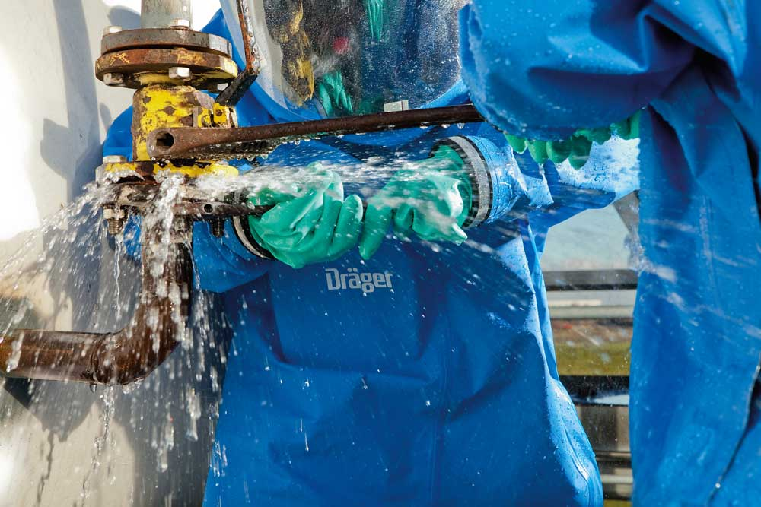  Continental_pp_Chemical_protection _suit.jpg | The chemical protection suit, which is manufactured using Continental’s innovative “Next Generation” fabric, is a reliable aid for firefighters and in industrial environments.  Photo: Drägerwerk AG
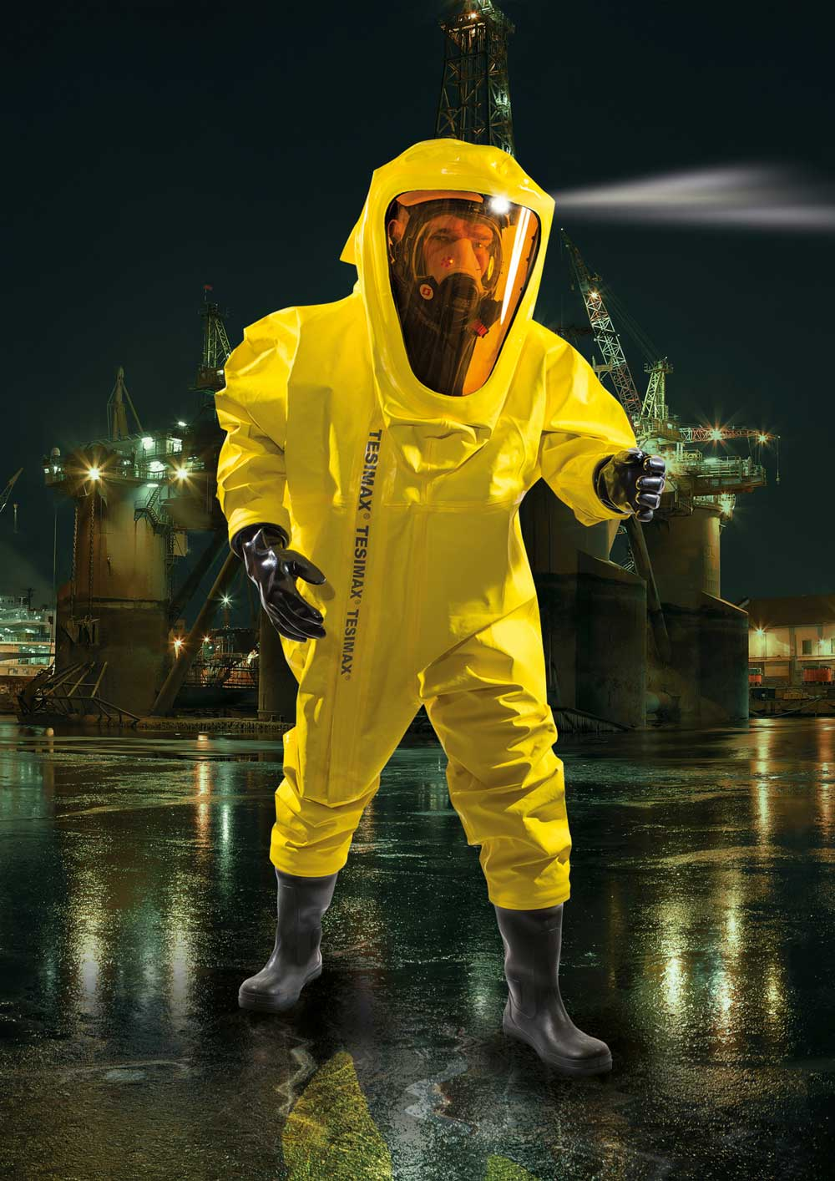  Continental_pp_Protective_suits.jpg | Continental supplies innovative materials for work at extreme temperature.  Photo: Tesimax
 | The materials for drysuits remain watertight even after 170 diving hours.  Photo: Kallweit
  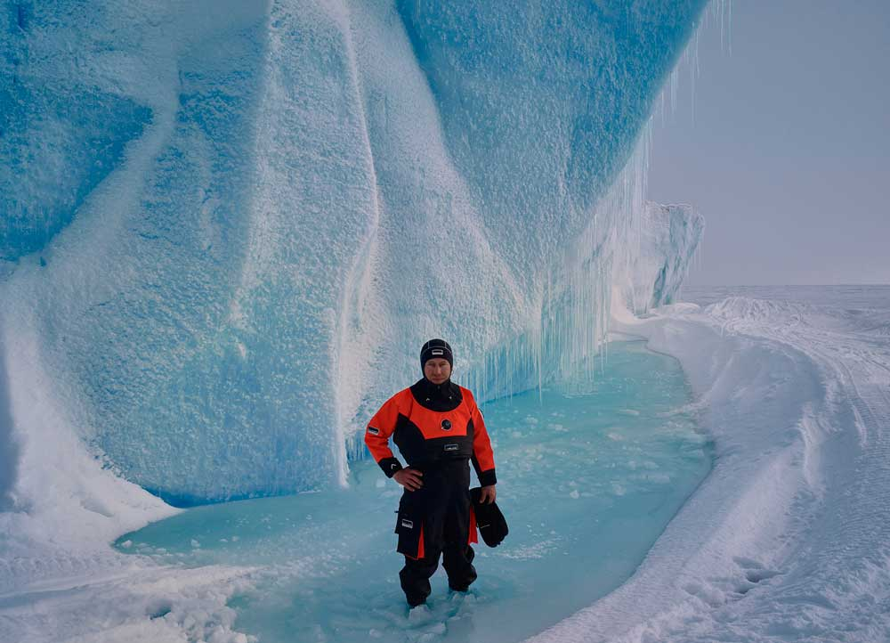  Continental_pp_Drysuits.jpg | The materials for drysuits remain watertight even after 170 diving hours.  Photo: Kallweit

