Press Release
New Metal Water Pump Housing

- Tough, durable solution for the automotive aftermarket
- Launched in CT 1143WP 2 and CT 1143WP 3 timing belt kits + water pump
Hanover, March 2019. Technology company Continental has unveiled an especially tough, durable aftermarket component for vehicle engines: a new metal water pump housing. These covers are usually made of plastic, mostly polyethylene or polyurethane. This material is comparatively inexpensive and therefore very popular in automotive engineering. Over time, however, this material becomes brittle, as a result of temperature fluctuations in the engine compartment, and cracks. It then often finally breaks when the water pump is changed, meaning that it too has to be changed. The new water pump housing from Continental, on the other hand, is made of cast aluminum and is therefore significantly tougher and more durable.
Continental is offering the aftermarket part for the first time in its CT 1143WP2 and CT 1143WP3 timing belt kits plus water pump. These are required for repairs on the engine of the Golf VI and other 1.8 and 2.0 TFSI engines built between 2004 and 2015. Up till now, workshops were only able to use the manufacturer’s complete original part with a plastic housing for such repairs. Anyone wanting an alternative had to source the water pump and housing separately. However, that often resulted in problems during fitting since the dimensions of the components did not match accurately. The dimensions of Continental’s new aftermarket component, on the other hand, are absolutely identical to those of the manufacturer's original part. That means the fitter can install the housing without further modifications and offer customers a durably reliable solution in excellent quality. For the first time, therefore, workshops can source a complete system comprising a water pump and a tough metal housing for these vehicles. “In this alternative to the original part of the manufacturer we are responding specifically to the needs of the aftermarket,” reports product manager Adrian Rothschild.
In addition to the power transmission belt and the water pump, the kit also contains the thermostat and the coolant sensor. Consequently, the fitter has all the necessary components quickly to hand, which makes the fitting work substantially easier and safer. “We are therefore offering our customers an optimized repair solution including the necessary sensor technology,” says product manager Adrian Rothschild.
Workshops can, as always, rely unreservedly on the quality: As with all components for the automotive aftermarket, Continental offers registered workshops a 5-year guarantee on this product.

Caption
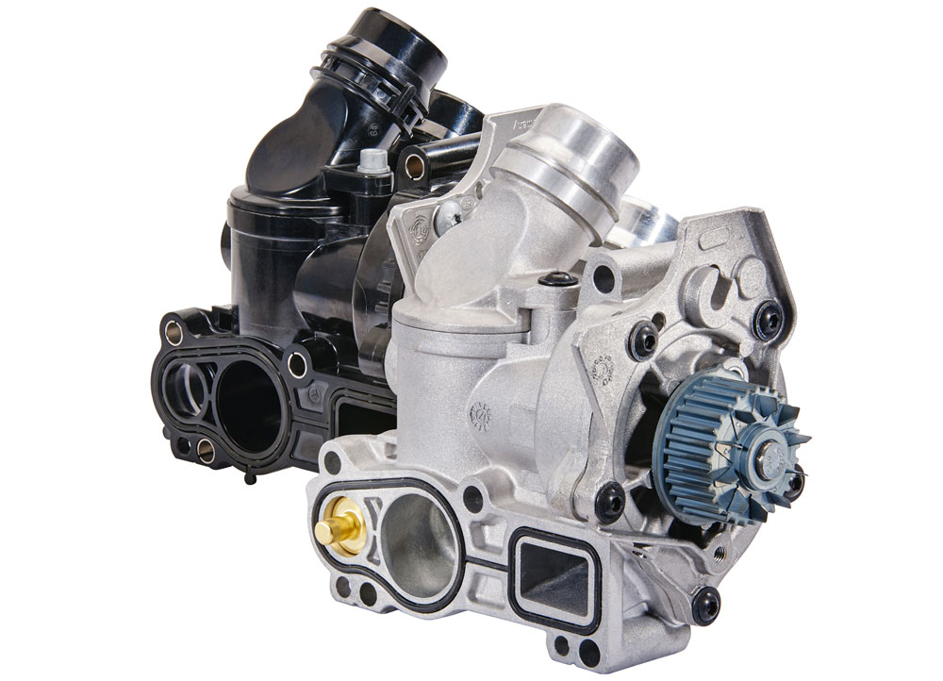
Continental_pp_Metal_Water_Pump_Housing.jpg
Continental has unveiled an especially tough, durable aftermarket component for vehicle engines: a new metal water pump housing.
Photo: Continental

Continental develops pioneering technologies and services for sustainable and connected mobility of people and their goods. Founded in 1871, the technology company offers safe, efficient, intelligent and affordable solutions for vehicles, machines, traffic and transport. In 2018, Continental generated sales of €44.4 billion and currently employs more than 244,000 people in 60 countries.

Press contact

Jochen Vennemann
External Communications Manager
ContiTech
Phone: +49 511 938-18024
E-mail: jochen.vennemann@contitech.de

Links

Press portal:
www.continental-press.com

Media database:
www.continental.com/media-center

Social media
www.contitech.de/twitter
www.contitech.de/YouTube

