Press Release
Continental Secures Follow-On Order for Shanghai Metro, in Turn Helping to Avoid Total Gridlock in China

- Original equipment manufacturer CRRC continues to rely on Continental’s products
- Continental air springs enhance ride comfort on Shanghai’s metro
- Less noise and vibration in the carriages reduce stress levels

Shanghai, January 2019. Technology company Continental has generated long-term business with its railway engineering components, securing a follow-on order for future metro projects in the Chinese city Shanghai. This move is seeing the corporation advance mobility by rail and, in turn, help to avoid total gridlock on China’s roads. This is important because although challenges posed by the daily volume of traffic are on a similar scale in megacities worldwide, the situation is most acute in China. Even on the eight-lane expressways of Shanghai and Beijing, cars cover barely half a kilometer in half an hour during peak times, making them generally no faster than pedestrians. The consequences are noise and extreme air pollution. To counteract this, new car registrations are now raffled off. In parallel with this, the Government is further expanding its railway networks and fleet of rail vehicles to provide commuters with a reliable and relaxed way of navigating the urban jungle.
With its 16 lines, Shanghai’s metro covers a 637-kilometer network every single day. State-of-the-art trains equipped with Wi-Fi operate on this sophisticated system. The Shanghai metro first opened 25 years ago with Line 1. Line 2 followed in 1999. Since then, the metro trains in this metropolis have been fitted with components and systems from Continental. The original equipment manufacturer and largest rail vehicle manufacturer worldwide, CRRC, will also be sourcing the products and service of the Continental Corporation for future projects. “Thanks to our new air spring systems, the Shanghai metro trains travel more quietly and with lower vibration levels than the older models,” says Jianhua Hao, head of marketing & sales at Continental China. This also enhances ride comfort for drivers and passengers alike – after all, just the background noise from the people in the carriages at peak times is extremely high. And when other noise sources such as that of the trains themselves are added, this really raises the stress levels. “The journeys on the Shanghai metro can sometimes be long, with some lines being 82 kilometers in length,” says Hao. Quieter vehicles definitely contribute to a more pleasant journey.

Enhanced ride comfort thanks to Continental air springs
To meet the growing requirements of the railway industry, Continental invests on an ongoing basis in the research and development of its products. Its extensive portfolio also includes air springs, which serve as a suspension mounting point for the vehicle body in the secondary suspension area between the bogie and the vehicle body – largely isolating it from the irregularities of the tracks. At the same time, they allow the bogie to turn as the train negotiates bends. “Our air springs have a low natural frequency, which minimizes the transmission of vibrations,” says Hao.
The planned expansion of the Shanghai metro network to 22 lines is scheduled for completion by 2020. The rail network will then cover a total of 970 kilometers and is thus expected to be the longest high-speed rail network in the world – complete with state-of-the-art technology from Continental.

Captions

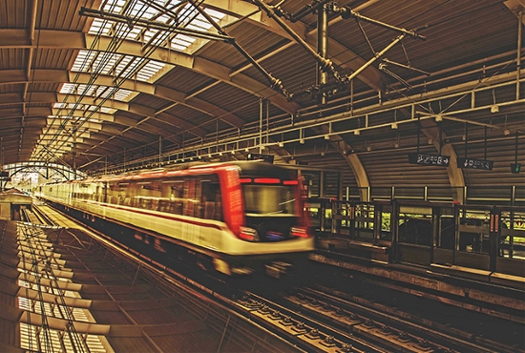
Continental_pp_Shanghai_Metro.jpg
With its 16 lines, Shanghai’s metro covers a 637-kilometer network every single day. State-of-the-art trains equipped with Wi-Fi operate on this sophisticated system.
Photo: CRRC

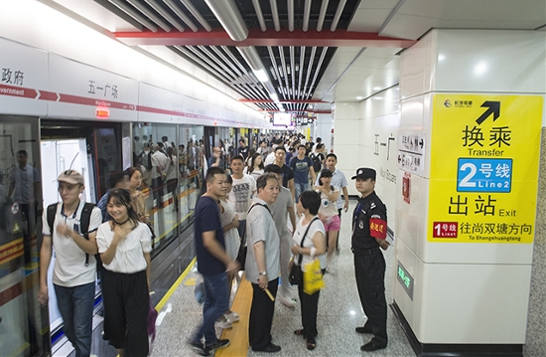
Continental_pp_Line1.jpg
Enhanced ride comfort thanks to Continental air springs.
Photo: CRRC
Continental develops pioneering technologies and services for sustainable and connected mobility of people and their goods. Founded in 1871, the technology company offers safe, efficient, intelligent, and affordable solutions for vehicles, machines, traffic and transportation. In 2018, Continental generated preliminary sales of around €44.4 billion and currently employs around 244,000 people in 61 countries and markets.

Press contact

Jochen Vennemann
External Communications Officer
ContiTech
Phone: +49-511-9381-8024
E-mail: jochen.vennemann@contitech.de

Li Che
Communications China
ContiTech
Phone: +86 21 6080 2500
E-mail: li.che@contitech.cn

Links

Press portal:
www.continental-press.com

Media database:
www.continental.com/media-center

Social Media
www.contitech.de/twitter
www.contitech.de/YouTube

