Press Release
Continental To Launch Production of Premium Automotive Interior Surfaces in India in 2020

- Automotive interior materials for Indian automotive industry
- Investment in state-of-the-art machines and facilities to the tune of some 22 million euros
- Series production scheduled to start in 2020 with approx. 110-strong workforce
- Environment-friendly biogas system will supply sustainable energy to plant
Pune, December 11, 2018. Technology company Continental performed the symbolic groundbreaking ceremony in Pune, India today, signaling the start of construction work on a plant to manufacture premium surface materials for the automotive industry. A 12,000 square meters manufacturing facility with an initial annual capacity of 5 million square meters is to be built on the four-hectare plot at a cost of about 22 million euros (18 billion rupees). The factory is scheduled to begin production in 2020 with a workforce of up to 110 employees initially.
Continental will supply surface materials to the local Indian market from Pune. “India is now rated as the fifth-largest automotive market in the world with huge growth opportunities,” says Dr. Dirk Leiß, who is responsible for the business unit for surface materials at Continental. “And every vehicle needs interior materials for seats, door trims and instrument panels. This investment will enable us in the future to offer our Indian customers local solutions that are manufactured in the market for the market.” It is estimated that the number of vehicles in India could more than double from the current 4.8 million to around ten million by 2025.
Premium interiors are an important selection criterion for end users
The Acella Eco artificial leather that will be produced in Pune from 2020 is already proving popular in India as a replacement for real leather. “Premium interiors are an important selection criterion for the end user,” emphasizes Leiß. The solvent-free and thus low-odor decorative material is hard-wearing and is available in a two-color design.
Continental has already been represented by a sales team in India for six years. It now supplies the country’s five largest vehicle manufacturers and one of the largest motorcycle manufacturers from other plants. “The new plant in Pune will enable us to further improve both our reaction times and responsiveness and lastingly grow our business in India,” says Leiß with conviction. In addition to Acella Eco, the plan is also to manufacture the environmentally compatible Yorn and Yorn Light expanded foils. The interior surface materials offer soft haptics and a broad processing spectrum. They also allow an extensive range of colors and grain designs.
Globally standardized, high quality standards
An environment-friendly biogas system will supply energy to the plant. Air treatment will be carried out in accordance with a stringent global standard for surface production specified by Continental. The plant, which will offer room for further expansion, will include production, warehousing, R&D labs, sales, logistics and product development facilities – and local purchasing. Only environment-friendly ink systems will be used on the shop floor.
Continental produces surface materials in 15 plants around the world and is therefore represented in the key markets in Asia, the Americas and Europe.
“We chose Pune as a location because of its closeness to current customers,” explains site manager Landry Tchapda. Numerous vehicle manufacturers and their system suppliers are right on the doorstep. The proximity to the sea port and airport and the large number of further and higher education institutions were further criteria influencing the choice. When choosing the plot in the Kesurdi area of the south of Pune, the industrial zone’s closeness to the Mumbai-Bangalore highway was a deciding factor.
In India, Continental currently has eight plants and 8,000 employees at 15 sites and is planning to increase the workforce size in the country to 10,000 in the next two years. The Continental Technical Centre India (TCI), which employs more than 3,000 engineers at present, is one of Continental’s three system and technology centers worldwide.

Captions

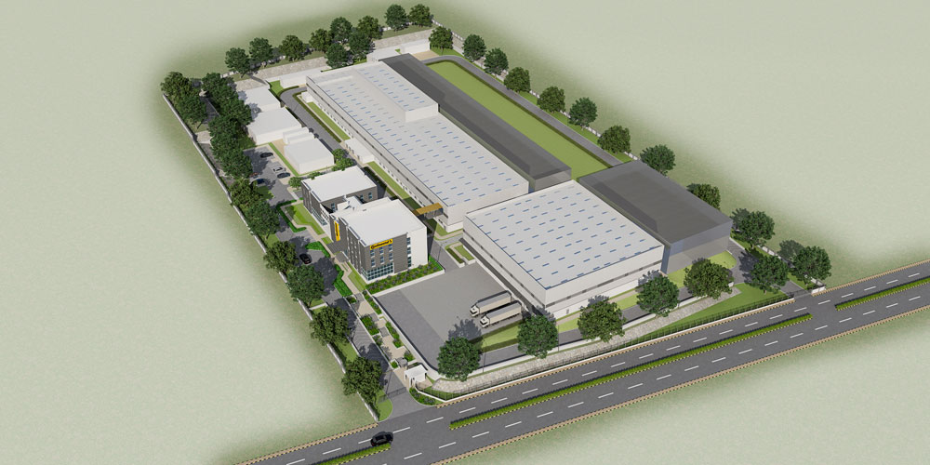
Continental will be manufacturing premium surface materials for the Indian automotive industry from 2020 onwards in the Indian city of Pune.
Photo: Continental
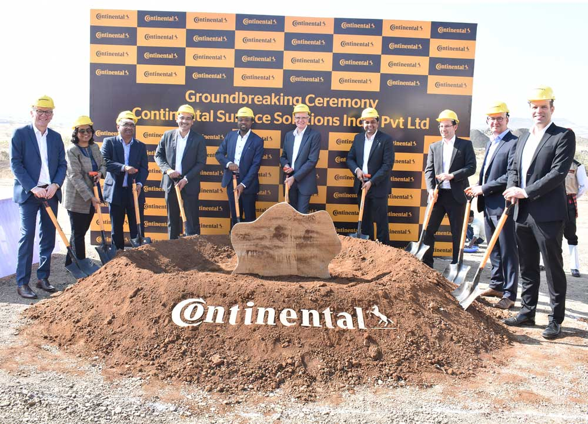
Groundbreaking ceremony for Continental’s new plant in Pune
Photo: Continental

Dr. Dirk Leiß is responsible for the business unit for surface materials at Continental.
Photo: Continental


Continental_pp_ Landry_Tchapda.jpg
Site Manager Landry Tchapda
Photo: Continental
Continental develops pioneering technologies and services for sustainable and connected mobility of people and their goods. Founded in 1871, the technology company offers safe, efficient, intelligent, and affordable solutions for vehicles, machines, traffic, and transportation. In 2017, Continental generated sales of €44 billion and currently employs more than 244,000 people in 61 countries and markets.

Press contact

Deepa Sasidharan
Manager Communication & Marketing
Continental AG
Phone: +91-80-66115645
Fax: +91-80-66115115
E-mail: deepa.sasidharan@continental-corporation.com
Jochen Vennemann
External Communications
Division ContiTech
Phone: +49 511 938-18024
E-mail: jochen.vennemann@contitech.de

Links

Press portal:
www.continental-presse.com

Video portal:
http://videoportal.continental-corporation.com
Media database:
www.continental-mediacenter.com

Social media
www.contitech.de/twitter
www.contitech.de/YouTube

