Press Release

Heimtextil
Continental Presents Sustainable, Well-designed, and Award-winning Innovations for Upholstery Materials

- Continental has won multiple awards for design and material innovations
- German Design Award 2020: skai Design Lab recognized for the design development process
- Iconic Awards 2020: newly developed, PVC-free material as a sustainable, vegan alternative to conventional synthetic upholstery materials
- Iconic Awards 2020: winning materials provide more comfort in combination with each other
- New trendy colors for more individuality in lobbies, conference rooms, restaurants, bars, hotel rooms, and the contract area

Frankfurt, 7 January 2020. The technology company Continental presents its innovations and sustainable upholstery materials at this year’s Heimtextil in Frankfurt am Main. The surface materials are oriented toward the future design trends in the living and contract area and have won numerous awards for this. Continental shows trade fair visitors, designers, architects, and interior designers a broad spectrum of versatile upholstery materials made from coated textiles of the skai brand and also demonstrates a sustainable alternative to conventional synthetic materials. In addition, professional visitors to the Continental booth D15 in hall 4.0 from 7 to 10 January will be met by a color offensive and a multitude of trendy colors for more individuality and design possibilities.
Award-winning skai Design Lab
The skai Design Lab was recently recognized with the German Design Award 2020 in the “Web” category. The jury explained its decision by pointing out the fact that the tool playfully offers an impressive variety of possibilities for design, while being delightfully simple and fun to use. According to the experts, one has to try it out for oneself. The skai Design Lab is the rational next step into the digital age and alters the entire design development process. Both registration and the use of the tool or services, such as sample orders, are free. More and more interior designers and planners use the web-based tool to individualize their projects. They can first select an appropriate digital printing design from a databank of several thousand options.
In a short span of time, the design is individually designed and adapted online with regard to color, size, and pattern repeat – resulting in diverse design possibilities. With the click of a mouse, the customers can then request genuine samples, which are shipped within 48 hours. In case of an order, the customer will choose between two material grades for digital printing. During embossing, three grains are available: from a fine sand structure to the typical textile structure to the classic leather grain.
Sustainable sitting comfort
The new development skai Pureto EN, which is made of polyurethane, is an alternative to conventional synthetic upholstery materials due to its materiality. It is PVC-free and is manufactured with an innovative, water-based PUR-system. It is also produced in Germany using resource-saving methods and is therefore consistently sustainable. The material characteristics of skai Pureto EN are also impressive: the material is hydrolysis-resistant and does not lose its characteristics when it comes into contact with water, water vapor, or moisture. In addition, this innovative material is a vegan alternative, is easy to clean, and it does not change its characteristics due to intense light or heavy abrasion. Its soft look and feel contribute to the high level of comfort when used on furniture.

The surface is a finely structured design. The material is available in 13 subdued, pastel tones of modern trendy colors. The innovation is particularly suitable for seating furniture in the office, hotel, and restaurant industries or in public buildings. It has already received two awards: after winning an Interzum Award: Intelligent Material & Design 2019 for high product quality, skai Pureto EN is also the winner of the Iconic Awards 2020: Innovative Interior in the textiles category.

Coordinated material and color combinations for more comfort
Combinations of colors and materials are one of the future trends and therefore ensure more individuality and comfort. The designers of Continental match the color nuances to one another and bring textile looks and delicate leather grains together. With its classic herringbone design in conjunction with its fine textile embossing, the new skai Torino FLS creates a modern textile impression. A soft-touch coating ensures extra softness and a pleasant feel.
Additionally, skai Topana FLS with its fine leather grain, is perfect for creating combinations. The coordinated pastel pallet of 14 colors reflects current color trends. Together, both materials beautify any room, whether as a wall covering or on seating furniture. The duo of skai Torino FLS and skai Topana FLS was also recognized with the Iconic Awards 2020: Innovative Interior in the textiles category.
The new surface material skai Kimera EN is suitable as a standard material for universal applications. With its characteristic cowhide grain, it gives furniture and walls a simple elegance and thus enhances rooms. The material, which is particularly suited for use in the contract area, is very robust and simultaneously comfortable. From the beginning, 18 trendy colors are available.
New trendy colors for more individuality
Continental is expanding its color spectrum and will offer additional trendy colors in the future in order to be even more individual in its reaction to the needs of designers and customers with a more versatile color palette. Since 2017, skai Paratexa NF has been used as an upholstery material for hospitality areas worldwide and is immediately available in the seven new pastel trendy colors. With a total of 21 color options now, the material is extremely tough and yet pleasantly soft. As a result, the high-quality surface with its very realistic textile look can be used anywhere – for seating furniture in lobbies, conference rooms, restaurants, bars, or hotel rooms. It is also suitable for upholstering walls or headboards. Its flame-retardant characteristics meet the highest international fire safety standards B1, DIN EN 13501 B-s3, d0, M1, and Crib 5. Its extremely detailed textile embossing makes skai Paratexa NF a premium product.
New colors for skai Soshagro EN as well: the surface has the realistic look of a manta ray. The color contrast is particularly exciting due to the fine matt-gloss interplay between the valleys and peaks. skai Soshagro EN is broadly applicable for upholstery and coverings – in the trendy and exclusive residential area, as well as in public buildings and facilities. It is especially suitable for decorative applications, which create focal points in rooms. The color palette here has been expanded by three bright, trendy colors, and now encompasses 15 modern colors.
The color offensive 2020 also extends to the Dynactiv Collection: Dynactiv Makari 160 is characterized by its detailed textile look. A special textile printing and the straight-line embossing give the material an even more realistic appearance. The available colors have been expanded by nine stylish colors. With a total of 32 trendy colors now, the material offers a broad variety for use in the hospitality area. A very fine leather grain characterizes the high-quality look of Dynactiv Gemini 175. Its flame retardant characteristics and very pleasant, natural feel make the material an obvious choice for use in hotels, public facilities, or cruise ships. The already large color palette continues to grow: with eight new colors, there are now 33 color variance available.

Continental develops groundbreaking technologies and services for the sustainable, interlinked mobility of people and goods. The technology company, which was founded in 1871, offers safe, efficient, intelligent, and affordable solutions for vehicles, machines, traffic, and transportation.
In 2018, Continental had a turnover of around 44.4 billion Euro and currently has more than 240,000 employees in 66 countries and markets.
Contact for journalists

Axel Schmidt
Head of Communications
Surface Solutions
Phone: +49 7947 81-522
E-mail: axel.schmidt@continental-corporation.com

Press portal: www.continental-press.com
Media library: www.continental.com/media-center
Twitter: www.twitter.com/Conti_Industry
LinkedIn: www.linkedin.com/company/Continental-Industry
YouTube: https://www.youtube.com/c/ContinentalIndustry

Illustrations and captions
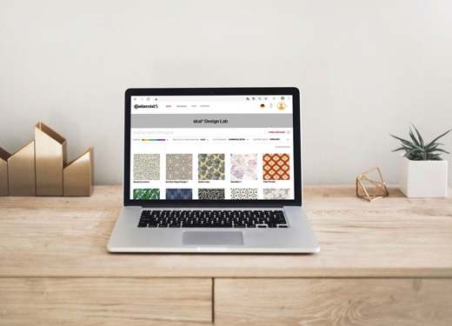  Continental_PP_skai_Design_Lab_  Laptop.jpg | With the skai Design Lab, contract suppliers can quickly and easily access individual upholstery materials. The innovative tool is a “winner” at the German Design Award 2020.
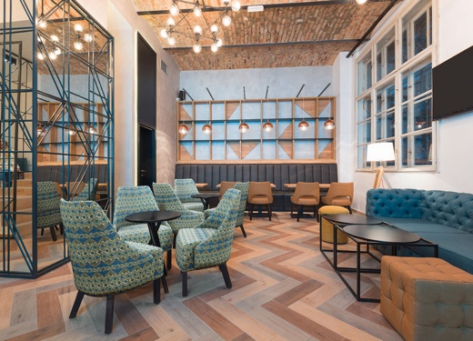  Continental_PP_skai_Design_Lab_Diamond_Tiles.jpg | With the skai Design Lab, individual accents can be created in the contract area. As can be seen here on the chairs digitally printed with the individual design Diamond Tiles.
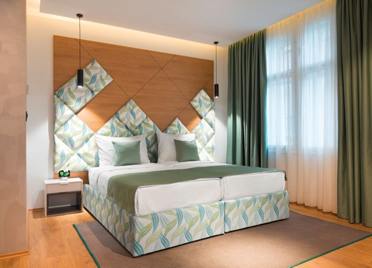  Continental_PP_skai_Design_Lab_  Embroidered_Leaves.jpg | Materials designed with the skai Design Lab can also be used in hotel rooms. Here, the individual design Embroidered Leaves decorates the frame and the extraordinary headboard.
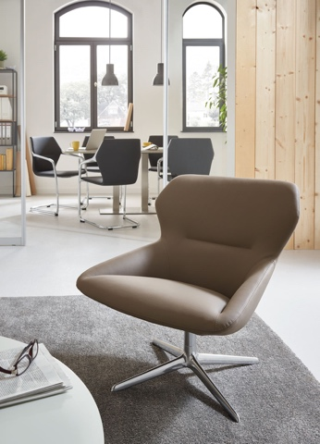  Continental_PP_skai_Pureto_EN.jpg | With its excellent product characteristics, skai Pureto EN is the sustainable and PVC-free alternative for the entire contract area. Recognized at the Iconic Awards 2020: Innovative Interior as the “winner” in the textiles category.
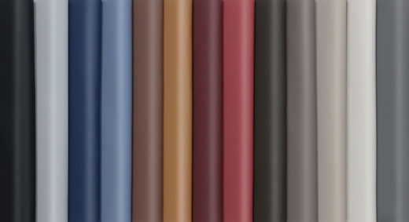  Continental_PP_skai_Pureto_EN_  new_colors.jpg | With 13 trendy colors, skai Pureto EN is available in a broad range of colors from the beginning.
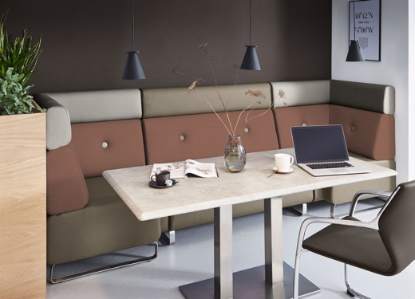  Continental_PP_skai_Topana_  FLS_Torino_FLS.jpg | Tone in tone, the textile herringbone design of skai Torino FLS meets the calm skai Topana FLS. The duo was recognized at the Iconic Awards 2020: Innovative Interior as the “winner” in the textiles category.
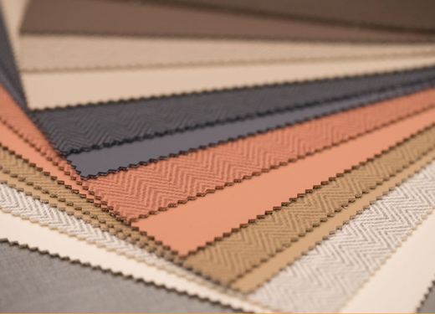  Continental_PP_skai_Topana_  FLS_Torino_FLS_Selection.jpg | skai Torino FLS and skai Topana FLS form an attractive duo for more comfort.
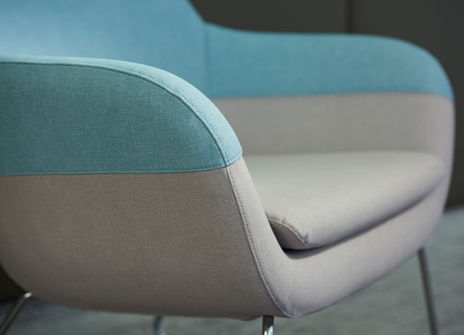  Continental_PP_skai_Paratexa_  NF.jpg | Impressive in the hospitality area with its very realistic textile structure: skai Paratexa NF.
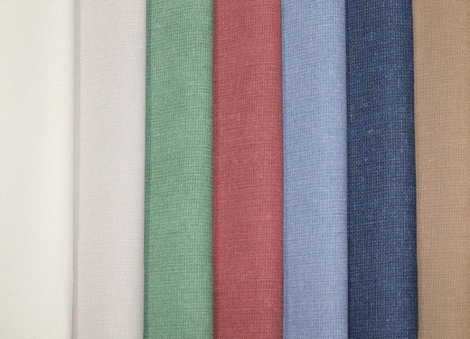  Continental_PP_skai_Paratexa_NF  _new_colors.jpg | Ivory, Cashmere, Vineyard, Marsala, Stone Blue, Deep Sea, and Gobi are the names of the seven new trendy colors for skai Paratexa NF.
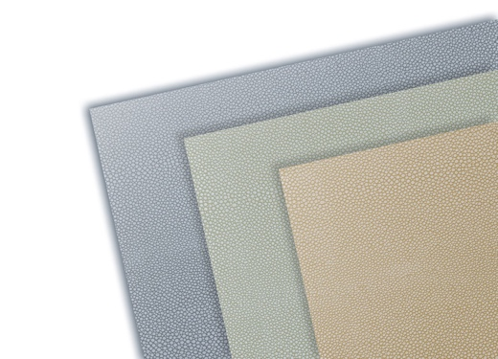  Continental_PP_skai_Soshagro_  EN_new_colors.jpg | The popular manta-ray design now has more color: skai Soshagro EN is now also available in the new trendy colors Grey Green, Greige, and Light Sand.

