SICAM 2026

Inspired by Nature: New Embossings and Colors
for Proven skai Furniture Films
- New options for established skai surfaces such as skai colore structure reflect current furniture trends and expand the portfolio with additional colors and décors
- Frame the Future: Fresh ideas for framed and slatted furniture fronts
- Design inspiration: Following its recent publication, the “Duality” TrendGuide provides visitors with impulses for discussions about future design trends
Weissbach, Germany, October 1, 2026. Continental's ContiTech Surface Solutions (SSL) business area is showcasing new options for established skai surface materials at SICAM 2026. The focus is on expanding existing product families with current colors and décors. The new variants provide furniture manufacturers with additional design possibilities, particularly in muted and nature-inspired shades. SICAM takes place from October 20 to 23, 2026, in Pordenone, Italy. Continental SSL will present its furniture surfaces and artificial leather portfolio in Hall 4, Booth B13 under the motto “Frame the Future.”
New Colors for Established Surface Solutions
A key focus of the exhibition will be new color variants within existing product lines. These include the skai colore structure SENSO and GEO films, which will be shown for the first time in the new colors ocher and grayish. The portfolio is further expanded with the new wood décor skai structure Wright Walnut, featuring an authentic American walnut appearance, and skai Maranello Oak, which creates natural accents with its rustic oak look and distinctive knot details.
As a contrast to traditional wood décors, Continental will also present new stone-inspired designs: skai Otranto, featuring a travertine appearance, and skai Nuvolento, inspired by terrazzo. Both décors are available in the contemporary color variants beige and grey.
In addition, Continental is expanding its ultra-matte surface skai colore classico ULTRA with additional shades within the existing color range. This makes it easier to combine different surfaces and materials across furniture applications.
Frame the Future: Fresh Ideas for Framed and Slatted Fronts
Under the guiding theme “Frame the Future,” Continental Surface Solutions will showcase solutions for framed and slatted fronts as well as other contemporary furniture concepts. Current décors, trend colors and surface structures take center stage at the booth. Featured materials include skai colore structure GEO, with its geometric patterns and matte-gloss effects, alongside other structured furniture surfaces that combine visual and tactile qualities.
“Duality” TrendGuide Provides Inspiration for Tomorrow's Designs
Many of the design concepts featured in the 2026 “Duality” TrendGuide have influenced the design of the exhibition stand. The guide explores how apparent opposites in society and design complement one another, creating new color palettes and surface worlds. Visitors can experience this tension firsthand through both tactile and visual design elements at the booth.
"We are particularly looking forward to SICAM 2026 because it will be the first opportunity to discuss our new Duality TrendGuide with visitors in person," says Ralf Imbery, Head of Design, Marketing and Technology at SSL. "With this guide, we underline our ambition not only to adapt to trends quickly, but also to help shape them. The exhibition stand reflects this approach by demonstrating how we translate emerging trends into our established surface solutions at an early stage, offering our customers inspiring new options."
Continental is a leading tire manufacturer and industry specialist. Founded in 1871, the company generated sales of €19.7 billion in 2025 and currently employs around 76,000 people in 54 countries and markets.
ContiTech is one of the world’s leading material experts for industry applications. The Continental group sector offers its customers reliable, safe and convenient industry and service solutions using a range of materials for off-highway applications, on rails and roads, in the air, under and above the ground, in industrial environments, for the food sector and the furniture industry. With about 20,000 employees (Status as of March 2026) at more than 60 sites globally, and sales of some 6.0 billion euros (2025), the global industrial partner is active with core branches in Asia, Europe and North and South America.
Press contact

Oliver Heil
Spokesperson EMEA
ContiTech
Continental
Phone: +49 511 938-56375
E-mail: oliver.2.heil@contitech.com

Press Portal: www.continental-industry.com/global/en/press
Websites: www.continental-industry.com
www.skai.com
LinkedIn: www.linkedin.com/company/continental-industry

Pictures/captions
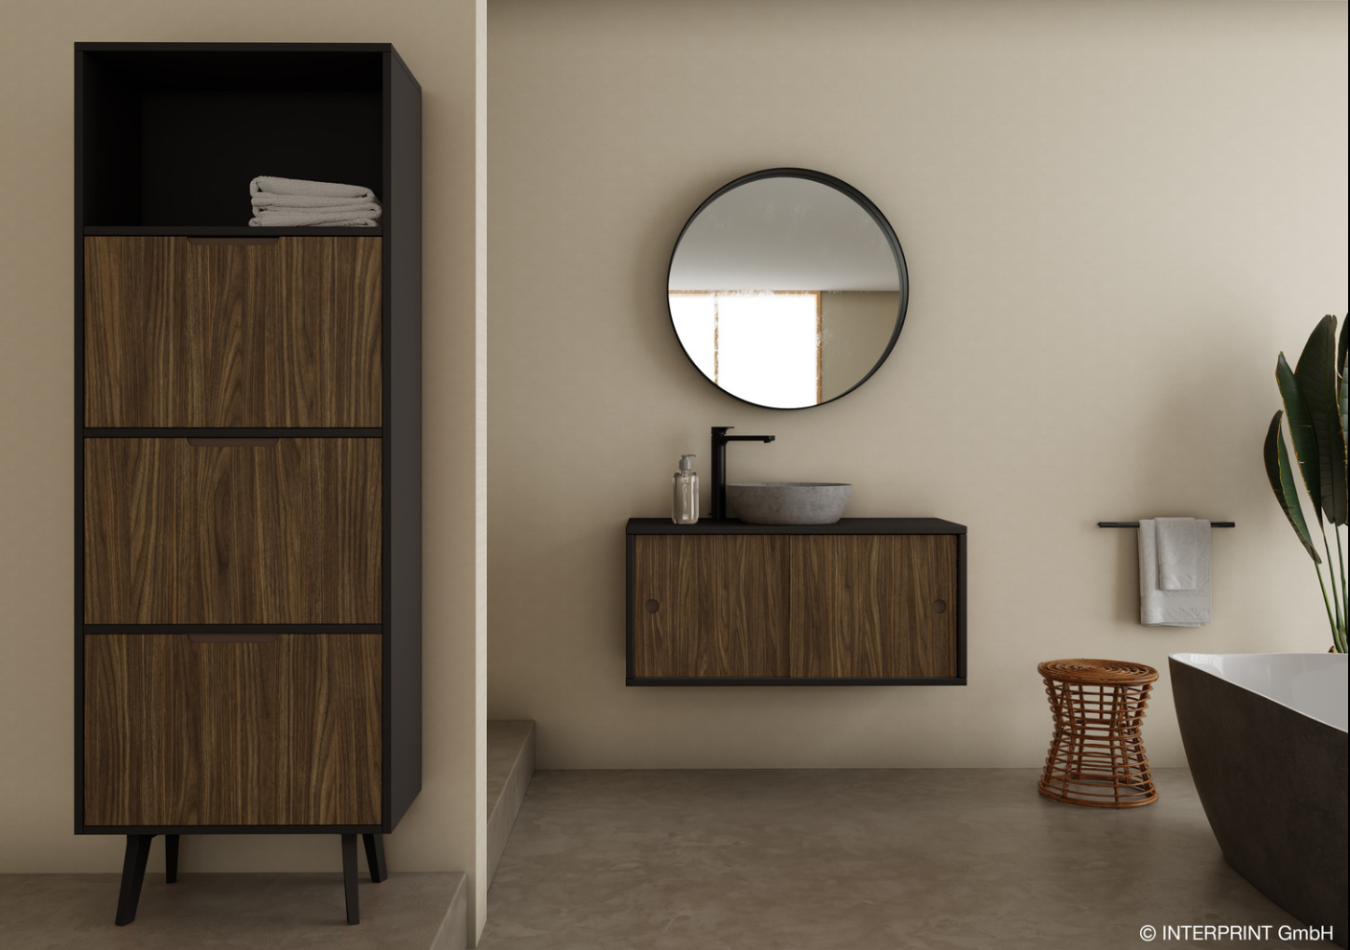  ContiTech_pp_skai_structure_Wright_Walnut | Skai structure Wright Walnut brown: The popular look of American walnut meets the refinement of a European décor. Linear cathedral grain, contrasting growth rings and the characteristic fine walnut pores emphasize the natural appeal of this timeless classic.  © Interprint GmbH
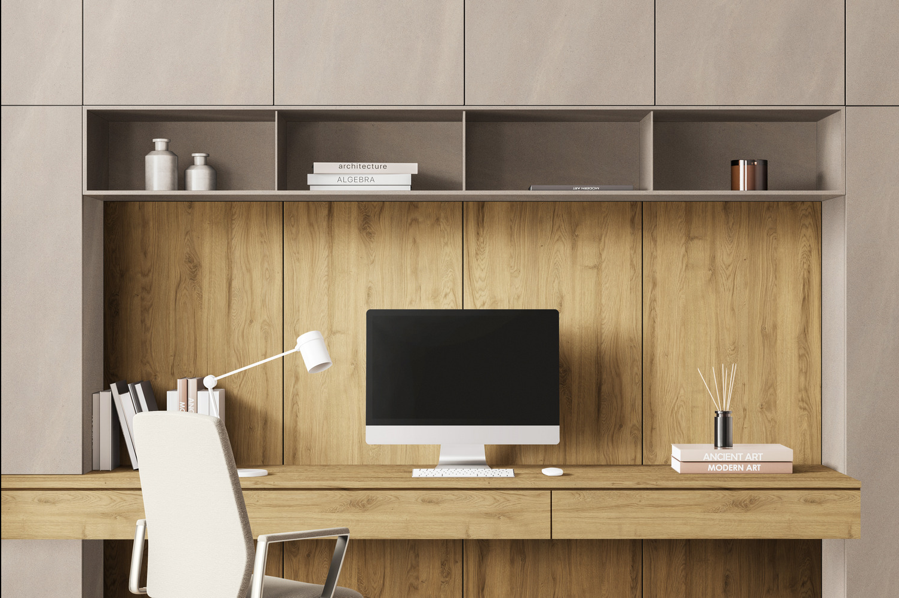  ContiTech_pp_skai_Maranello_Oak_natural | Skai Maranello Oak natural: This rustic yet elegant oak décor celebrates natural authenticity with distinctive knots, subtle cracks and dynamic grain patterns. Its characterful design conveys a strong connection to nature and brings warmth and vitality to interior spaces.  © LamiGraf
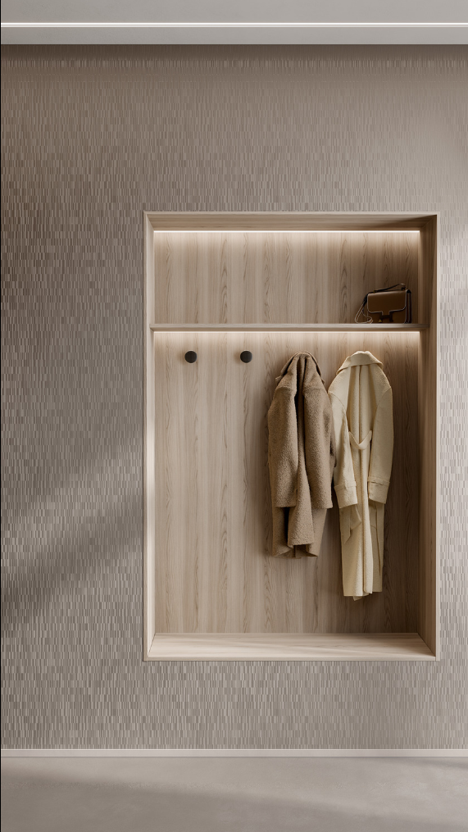  ContiTech_pp_skai_colore_structure_grayish | skai colore structure GEO creates a distinctive visual appearance through irregular rectangular patterns and striking matte-gloss effects. Surface structures of varying depths also deliver an innovative tactile experience that conveys a sense of robustness and durability.  © Gruppo Mauro Saviola

  ContiTech_pp_Ralf_Imbery | Ralf Imbery is head of Marketing, Design and Technology Surface Solutions at ContiTech.

